This is the author’s pre-print (post peer-review) of

Spolia as speculation

Paul O’Kane
Critical Studies, Fine Art, Central St Martins College, University of the Arts London, London, UK

ABSTRACT
Do the concept of spolia, the ideas of Georges Bataille, Walter Benjamin’s ‘Angel of History’ and the practices of artists point to the conclusion that there is no such thing as ‘waste?’ Are waste and value conflated today as never before? Is waste a modern, capitalist concept or conceit? These are some of the questions that motivate this article and which it hopes to illuminate, if not fully to answer. The article consciously mixes objective speculation with subjective and empirical experience and also features the writer’s own artworks as examples. The reader is invited to consider a constant, immanent economy; an endless, formless, qualitative ‘accountancy’ (perhaps anaccountancy) that avoids separate columns for profit and loss and dispenses with finalizing totals. This form of evaluation can be applied both to the content and the style of the article. The author draws upon the thought of Georges Bataille (as inspired by Nietzsche) to illustrate the concept of spolia as an affirmation of perceived ‘waste’. Waste is considered a historically variable concept, examined here in terms of capitalism and of bourgeois consumerist values. The author draws upon his own photography practice and also references Dutch seventeenthcentury flower painting while alluding to the writings of Walter Benjamin, Giacomo Leopardi and Charles Baudelaire in dialogue with those of Bataille/Nietzsche.

Nietzsche joined the intelligible to the sensible in himself and there is nothing that he gave as the purpose of his thought, unless it be the sovereign moments that give humanity its countenance. No cause, no commitment issue from an empty generosity, with which no expectation is connected. But Nietzsche is on the side of those who give, and his thought cannot be isolated from the movement that tried to promote a resumption of life in the moment, in opposition to the bourgeoisie, which accumulates. (Bataille 1991, 370–371)

So much in our world is offered only for it to fall, by the way, to fall into obscurity, into the margins, gutters and ditches. Much goes unrecognized, dismissed. Beings with potential are reduced by crude hierarchical organization, tribalism, nepotism and primitive competitiveness, to underdogs, documents. Valuable artefacts are shuffled off to the archive only to fall out of it, out of organization altogether, into an ultimate entropy, out of time, out of sight, value and history. Half a century after Bataille’s death art and thought are still blighted by the dominant, seemingly immovable bourgeois class, who pervert these sacred pursuits to banal, self-empowering ends, abusing the sacred value of art and thought, bending it to short-sighted capitalist purposes.
But this need not break our hearts or induce in us despair. Creative thought and its writing is a process inevitably shot-through with hope, gleaming with traces of potential redemption while unarguably imbued with and sustained by a certain faith. If art and artists are buoyed by an-economic belief then ‘waste’ is also little more than an all-toohuman conceit, an emotional evaluation of resources over which we believe we assert more qualitative and quantitative control than we really do. Spolia is a useful figure capable of making a contribution to such a conclusion.
Despite common parlance, it is not really possible to ‘waste time’. The busy professional who misses their flight rails in vain against time ‘wasted’, until, that is, they reconcile themselves with their suddenly imposed powerlessness and with the inexorability of events beyond their control. At best they will affirm any ‘downtime’ they have been unexpectedly gifted, not as a reward for a wilful act but as bequeathed by the unruly gods of chance. And ‘downtime’ is a rare, perhaps sacred time in which more can occur than can within more clearly occupied, applied or instrumentalized times. Meanwhile, the past, as time we appear to have ‘lost’, time which seems abandoned, used and ‘wasted’, lying beyond the reach of any acquisitive, instrumentalizing will, nevertheless remains productive, if in nothing else than as a productive residue of meaningful memory that in many ways produces and enables our present.
In this respect nothing of past time, can be ‘wasted’, not a drop, not one of those moments, hours, days, those years or decades that we may have regarded – in their moment and subsequently – as ‘wasted’ or wasteful. As we know, and as the masterful Marcel Proust famously strived to demonstrate, just one unanticipated moment of presence can transform the way we perceive and evaluate apparently ‘lost’ or ‘wasted’ time.
Similarly, destruction may be deemed (de)constructive. The icons of one culture or one time are torn down, but only to be reconfigured as pieces of the iconography of another time, another regime, belief or society. We see this most obviously in the particular aestheticization awarded by modern society to the ruin, the fragment, to broken statuary. It can be seen explicitly today in architect Renzo Piano’s grandiose and graphic ‘Shard’ building in London, whose pinnacle appears pre-distressed, pre-destroyed as if anticipating its demise even in the unveiling of its air piercing innovation. To look up at the apparently broken pinnacle of The Shard is to be immediately minded of those far stouter towers of the World Trade Centre in New York, as they stood until the morning of 11 September 2001. The narrowing Shard, it is clear, would be harder to hit with a passenger jet flown by an amateur pilot hi-jacker (or a seasoned pilot with a knife at his throat.) The Shard is ‘preruined’, a building that incorporates and reinvests failure, destruction, history and breaking news into its fabric and form.
Today, we see constant – we might say immanent – re-evaluation of the past in our increasingly archival culture and our voracious appetite for all things nostalgic and ‘retro’. Everything of the past is permitted and nothing is wasted. Some perceived lack concerning both future and present demands that no past can be ‘lost’, ‘wasted’ or allowed to rest. How often today do we (rich, modern citizens of so-called leading nations) really destroy and discard? We daily interact with, and tend to archive, digital, virtual signs while only virtually, digitally ‘discarding’ them, if at all, and then do so only using digital, virtual ‘Trash’ that emits a more or less satisfying simulation of the sound of destruction, standing-in for our loss of any real, any actual loss. Meanwhile, when we place real refuse into real refuse bins the ritual becomes increasingly complex, thoughtful, scientific, involving variously coloured and shaped receptacles and following increasingly complex written directives. Most of what we discard is rapidly retrieved by teams of skilled and noble council workers who ship our detritus off to be recycled and reformed into someone else’s future. So can we really call this ‘waste?’
We surround ourselves with speculative spolia, laying it down beneath and behind our visible practices like creative compost from which we hope our own future might grow. As artists we might surround ourselves with the fecundity of apparent waste. Consider the romantic image of the most expressive modern painter’s studio, or the writer’s archive of incomplete manuscripts, including sketches, outtakes, versions and quietly treasured juvenilia. Francis Bacon’s studio, strangely preserved and curated at Dublin’s Hugh Lane Gallery, piled high with smeared paint and fading media. Kurt Schwitters rescuing bus tickets and buttons from pre-war German streets, only to then reestablish them triumphantly in compositions of equivalent values. Schwitters thus championed a holistic relativism through the quintessentially modern art of collage.
All such spoliation is not exceptional, not peripheral or marginal according to the more horizontal organization of values we are considering here, but is, rather, the norm. It is the ashes that return to ashes, the dust to dust as ‘pre-loved’ bricks and mortar are re-invested, yesterday’s proud walls become the hardcore of tomorrow’s foundations, and sometimes vice versa too. On what is often referred to as a ‘shrinking planet’, whose shared resources are increasingly bickered over by a rapidly increasing population, most of whom now live in ever-growing cities and megacities, spolia increasingly becomes the morbid air that we breathe, a form of death in life.
Spolia troubles both the scale and orientation of our time. The art, thought and writing of Robert Smithson might thus be implicated here as that of an artist influenced by radical art historian George Kubler to consider art history within less anthropocentric, more geologic time-spans within which values of ‘waste’ and loss become either all or nothing.¹ (Kubler 1962; Smithson 1996)
As Smithson might have observed, in geologic, inhuman expanses of time, all structures of matter or thought become mere hesitations, temporary formations negotiating an ultimately entropic, falling, failing and deforming trajectory. Thus, all aspirations to succeed, overcome and transcend, to ‘author’ and construct, become delusory conceits, imbalances we might say, revealing at best what Nietzsche indicted as the all-too-human failing of our mal-directed (sic) ‘will to power’.
But what would a life or a persona be that truly knew how to balance value and waste, construction and destruction, reconciling our aspiration to achieve with our ultimate, inevitable, inexorable and inexplicable entropic failure? Thought, philosophy and a history of ideas, as well as the art of writing, have always redeployed the spolia of previous attempts to seek truth, cultivate knowledge and question preconceptions. The recycling of spolia is not an exception or curiosity but a rule in our philosophical and historical tradition. Not marginal but central.
One of the least reassuring aspects of Plato’s dialogues is that they entertain existing popular philosophical preconceptions only as ‘straw men’, each rhetorically set-up only to be cast down, trumped, their constituent parts reformed in the image of more rigorous Socratic thought. Freud’s desk is littered with images of the classical myths he reinterpreted and concocted into modern medicine for the newly empowered bourgeoisie. Meanwhile, Hegel’s dialectics require the sacrifice of every thesis on the way to a temporary synthesis; and this schema, obliquely at least, might also have inspired Walter Benjamin’s memorable image of the ‘Angel of History’ (Benjamin 1970, 253–264)
Benjamin’s angel continues to appeal to us, not only rhyming with our sense of a disoriented journey through thought and history but also because it insists that we fix our eyes, not on the reassurance and hubris associated with construction and achievement, but on destruction, the ultimate ruin of all so-called achievement. It asks us to meditate upon the ‘one single catastrophe that keeps piling wreckage and hurl(ing) it in front of (the angel’s) feet’ (Benjamin 1970, 253–264).
This ‘one single catastrophe’ belies not only achievement but also (what Benjamin, in the same text refers to as) the ‘chain of events’ that ‘we perceive’ as an organization of history into event and non-event, value and non-value, importance and unimportance, worth and waste (Benjamin 1970, 253–264). In denying us a chain of distinct events, Benjamin scrambles all waste with all value. In Benjamin’s image of the ‘Angel of History’, the spolia of one supposedly individuated historical event or philosophical idea is certainly not revalued and reinvested in a subsequent idea or event according to the Hegelian schema, if only because there is no such convenient distinction between events and ideas, but only the (more Bergsonian) duration of ‘one single catastrophe’. The angel sees a non-incrementalized time; sees history as one great and continuous disorganization and devaluation, all through a retrospective and helpless gaze. Ultimately, it is difficult to discern in this image either ‘waste’ or ‘value’, nor any incremental or distinguishable events by means of which ‘waste’ could be reinvested or evaluated. Benjamin’s ‘Angel’ is an effective and profound image if only because modern, historical man is nothing if not hubristic and therefore needs this ‘counter-image’ by means of which ‘progress’ is perceived also as destruction; a ‘counter-image’ by means of which all value is also perceived as waste (Bourriaud 2002).²
In the following section, I take the liberty, risk or opportunity to consider an example of my own practice (Figure 1) in light of the ongoing discussion. Damage has evidently been done to this photographic image, however, it is not added by means of a digital application or ‘filter’, nor is it caused by the natural ageing of the image, but occurs in the very moment of its manufacture – at birth, so-to-speak. The damage is the image, the image the damage. The damage is only as true and as valuable as the image and the two are indistinguishable. We are not so much looking at a damaged image as at an image that, in being made is necessarily damaged, destroyed or apparently ‘wasted’ in the service of its construction. The value of the image and the relative value of its various aspects – its content, process, etc. – are thus brought into question from the outset. This artwork questions value, starting with its own value. Even as the plastic film base and light-sensitive coating are ripped by being transported through the ‘wrong’ anachronistic camera, and wound on an inappropriate spool, destruction nevertheless appears to create a value. The scratched surface of this photograph may also draw our attention to the palimpsest that allows us to see each element, both allegorically and literally, through another. Here, we see flowers through destruction and destruction through flowers, graffiti through flowers and flowers through graffiti, nature through culture, content through process, formation through destruction, achievement through failure, value through waste, etc.

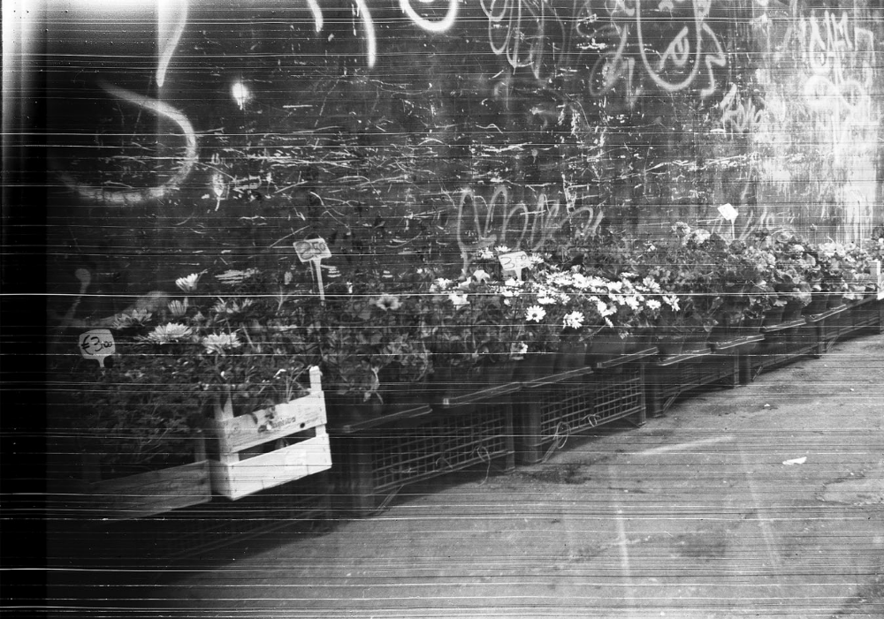
Figure 1. Porta Portese, 2007–2016, digital photographic print from scanned B&W negative.

But what of the content or narrative of this photograph, its configuration of meaningful signs? Most obviously perhaps, there are flowers, arch-signifiers of beauty, love or mourning, of nature, fragility and ephemera. There is also graffiti in equal measure, graffiti as perhaps a kind of urban flora that decorates and patinates, celebrates and berates the fabric of every city, that illuminates, with its postmodern scripture, those ‘empty lots’ that form an arcane but apparently essential part of capitalism’s enterprise and which are otherwise decorated only by the ubiquitous and tenacious Buddleia (sometimes devalued and demonized along with other spontaneously emerging wild plants as a ‘weed’).
The flowers in the photograph are for sale. The graffiti is not (although graffiti is becoming increasingly commodified and incorporated into the art market.) The flowers have prices, something that may often strike us as absurd, to place prices on flowers, of all things? The prices are given in Euros, and so, though the photograph might at first sight seem difficult to place and to date (different eras seem confused) we are surely in post-EU Europe, a more or less united Europe which may, in our lifetimes be breaking up again, relinquishing its ideal of a shared multi-national economy, currency, market, territory and moral code.
To turn away momentarily, to other, further historical concerns, we might here also consider seventeenth-century Dutch trading society – one of the birthplaces of modern capitalism – as it abundantly celebrated and artfully recorded for posterity the relationship that it made between flowers, art and commerce thereby establishing a modern, aesthetic and economic value of flowers as something bred, harvested, desired, supplied and commodified as objects of international trade; fragile exotica destined for the middle-class domestic interior. They were also abundantly and enthusiastically represented by painters, and once preserved in oil paint, behind varnish, frames and glass, were kept first in small domestic collections, then by museums. As a result their 400-year-old petals are yet to fall, art suspends their value, disallowing, preventing them from becoming waste. Art thus aspires to preserve life itself (Slive 1995).
The flowers in my own photograph are cheap, common, anexotic (sic). They are neither protected nor carefully arranged and, costing merely a few euros look unlikely to endure for long. They are also, we might say, rendered cheaply, photographed with an antiquated, redundant and discarded Kodak Brownie camera – itself gleaned from a flea market – using anachronistic, inappropriate film. These cheap and common flowers are denied what we might consider to be the crucial value of their colour, along with their motion, their texture, and what Benjamin famously called their auratic ‘unique presence in time and space’ (Benjamin 1970, 217–251).
Rendered only in shades of black, white and grey, and thus rendered austere – as if alluding to economy by means of an impoverished garb – they may even be ‘celebrating some funeral’ as Baudelaire once said of the frock-coated populace of modern Paris. In their very austerity, these flowers may then appear more ‘modern’ than the seventeenth- century Dutch, oil painted variety, if only because all that is modern becomes for us both photo-graph-ic and inescapably historical. Baudelaire challenged the first modern artists to produce ‘colour’ using only ‘black, white and grey’, a request answered dutifully, first by Whistler and later by various minimalists, as well as by photographers whose limited chemistry initially meant that they could not do otherwise (Baudelaire 1992, 104–108).
This scene, these flowers, this graffiti, like my crude camera, were all found in the Porta Portese flea market in Rome where the city’s dead devote their very own spolia, the socalled bric-a-brac that marks out our modern life (old cameras, photographs, chairs, candlesticks, mirrors and birdcages) to feed the future. There in the flea market, the young and (for now) upwardly mobile, selectively seize on certain signifiers of taste and cool to establish retro-chic or poverty-chic and emerge triumphant in response to, and as an aspect of an increasingly brutalizing and totalizing, spectacularly ‘new’ and increasingly consumerist economic system. Their new life and new values browse, finger, choose and nudge a new style, a new mode, fashion, a new way of dressing life, out of the rot and failure of the old.
Andre Breton, in his book Mad Love, described accompanying the artist Giacometti to a similar market in Paris, where he was able to locate, record, share and demonstrate Surrealist principles of chance, juxtaposition, unconscious drives and psychoanalytic interpretations with the aid of one or two found objects (Breton 1987). Walter Benjamin, in his essay on Surrealism, celebrated Breton as a modern genius who innovated by locating ‘revolutionary energies’ in ‘the outmoded’, including ‘the dresses of five years ago’, ageing trains, ironwork and café’s that have gone out of fashion. Thus, Benjamin, inspired and abetted by Breton, describes the spoliatic nature of modern progress (even of ‘revolution’) as not so much Hegelian or dialectical but rather as a kind of seamless, inexorable and barely representable leapfrog of past into future, waste into value, and vice versa – ad infinitum (Benjamin 1997, 225–239).
The scarred and ripped surface of my own photograph aspires to be its ur or meta image, a base material fact that pulls flowers, prices, walls, crates and graffiti together, synthesizing what are otherwise semiotically differentiated elements which – like the ‘one great historical catastrophe’ seen by Benjamin’s Angel of History – are not in fact distinct. Given less attention to rationalizing semiotics, and more to base materiality, so in art as in life, worth and waste, damage and value become one. The rips and scars point to a base materiality shared by all aspects of both ‘image’ and ‘damage’, both ‘value’ and ‘waste’, point to all that is beyond, before, and after the separation of image and damage, value and waste.
To move towards a conclusion, I would like here to turn towards one or two further concrete examples, this time taken from what is sometimes called ‘the natural world’ and accompanied again by the thought of the dissident Surrealist and radical economist Georges Bataille, who took interest not only in ‘The Language of Flowers’ (Bataille 1985, 10–14) but also in what he called General Economy (Bataille 1988, 19–41), thereby alluding holistically to the relative value of all things, including apparent ‘waste’ and wastefulness.
Cheap flowers, seeded from heads that drop thousands of seeds as their own wild speculations, proffer their own spolia¸ shedding petals, leaves and blossoms even as they fall onto barren concrete or synthetically sealed domestic floors. Nothing is ‘wasted’, nature itself knows no-such all-too-human concept. ‘Waste’ itself comes to appear unnatural. Given just a slight shift of an all-too-human emphasis ‘waste’ becomes also positive, fecund, a fertile virtue implicating an alternative, more generous economy. What might today’s dominant, parsimonious and protestant, European, capitalist economists do with the profligate economic model of a creature like the colourful Camellia? ³ (Figure 2). Queen of its own irrational economy, sovereign; absorbing and emulating the even more ‘wasteful’ sun that shines upon it, the Camellia proliferates itself through exuberant and vivid cycles of growth and decay. We call the Camellia’s abundant blooms first ‘beautiful’ then ‘ugly’. ‘Beautiful’ while upstanding and up-reaching in their useless spectacle, then ‘ugly’, repellant, once discoloured and deformed, once fallen

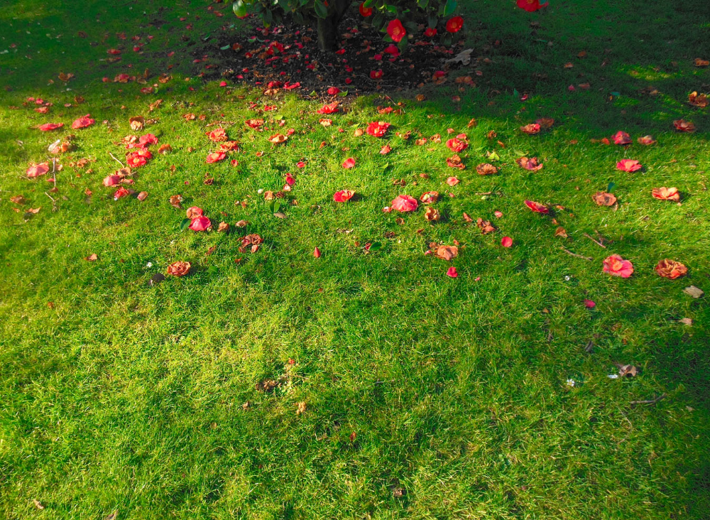
Figure 2. Camellia.

into mere use as food for the earth and for the plant’s even uglier roots. Pink petals rapidly become raw black energy ripe for the perpetuation of self, species and others. Here, we sense Bataille’s holistic socio-economics (‘The Language Of Flowers’, Visions of Excess, The Accursed Share, gift economy, General Economy, Potlach, Sacrifice, etc.) (Bataille 1985, 1988, 1991) and from a Bataillean perspective, progress and value in both art and life are never necessarily modern, linear, assured and aspirational, but must also and always ‘account’ for the potlatch of a thousand seemingly wasted projects, multiple failures, errors, as offerings to the ‘gods’ of time and chance, which are in one way or another re-‘invested’ and thus spoliatic, inexorably, inevitably returning to us in exchange for an as yet unknown but always implicit further return.
Finally, and to round-up an underlying Italianate theme as appropriate to this paper’s original incarnation as a contribution to a symposium at The British School at Rome, we might here also invoke the poem, Broom (or The Flower of the Desert) by Giacomo Leopardi. The enduring sentiment of this poem offers hope to all those who know seemingly wasteful defeat, destruction and desolation, as it juxtaposes nature’s ability to annihilate (through the image of an eruptive volcano) with (using the image of wild broom) nature’s equal power to regenerate itself.
But crucially, and as can be seen in the final stanzas of the poem, Leopardi warns against a too ‘human’ approach to life, and thus, inspired here by flowers, the poet nods to a way of accounting for our value, our time and our fates that is less hubristic and thus more appropriately attuned to acceptance of a humble, yet nevertheless noble place within and between the greater and wiser powers and extensities of nature. We might withstand obliteration, springing back like the broom, even from the ashes of a volcanic eruption and thus living again in a future in which we cannot help but invest ourselves. Nevertheless, we should live without any all-too-human assumption or delusion of immortality and instead accept more humbly our own place within a ‘general’ economy, wherein even life and death are no longer clearly opposed as antithetical, plus and minus, positive and negative values, and wherein, thus, nothing can clearly be regarded as ‘wasted’.
…So – indifferent to men and what men call
Antiquity, to all the ties that bind
One generation to another – nature
Stays forever green, or seems,
Having so vast a path to travel,
To stay still forever, Meantime kingdoms perish,
Nations and the tongues of nations
Pass away: nothing of this at all she’ll see:
And man boasts he owns eternity
And even you, delicate hedges of broom,
Who bless this desolation
With groves of fragrance,
Even you will succumb soon enough
To the tyranny of fire from underground
Returning to its old haunts,
The fire will spread its deadly mantle
Over your tender hedgerows; then,
Beneath its fatal weight you’ll bend
Your innocent, unresisting heads. But
Till that time comes you won’t bow down
Like cowards before the one who’ll destroy you,
Seeking your salvation in vain; and you won’t
Raise vainglorious heads to the stars
Or up above this wasteland where
By chance and not by choice you have
Your birthplace and your home; and still
You’re wiser and that much less weak
Than man, inasmuch as you don’t believe
These delicate stems of yours have been,
By yourself or the fatal scheme
Of things fashioned for immortality. (Leopardi 1997, 87–89)

Notes 1. We might take this as a spur to also consider Aboriginal Australian or Native-American Indian beliefs and peoples whose unframed or differently framed understanding of time, value and economy lies beyond the reach of modern representational systems in forms of alterity. Given such examples – of other times, other societies, other ways of thinking – ‘waste’ increasingly appears to be a merely local, modern, we might justifiably say ‘bourgeois’ concept, that is, in reality, an aspect or conceit only of modern capitalism. Nevertheless, the concept is generative, allowing us to consider many established phenomena and procedures in its light.
2. Bourriaud uses the term ‘counter-images’ in his publication ‘Postproduction’ with reference to updated forms of détournement found in contemporary artists’ practices (Bourriaud 2002). 3. Here, I am thinking of the current British chancellor, his British Conservative Party, and also the ways in which Germany and the most successful EU states recently responded to the European economic crisis and the response to requests for assistance made by struggling Greece.

Disclosure statement
No potential conflict of interest was reported by the author.

Notes on contributor
Paul O’Kane is an artist, writer and lecturer based in London. He writes regularly for Art Monthly magazine as well as for Third Text, Wasafiri, Miraj and other referee journals and artist’s catalogues. Paul O’Kane maintains an experimental weekly Blog ‘750wordsaweek’ (https:// 750wordsaweek.wordpress.com/) exploring the limits and freedoms available to art writing. Paul O’Kane is an International Member of AICA (Association Internationale des Critiques d’Art). Paul O’Kane completed a PhD in History at Goldsmiths College, University of London, 2009. Paul O’Kane exhibits artworks that relate a history of technologies to accounts of subjective experience, history and narrative. He teaches Fine Art, Critical Studies and Art History as an Associate JOURNAL OF VISUAL ART PRACTICE 9 Lecturer at CSM and Chelsea Colleges (University of the Arts London) and as a lecturer at SOAS (University of London) and as a visiting lecturer at other colleges.

References
Bataille, Georges (Stoekl, Allan. ed.) 1985. Visions of Excess: Selected Writings, 1927–1939. Minneapolis: University of Minnesota Press.
Bataille, Georges. 1988. The Accursed Share: An Essay on General Economy/Vol.1, Consumption. New York: Zone.
Bataille, Georges. 1991. The Accursed Share: An Essay on General Economy/Vols. 2 and 3: The History of Eroticism; Sovereignty. New York: Zone.
Baudelaire, Charles. 1992. Selected Writings on Art and Literature. London: Penguin Books.
Benjamin, Walter. 1970. Illuminations. London: Cape. Benjamin, Walter. 1997. One-Way Street: And Other Writings. London: Verso.
Bourriaud, Nicolas. 2002. Postproduction: Culture as Screenplay: How Art Reprograms the World. New York: Lukas & Sternberg.
Breton, André. 1987. Mad Love: L’Amour Fou. Lincoln: University of Nebraska.
Kubler, George. 1962. The Shape of Time: Remarks on the History of Time. New Haven, CT and London: Yale University Press.
Leopardi, Giacomo. 1997. Leopardi, Selected Poems. Translated and edited by Eamon Grennan. Princeton, NJ: Princeton University Press.
Slive, Seymour. 1995. Dutch Painting, 1600–1800. New Haven, CT: Yale University Press.
Smithson, Robert (Flam, Jack. ed.). 1996. The Collected Writings. Berkeley: University of California Press.

