HOW TO OPERATE THE KOREA TOWN KARAOKE SYSTEM

1. Collect microphone(s) from Reception
2. Switch microphone on and test. See if you prefer Echo, Bass or Treble added to your voice
3. Choose the KaraFun app
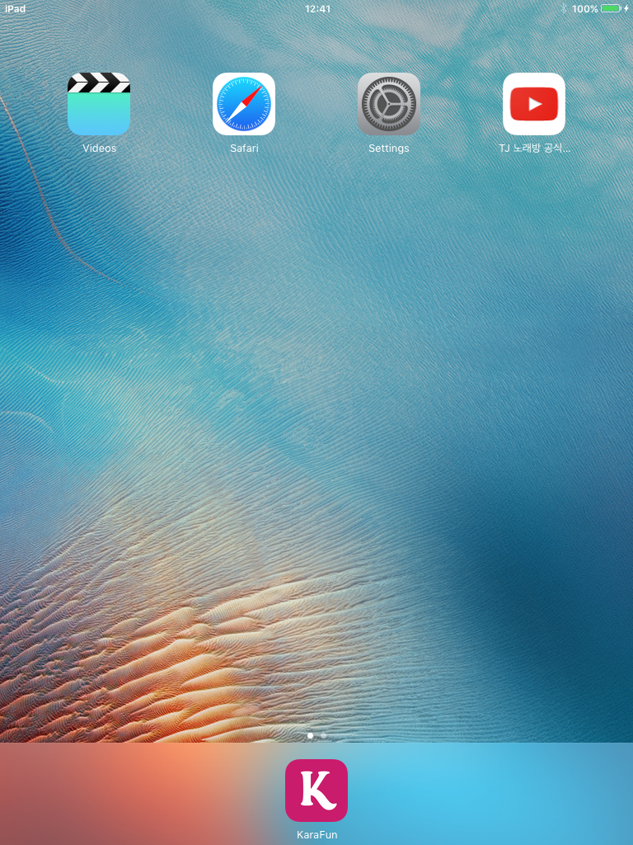
4. Choose the My songs icon
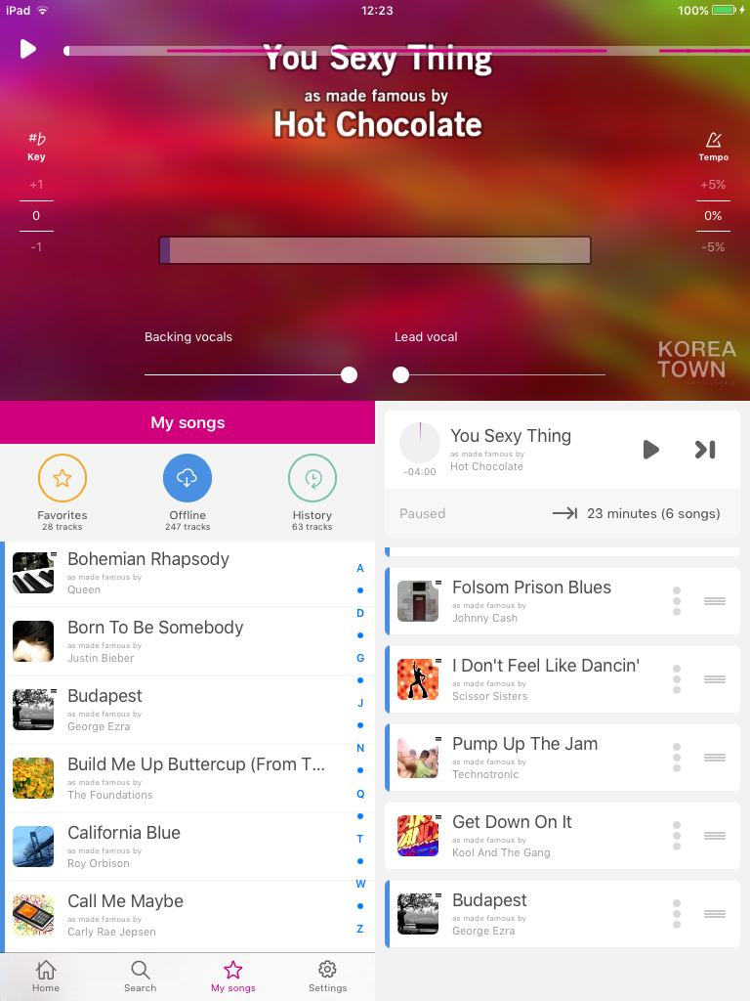
5. Choose the Offline icon
6. Scroll down and choose your song
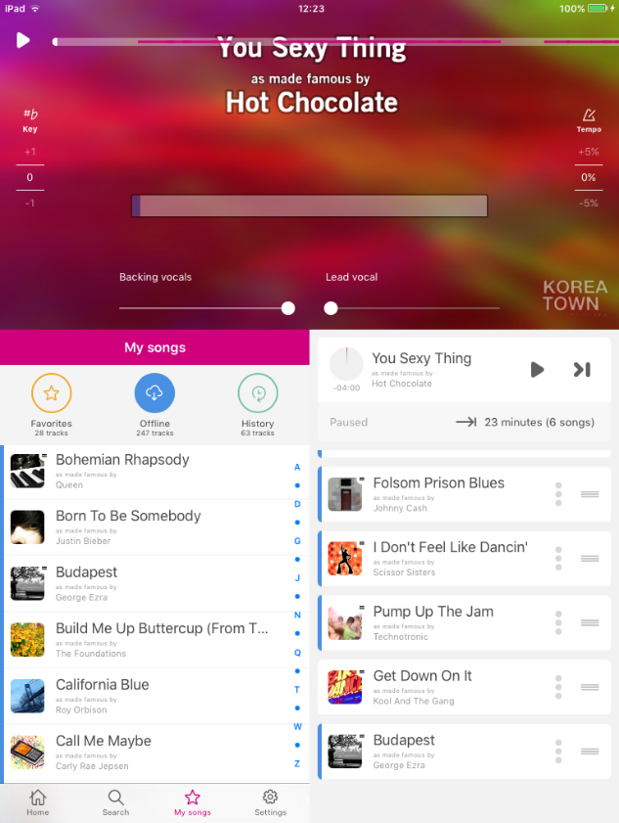
7. Touch the play (triangle) icon
8. You can adjust the backing vocals and lead vocals to your choice using the sliders (adjacent to the KOREA TOWN logo)
9. There are only 3 Korean songs in the KaraFun app, all by PSY. If you want to access more Korean songs then exit the KeraFun app and enter Videos. Here you will find some specially prepared Korean karaoke videos by William Ho.
