Tish Murtha: Works 1976–1991 – The Photographers’ Gallery – 2018 – List of Works – Loan Form

Elswick Revisited
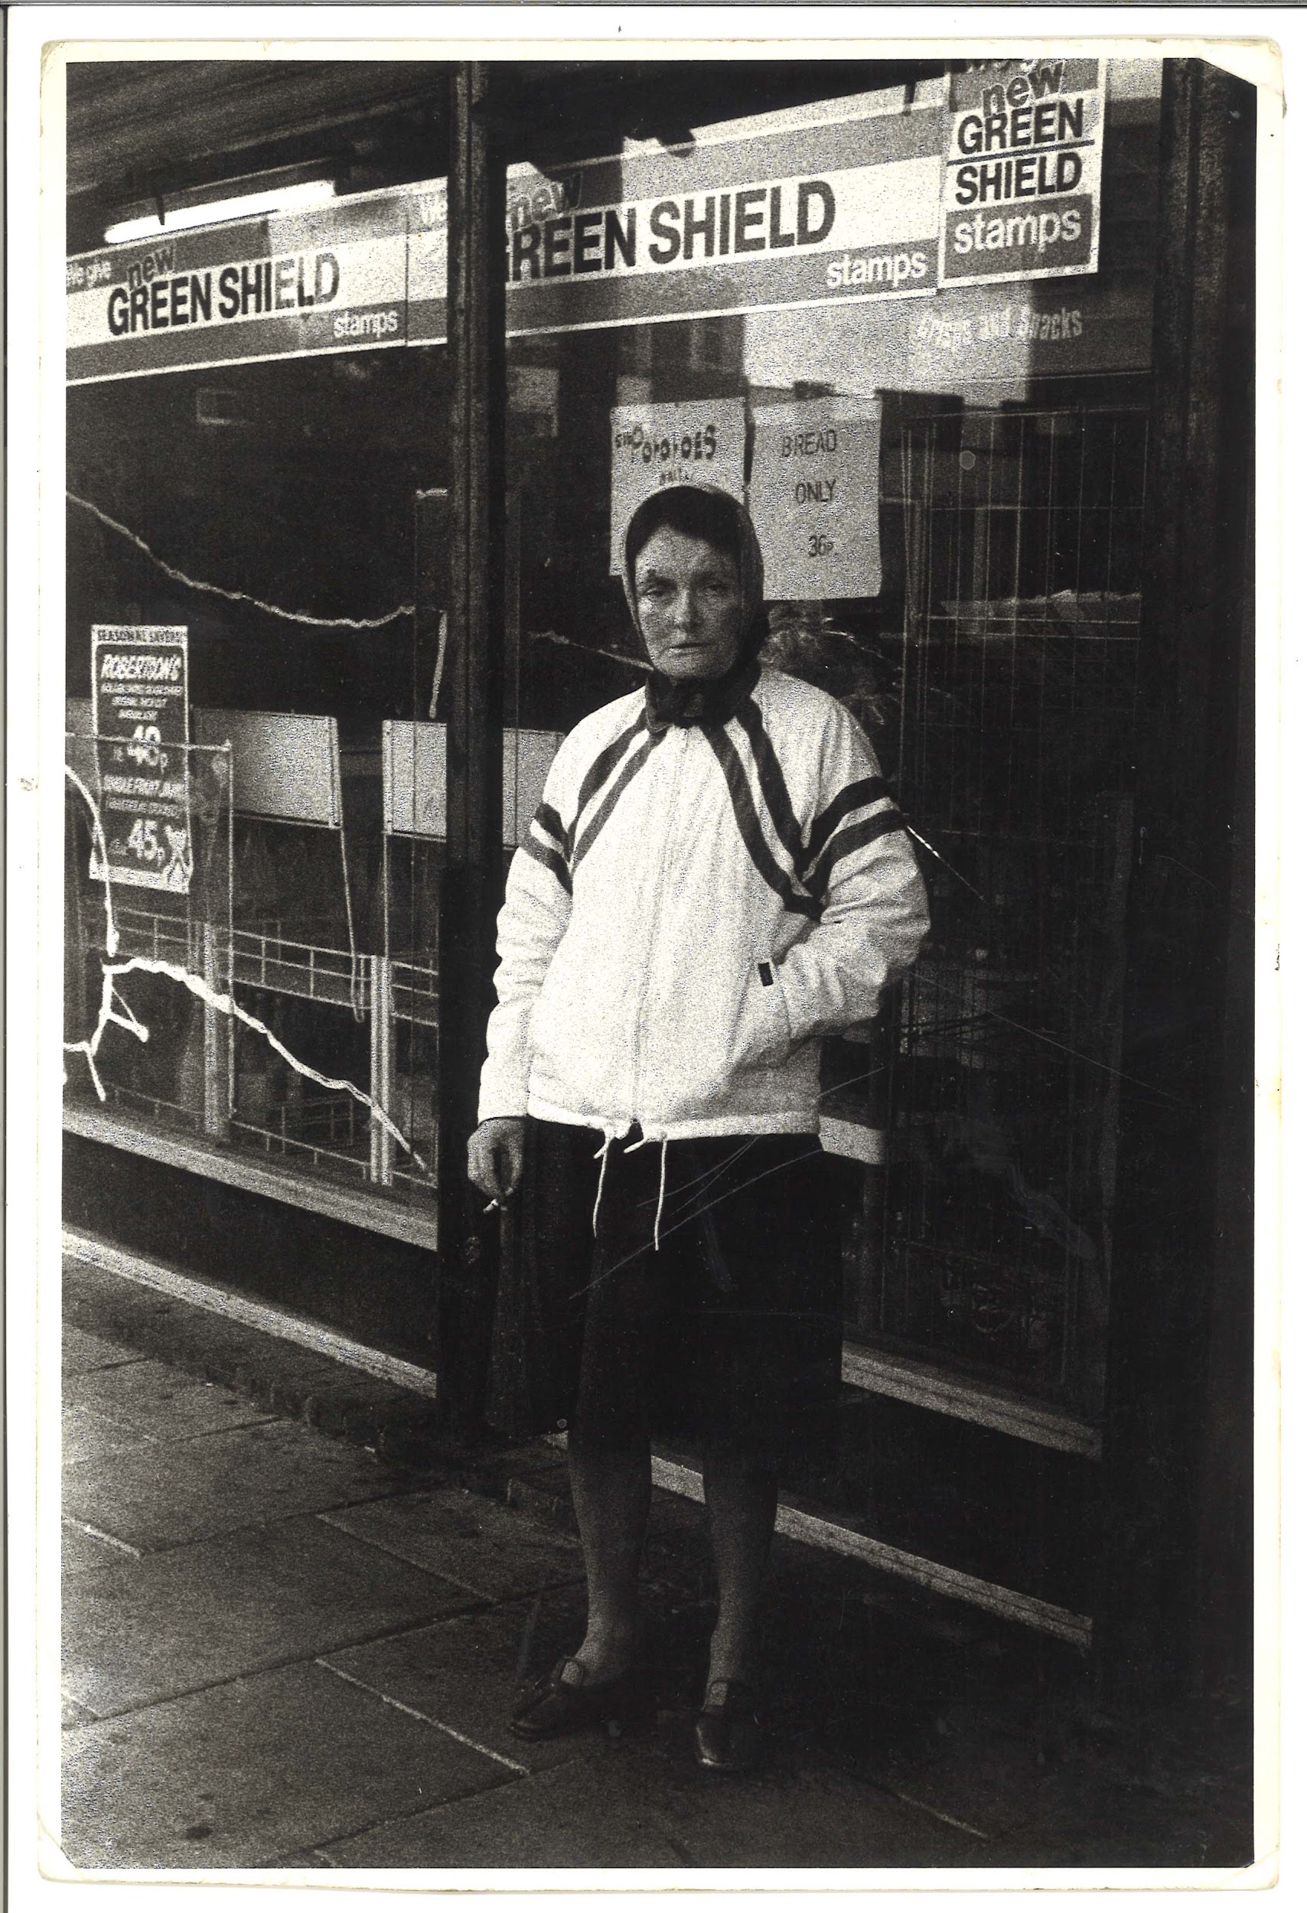 | TM_TPG_Elswick Revisited_2 | 215 x 310mm (approx) | Vintage print, loaned by Karen McQuaid / TPG on 08/05/18  From Ella Murtha material held at PARC | Elswick Revisited | 1
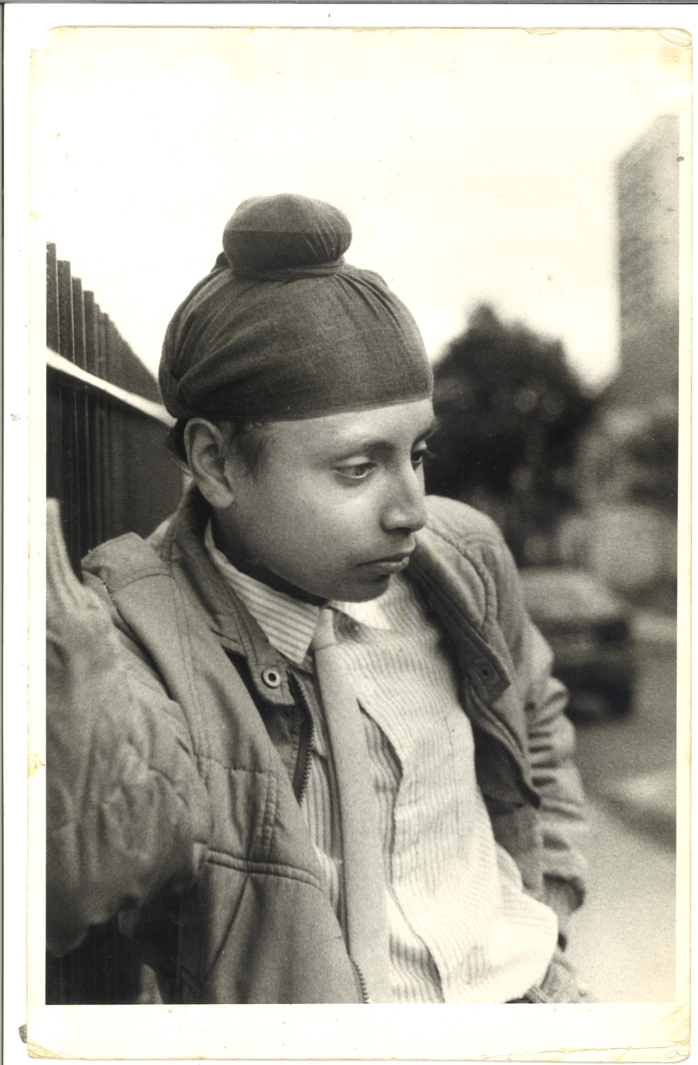 | TM_TPG_Elswick Revisited_3 | 215 x 310mm (approx) | Vintage print, loaned by Karen McQuaid / TPG on 08/05/18  From Ella Murtha material held at PARC | Elswick Revisited | 2
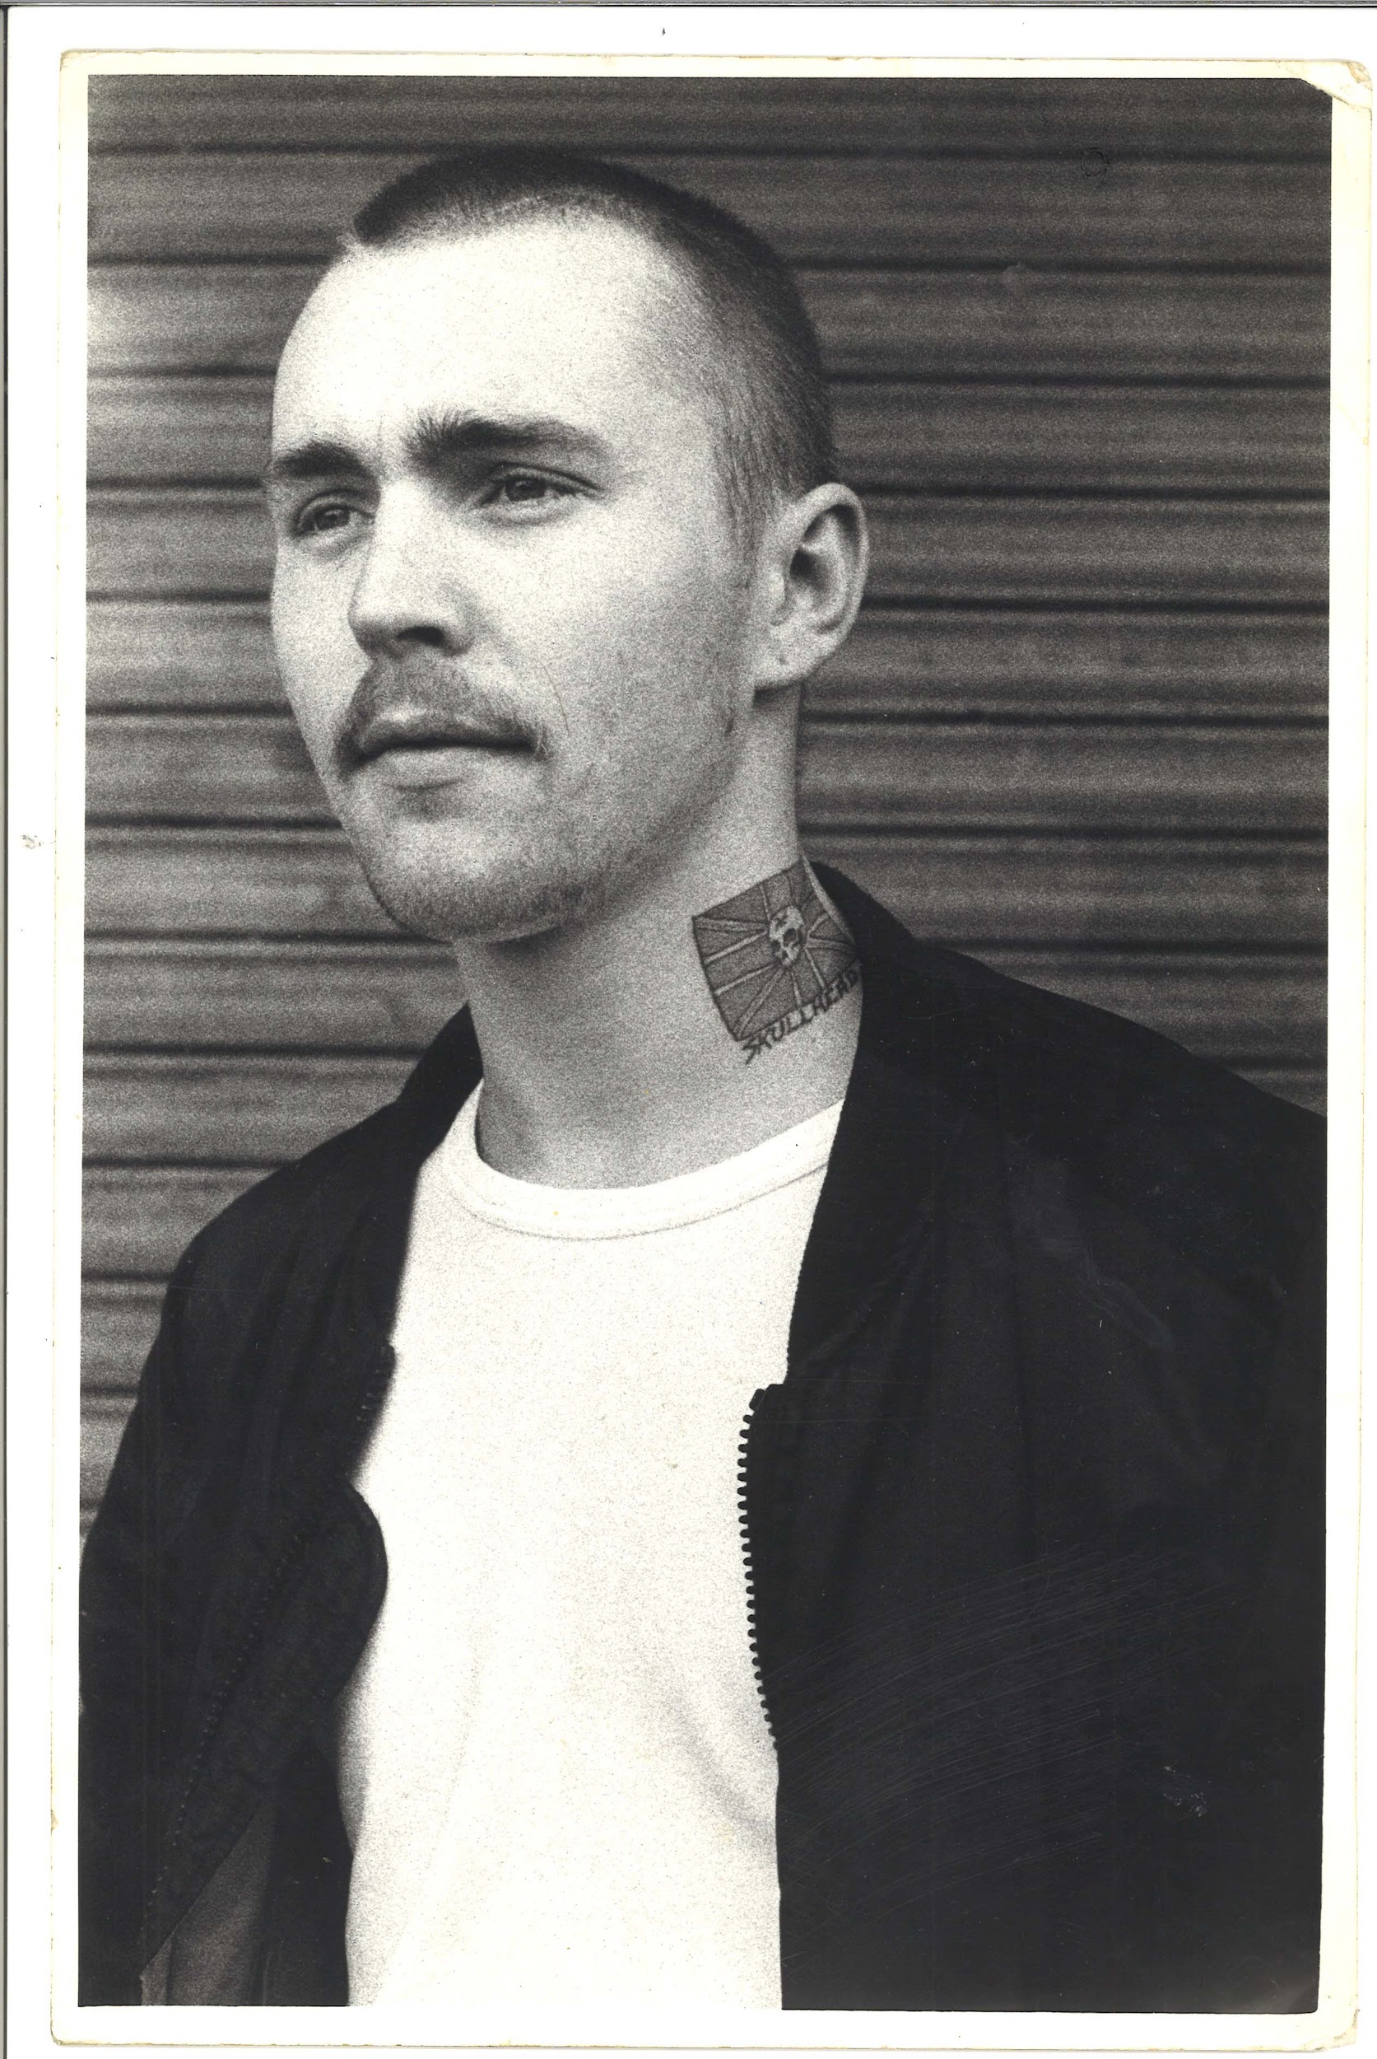 | TM_TPG_Elswick Revisited_4 | 215 x 310mm (approx) | Vintage print, loaned by Karen McQuaid / TPG on 08/05/18  From Ella Murtha material held at PARC | Elswick Revisited | 3
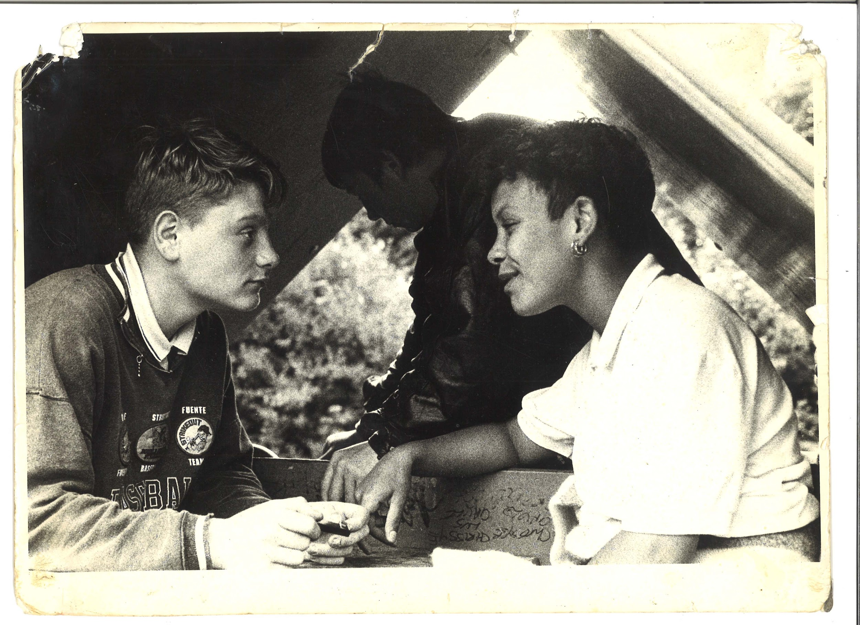 | TM_TPG_Elswick Revisited_8 | 310 x 215mm (approx) | Vintage print, loaned by Karen McQuaid / TPG on 08/05/18  From Ella Murtha material held at PARC | Elswick Revisited | 4
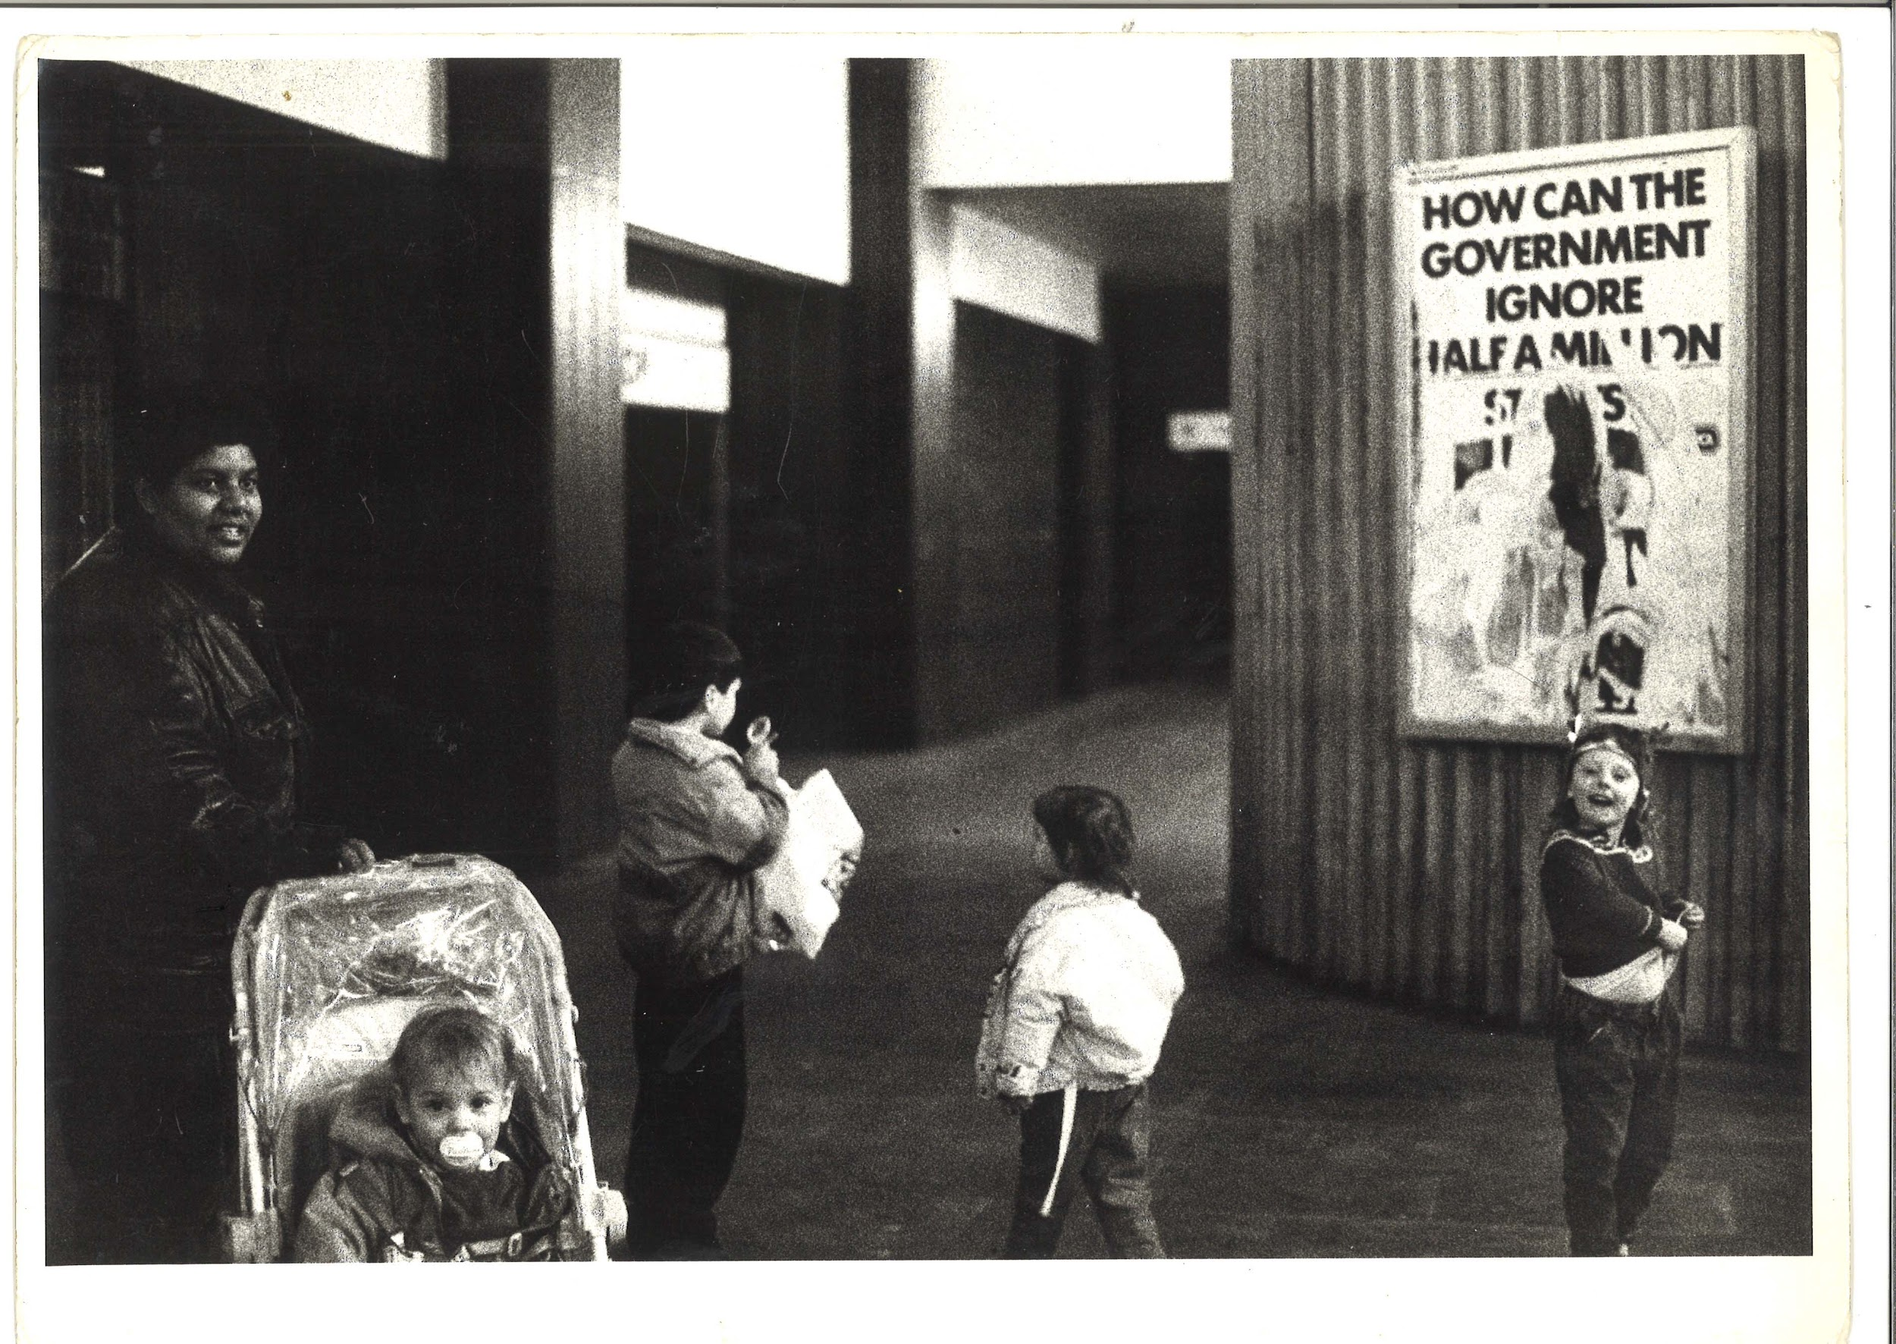 | TM_TPG_Elswick Revisited_9 | 310 x 215mm (approx) | Vintage print, loaned by Karen McQuaid / TPG on 08/05/18  From Ella Murtha material held at PARC | Elswick Revisited | 5
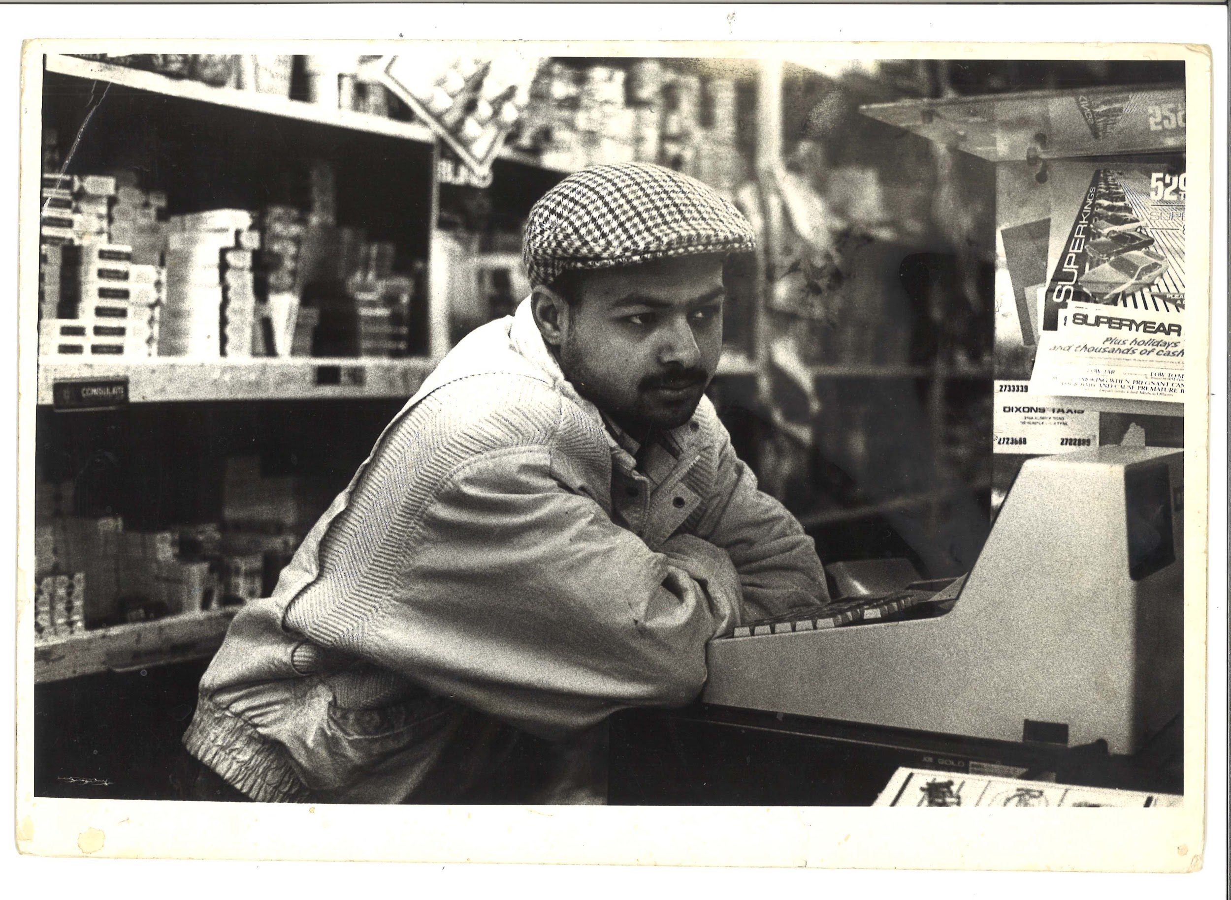 | TM_TPG_Elswick Revisited_10 | 310 x 215mm (approx) | Vintage print, loaned by Karen McQuaid / TPG on 08/05/18  From Ella Murtha material held at PARC | Elswick Revisited | 6
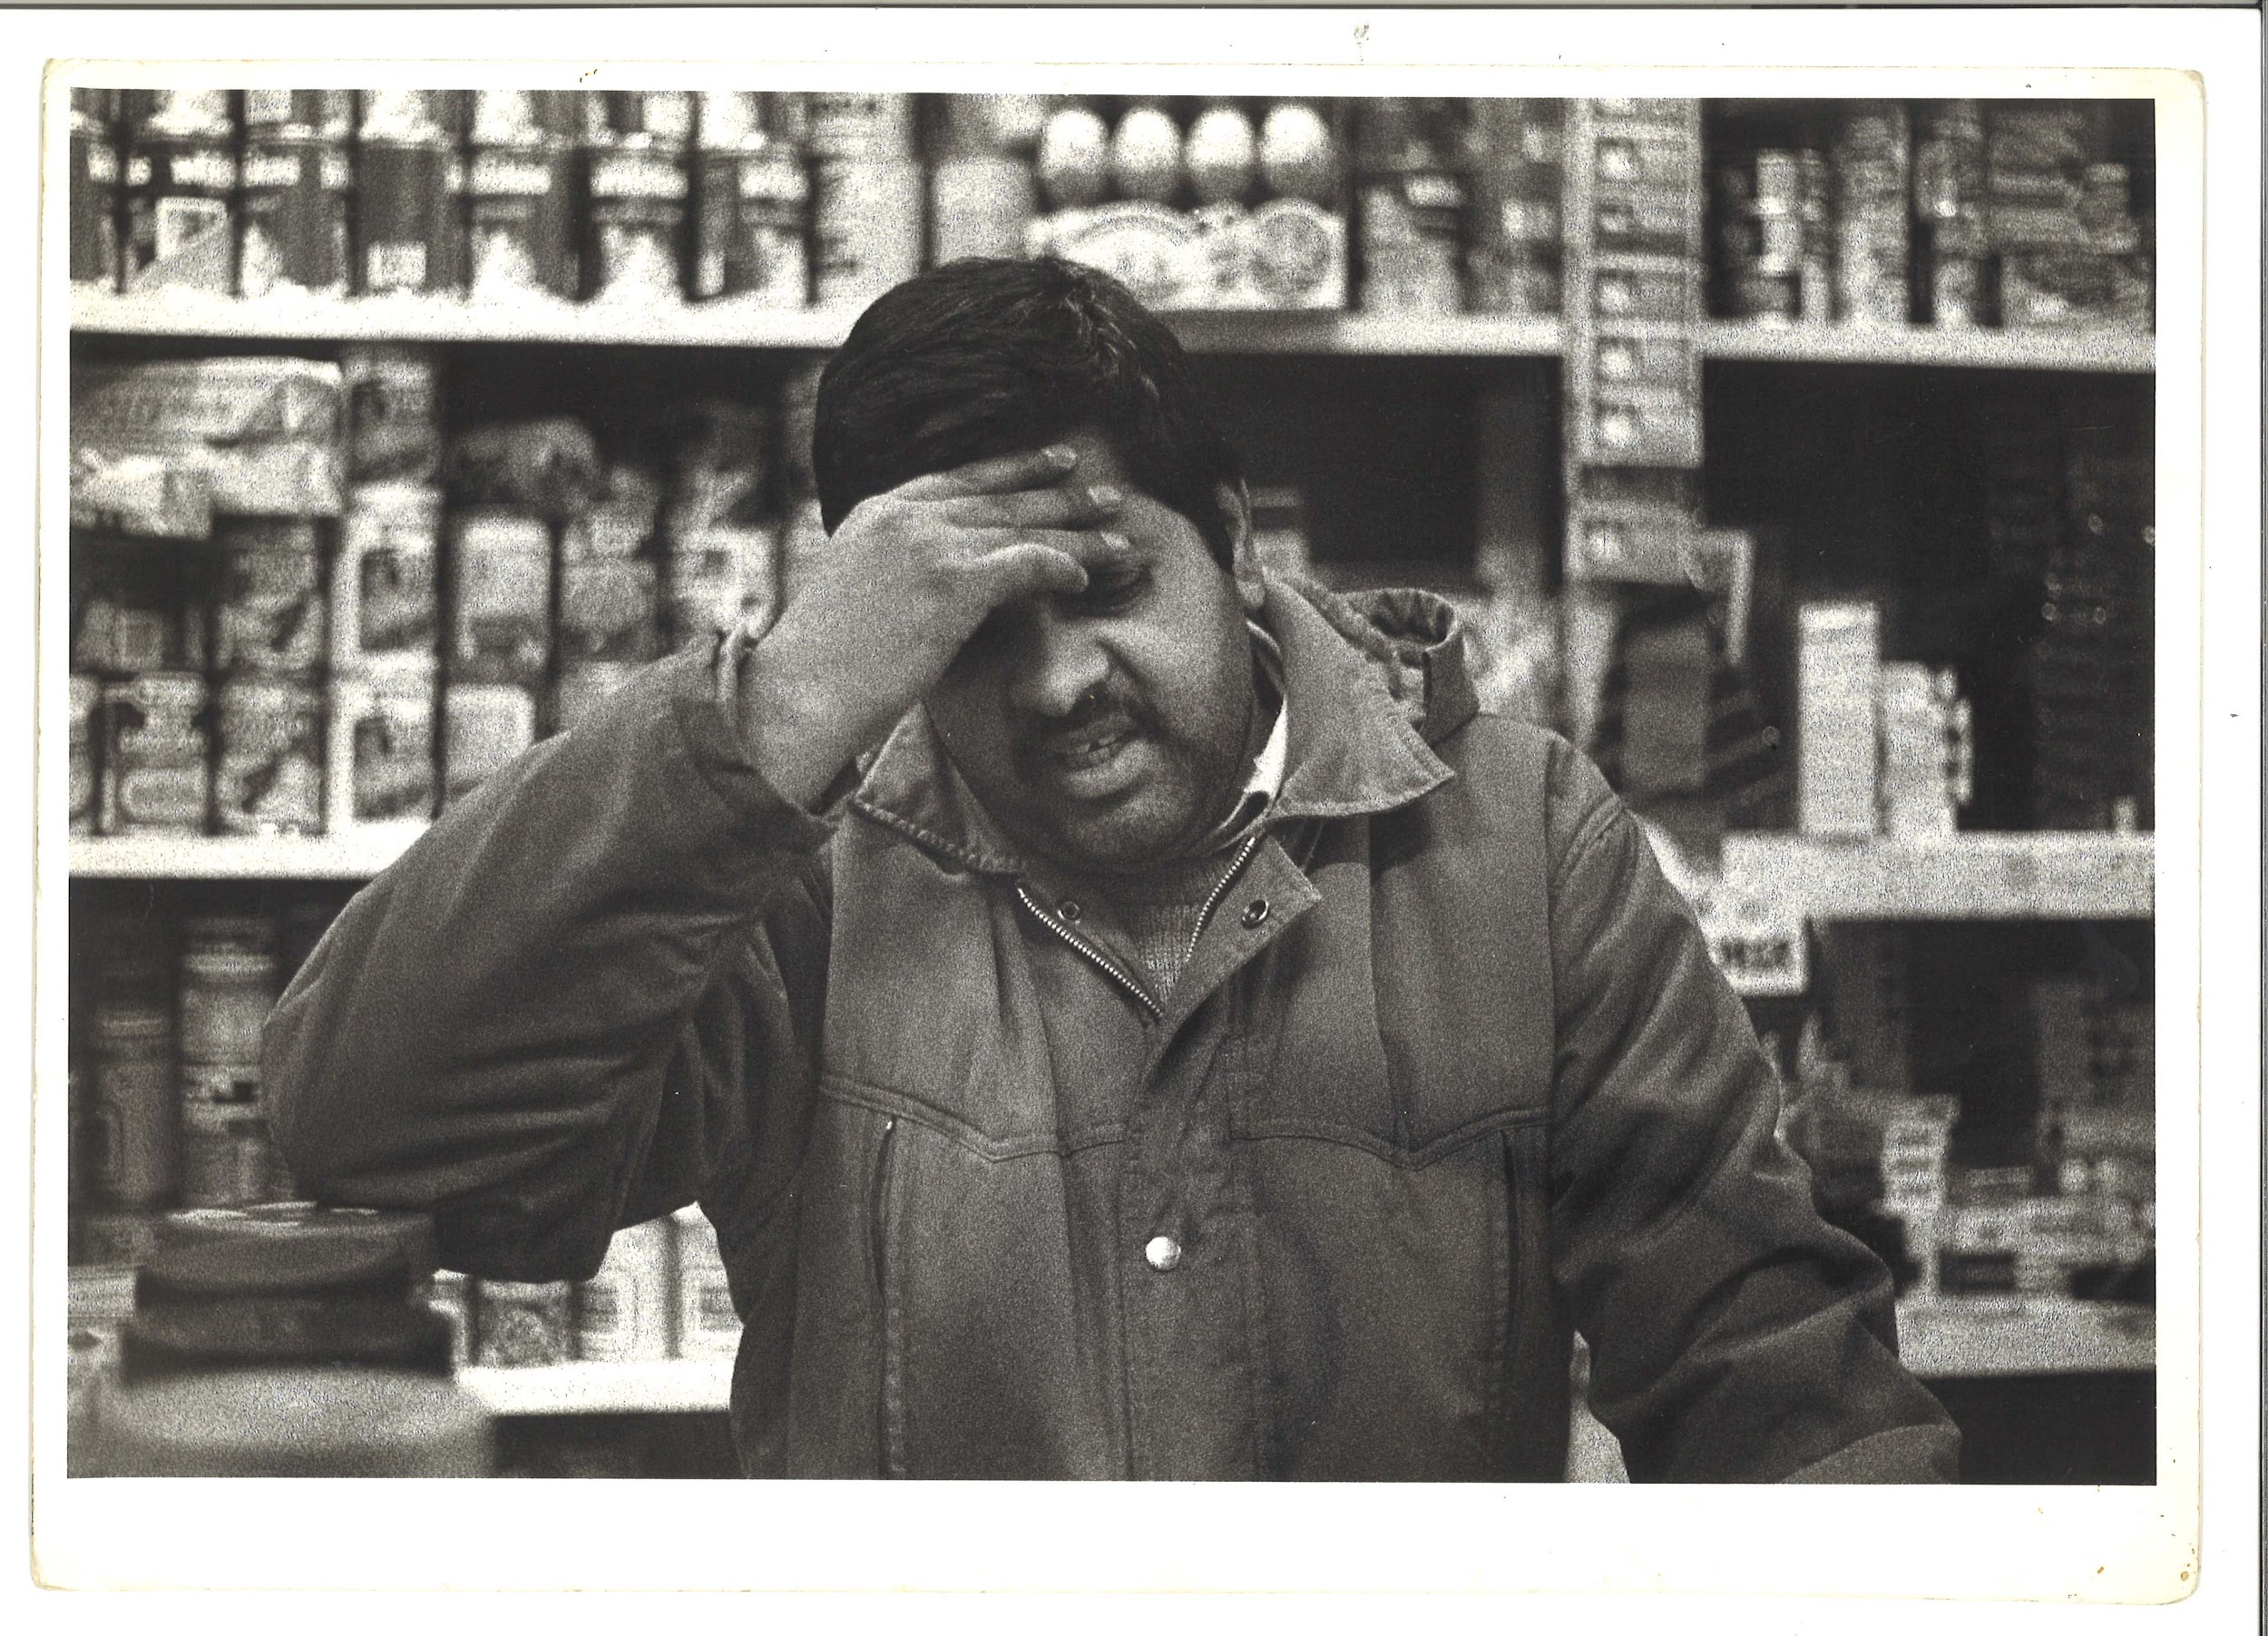 | TM_TPG_Elswick Revisited_11 | 310 x 215mm (approx) | Vintage print, loaned by Karen McQuaid / TPG on 08/05/18  From Ella Murtha material held at PARC | Elswick Revisited | 7
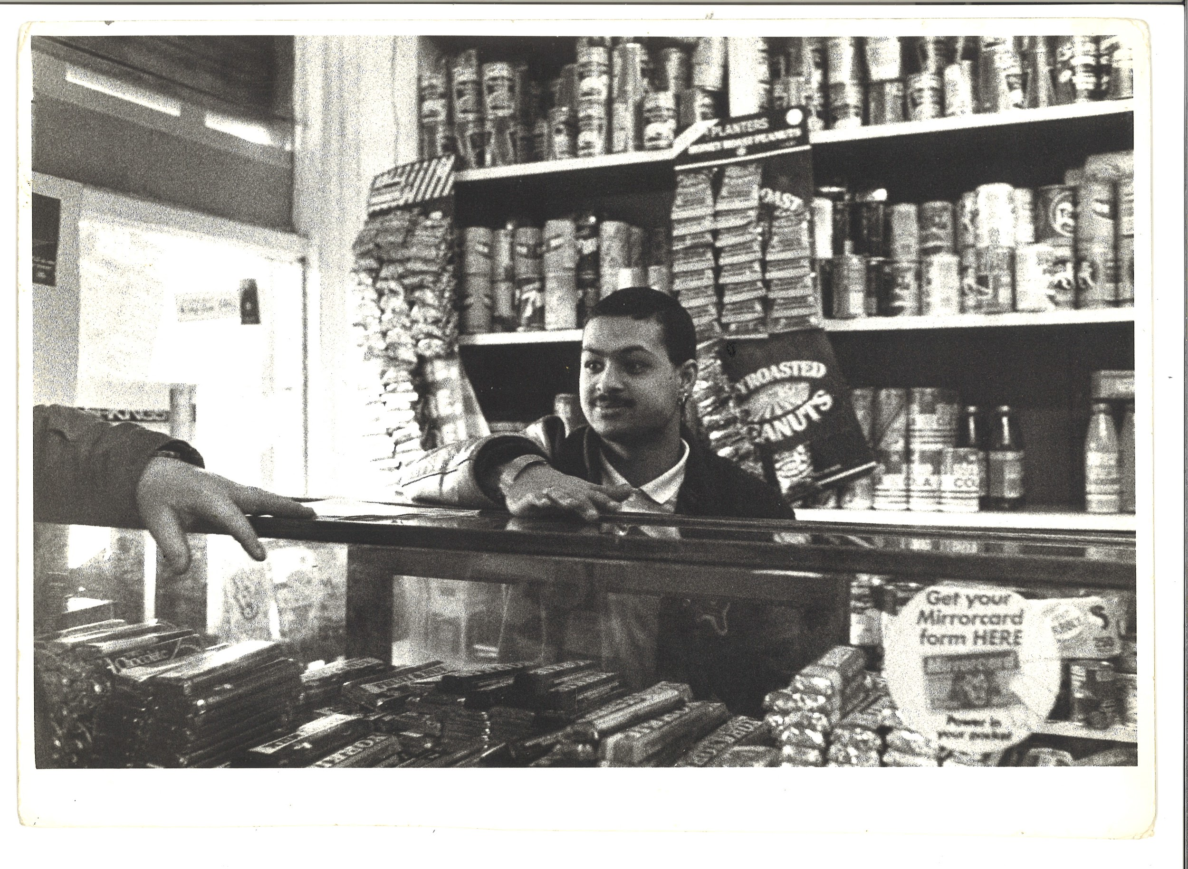 | TM_TPG_Elswick Revisited_12 | 310 x 215mm (approx) | Vintage print, loaned by Karen McQuaid / TPG on 08/05/18  From Ella Murtha material held at PARC | Elswick Revisited | 8
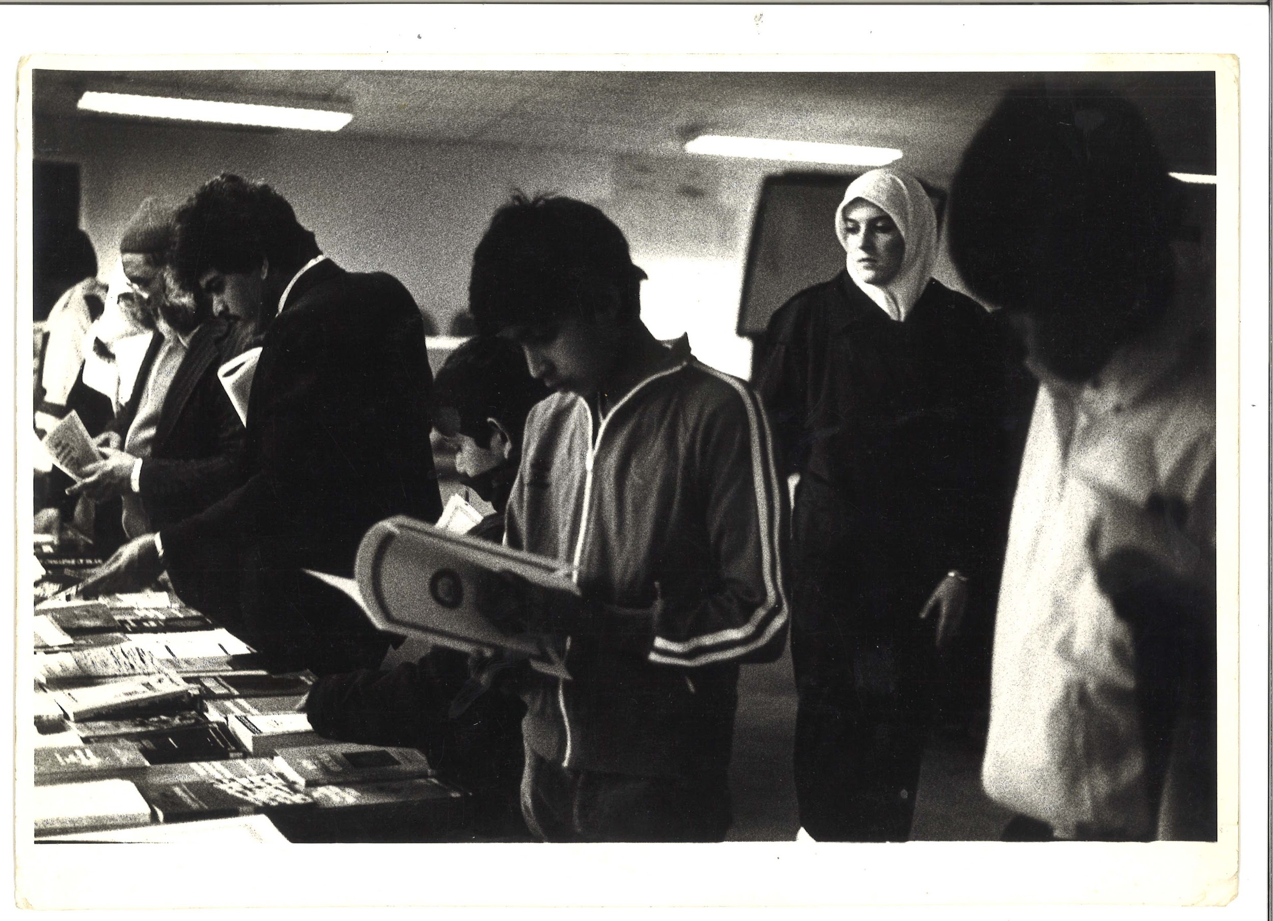 | TM_TPG_Elswick Revisited_13 | 310 x 215mm (approx) | Vintage print, loaned by Karen McQuaid / TPG on 08/05/18  From Ella Murtha material held at PARC | Elswick Revisited | 9
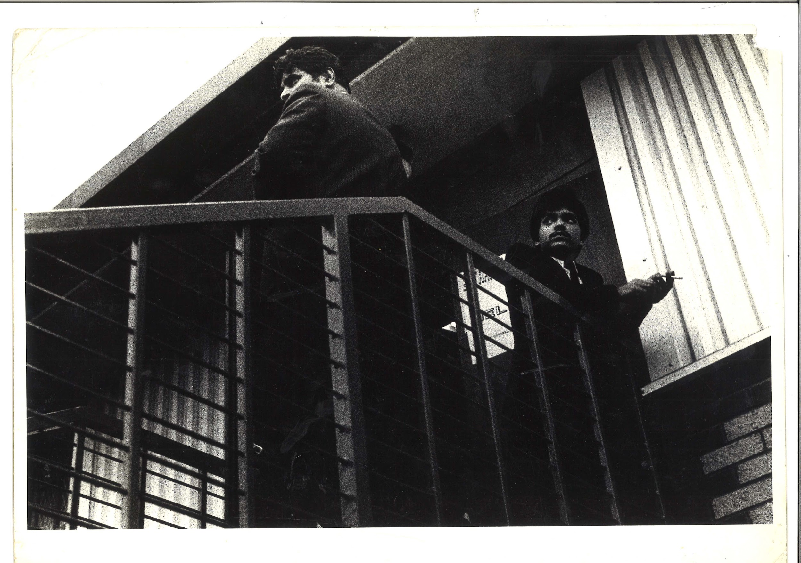 | TM_TPG_Elswick Revisited_14 | 310 x 215mm (approx) | Vintage print, loaned by Karen McQuaid / TPG on 08/05/18  From Ella Murtha material held at PARC | Elswick Revisited | 10
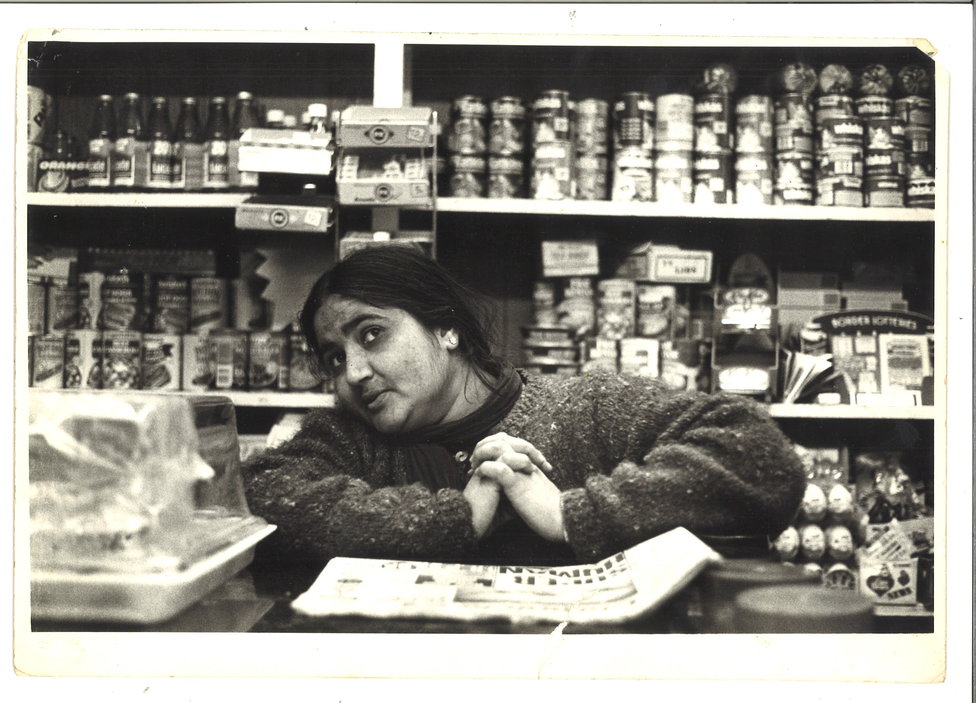 | TM_TPG_Elswick Revisited_15 | 310 x 215mm (approx) | Vintage print, loaned by Karen McQuaid / TPG on 08/05/18  From Ella Murtha material held at PARC | Elswick Revisited | 11
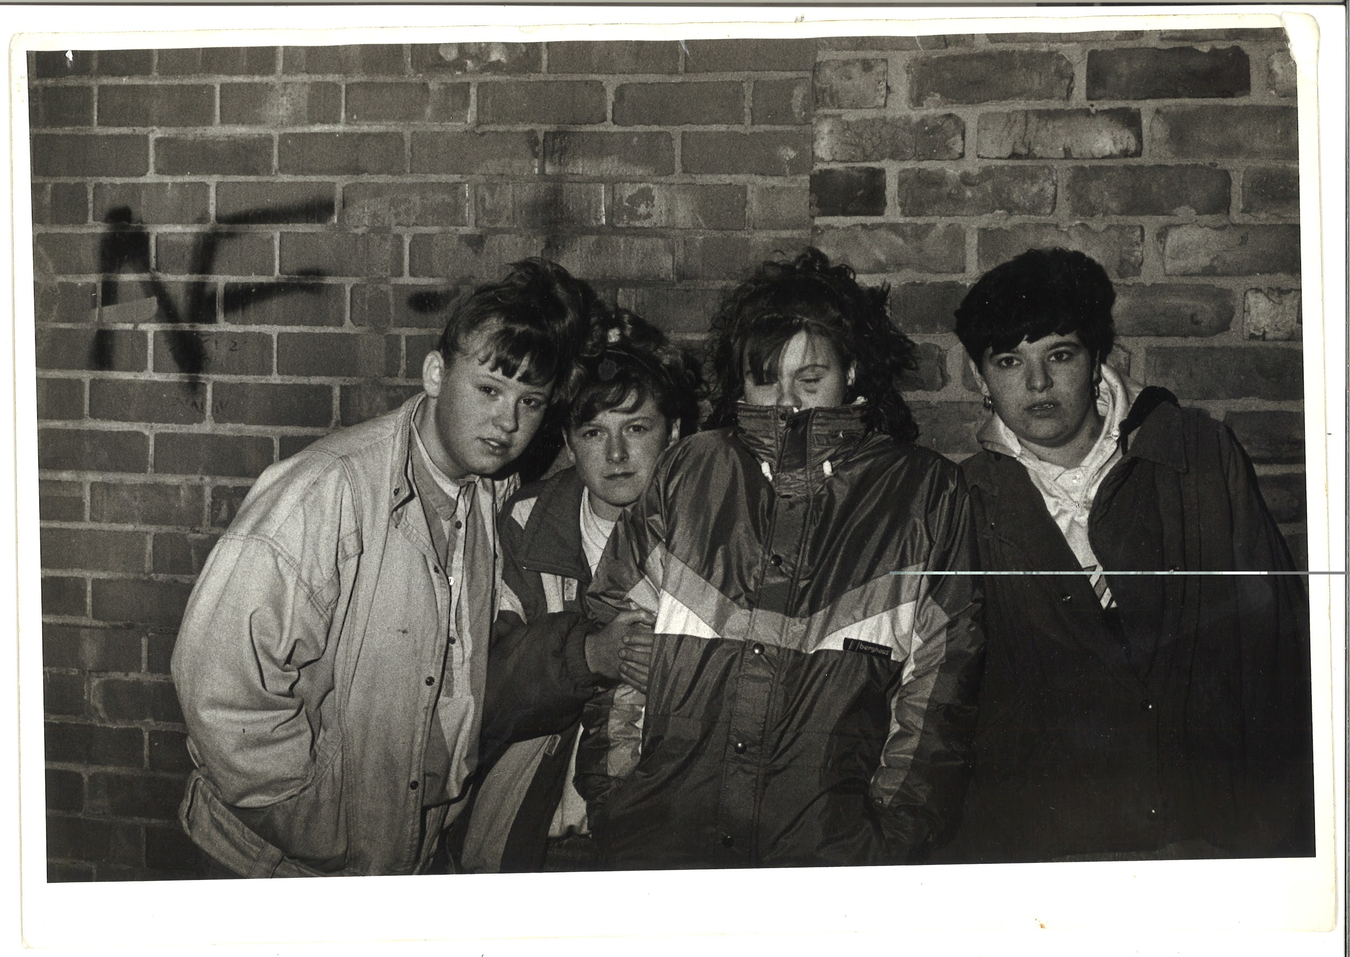 | TM_TPG_Elswick Revisited_16 | 310 x 215mm (approx) | Vintage print, loaned by Karen McQuaid / TPG on 08/05/18  From Ella Murtha material held at PARC | Elswick Revisited | 12
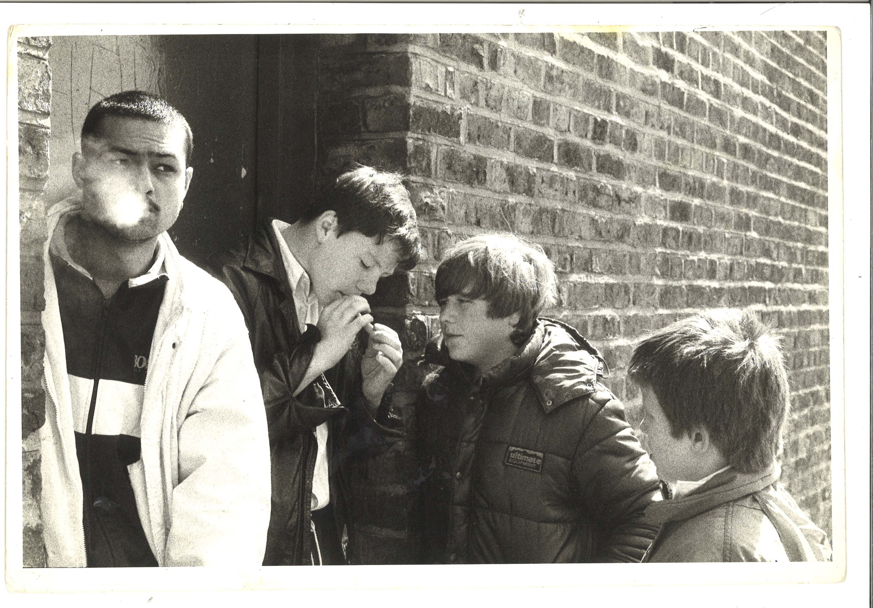 | TM_TPG_Elswick Revisited_17 | 310 x 215mm (approx) | Vintage print, loaned by Karen McQuaid / TPG on 08/05/18  From Ella Murtha material held at PARC | Elswick Revisited | 13
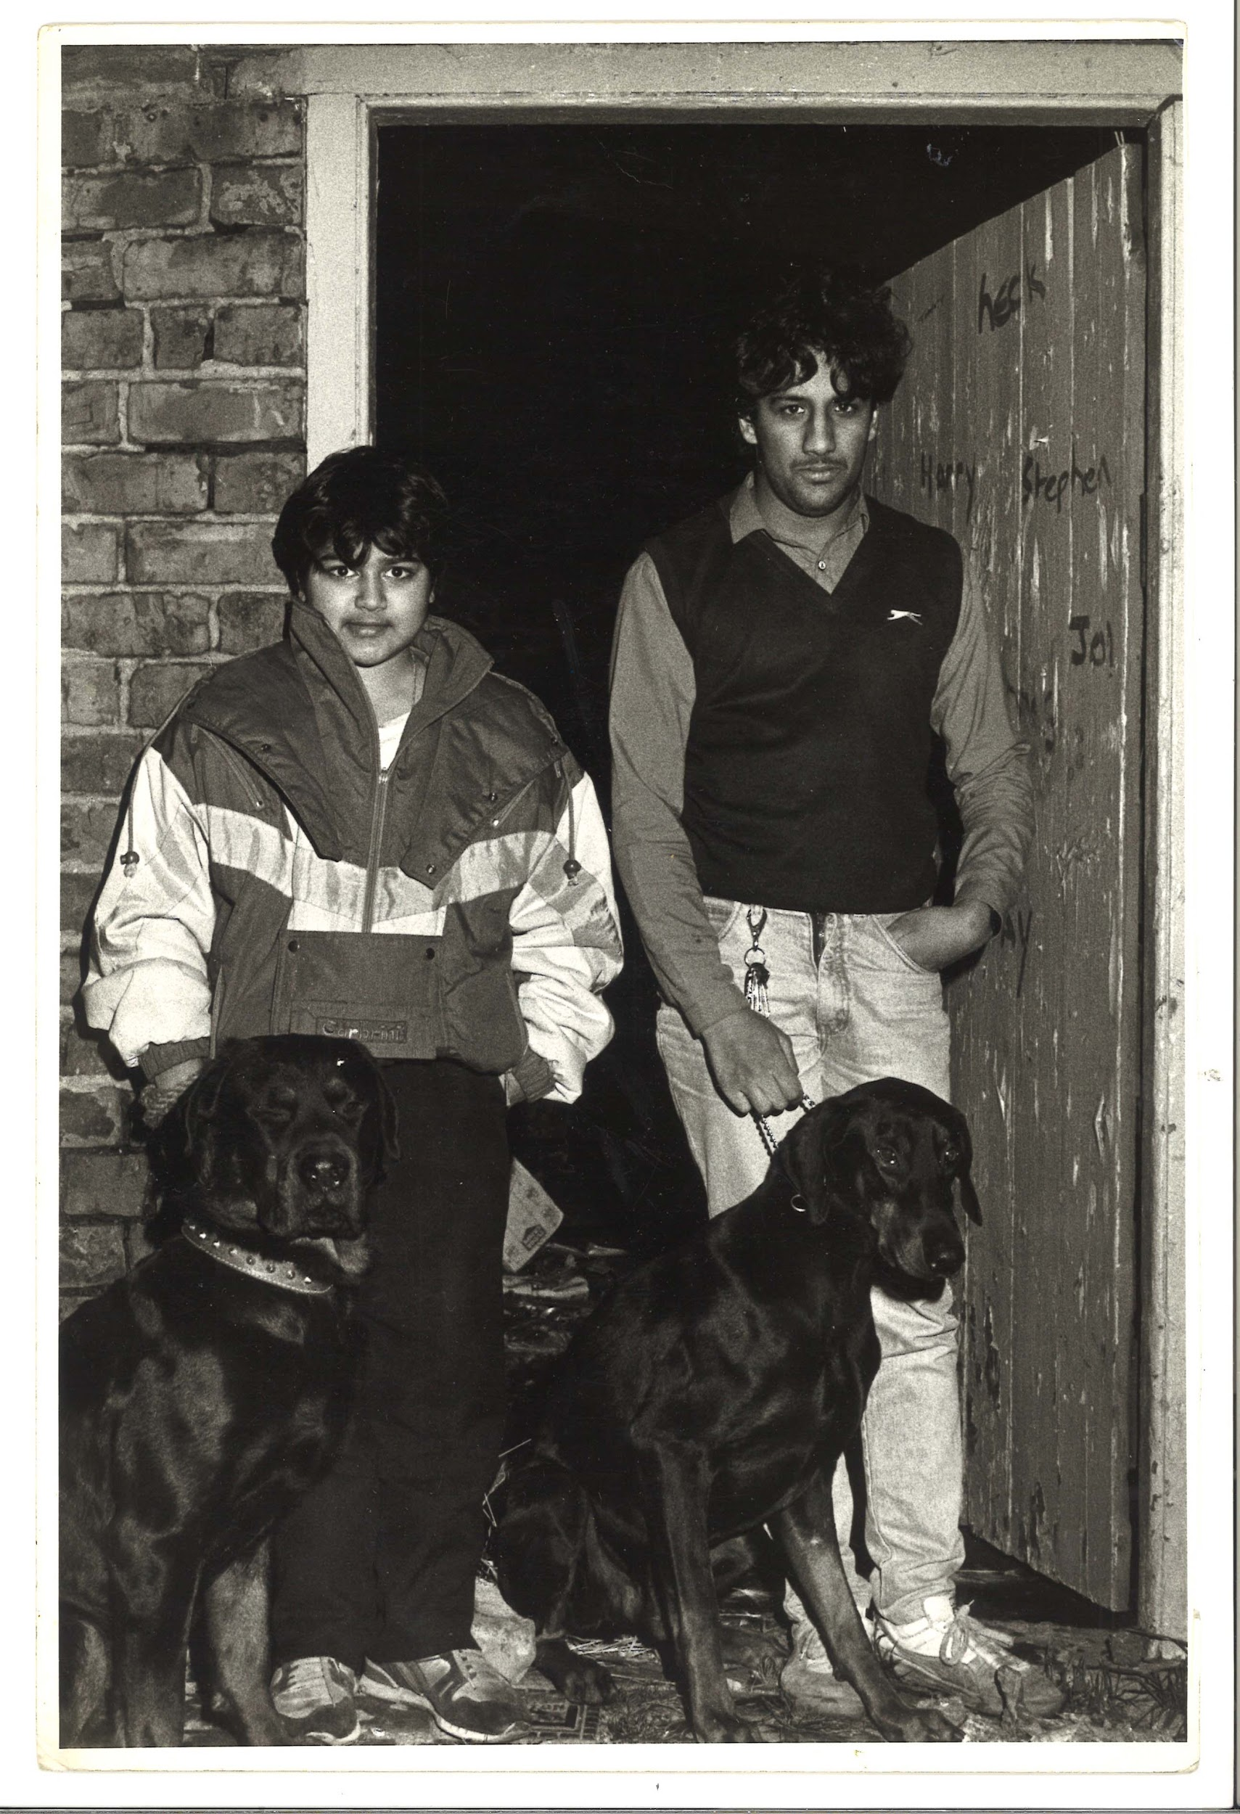 | TM_TPG_Elswick Revisited_18 | 215 x 310mm (approx) | Vintage print, loaned by Karen McQuaid / TPG on 08/05/18  From Ella Murtha material held at PARC | Elswick Revisited | 14
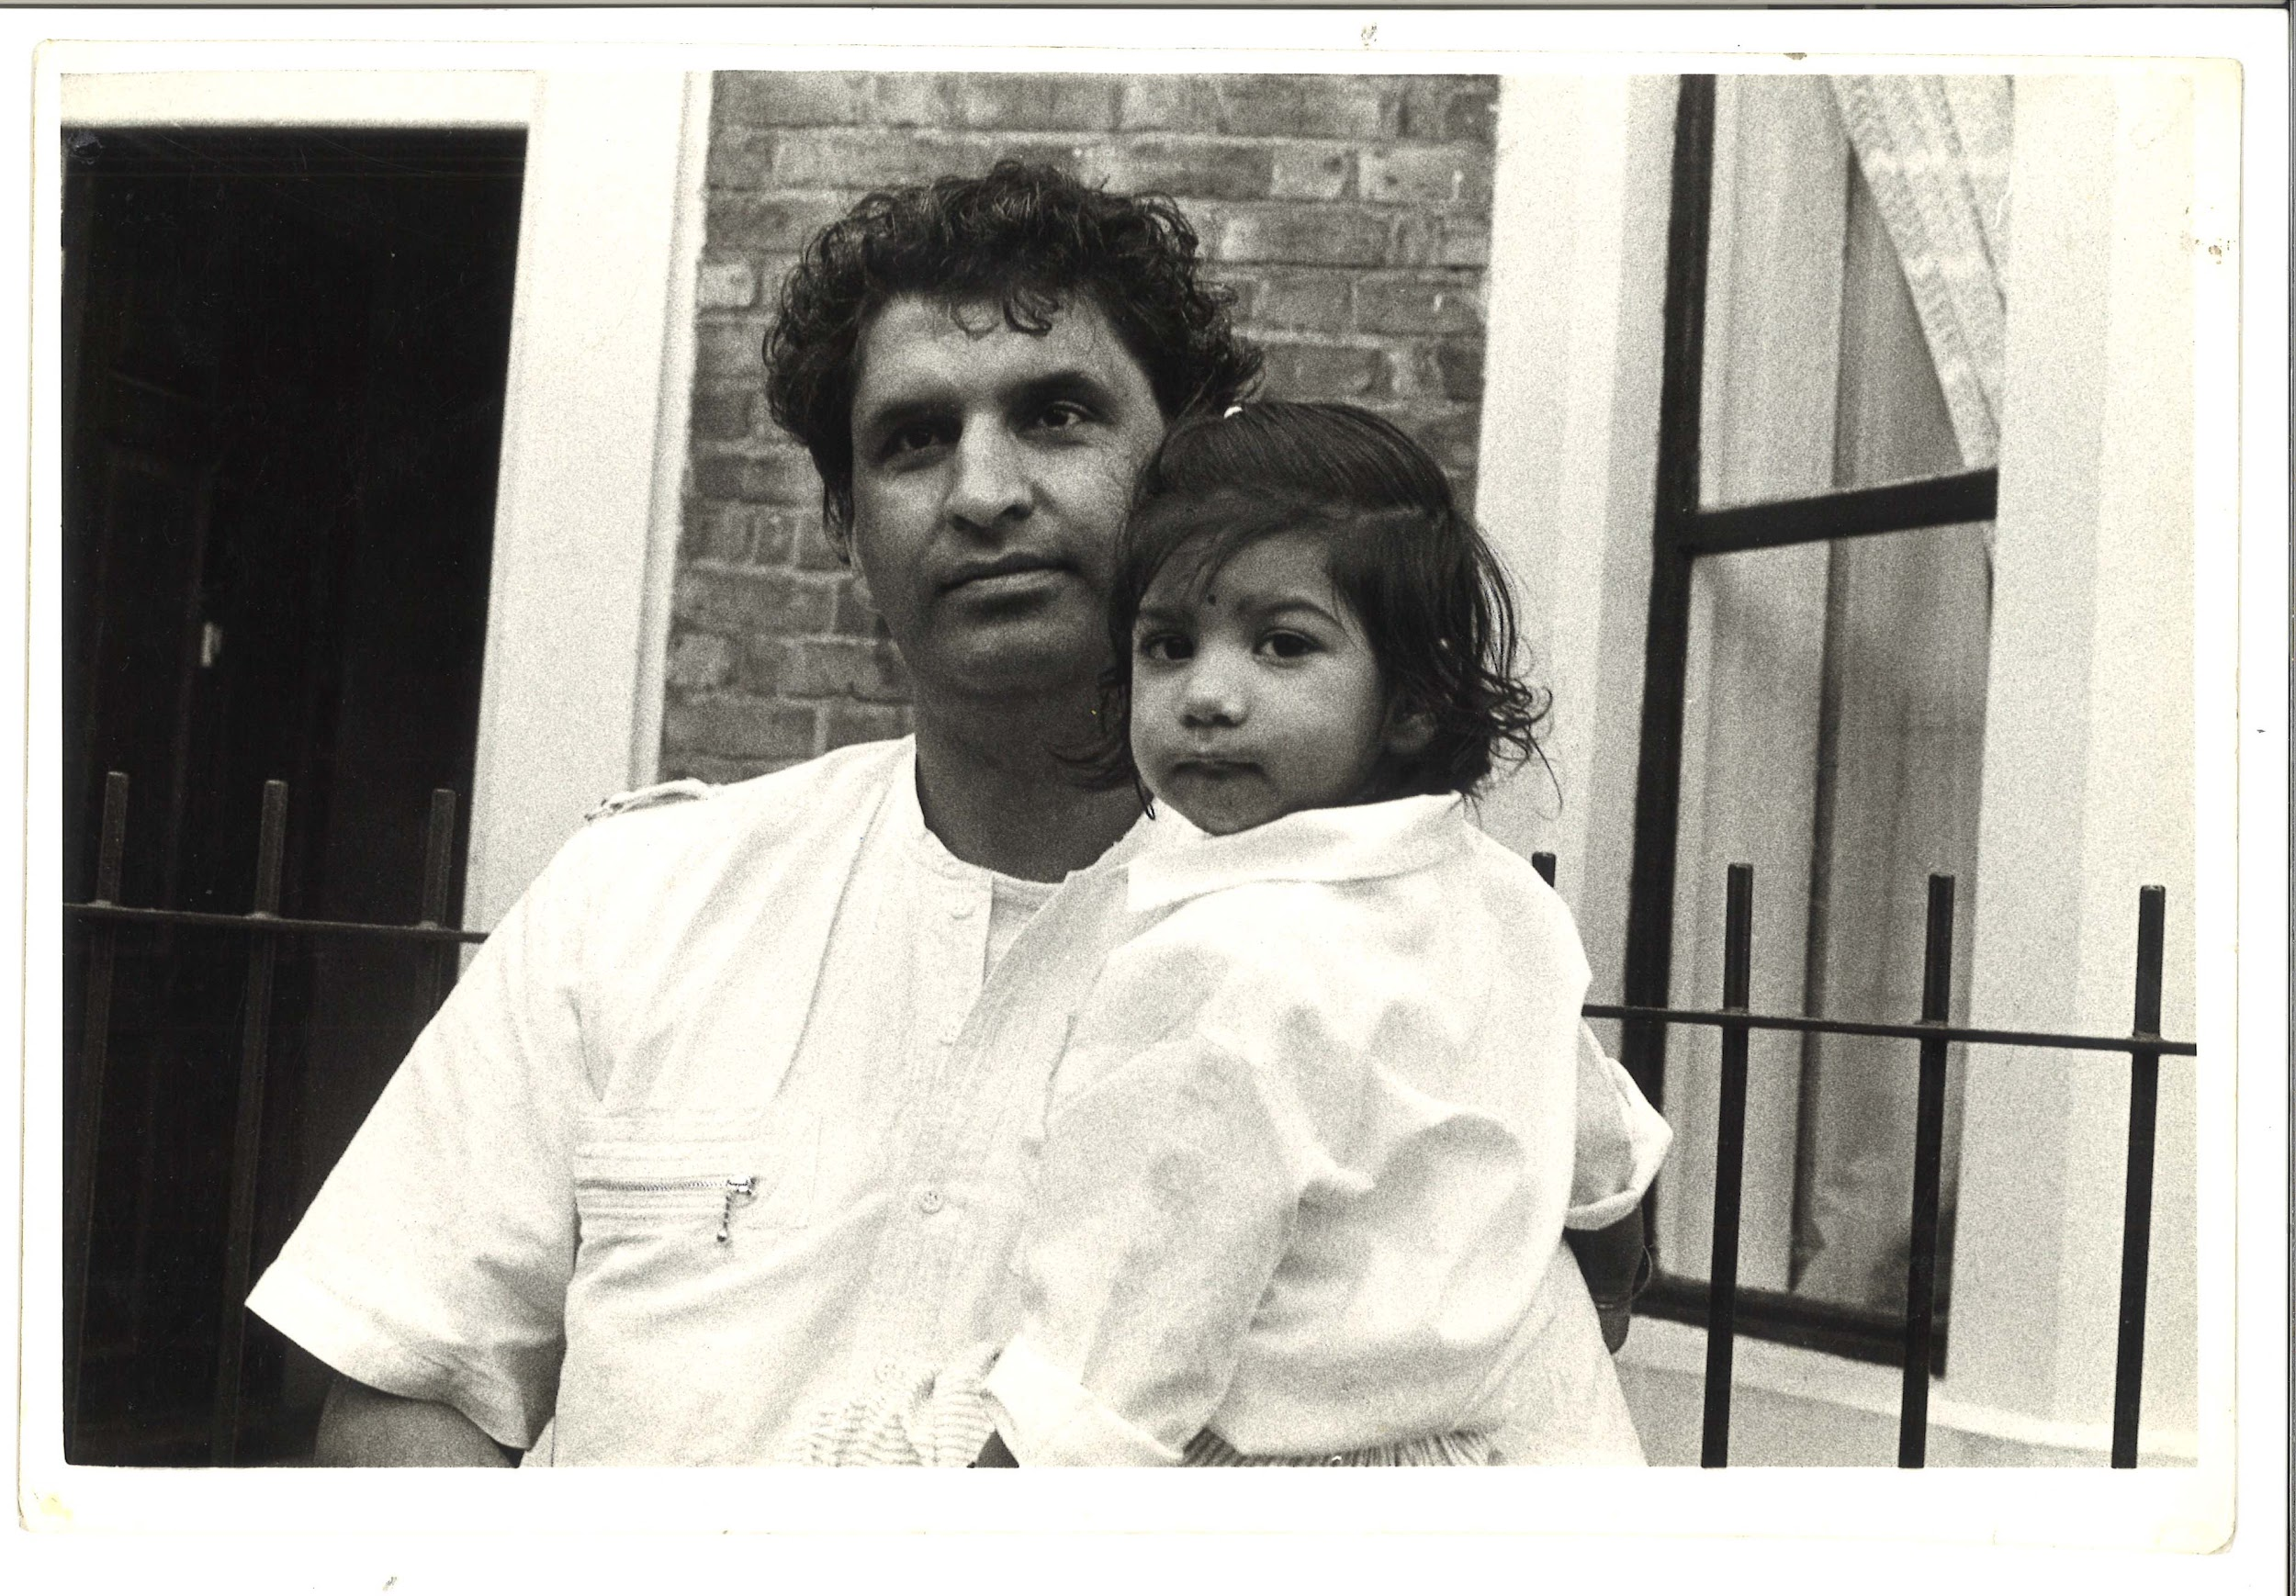 | TM_TPG_Elswick Revisited_19 | 310 x 215mm (approx) | Vintage print, loaned by Karen McQuaid / TPG on 08/05/18  From Ella Murtha material held at PARC | Elswick Revisited | 15
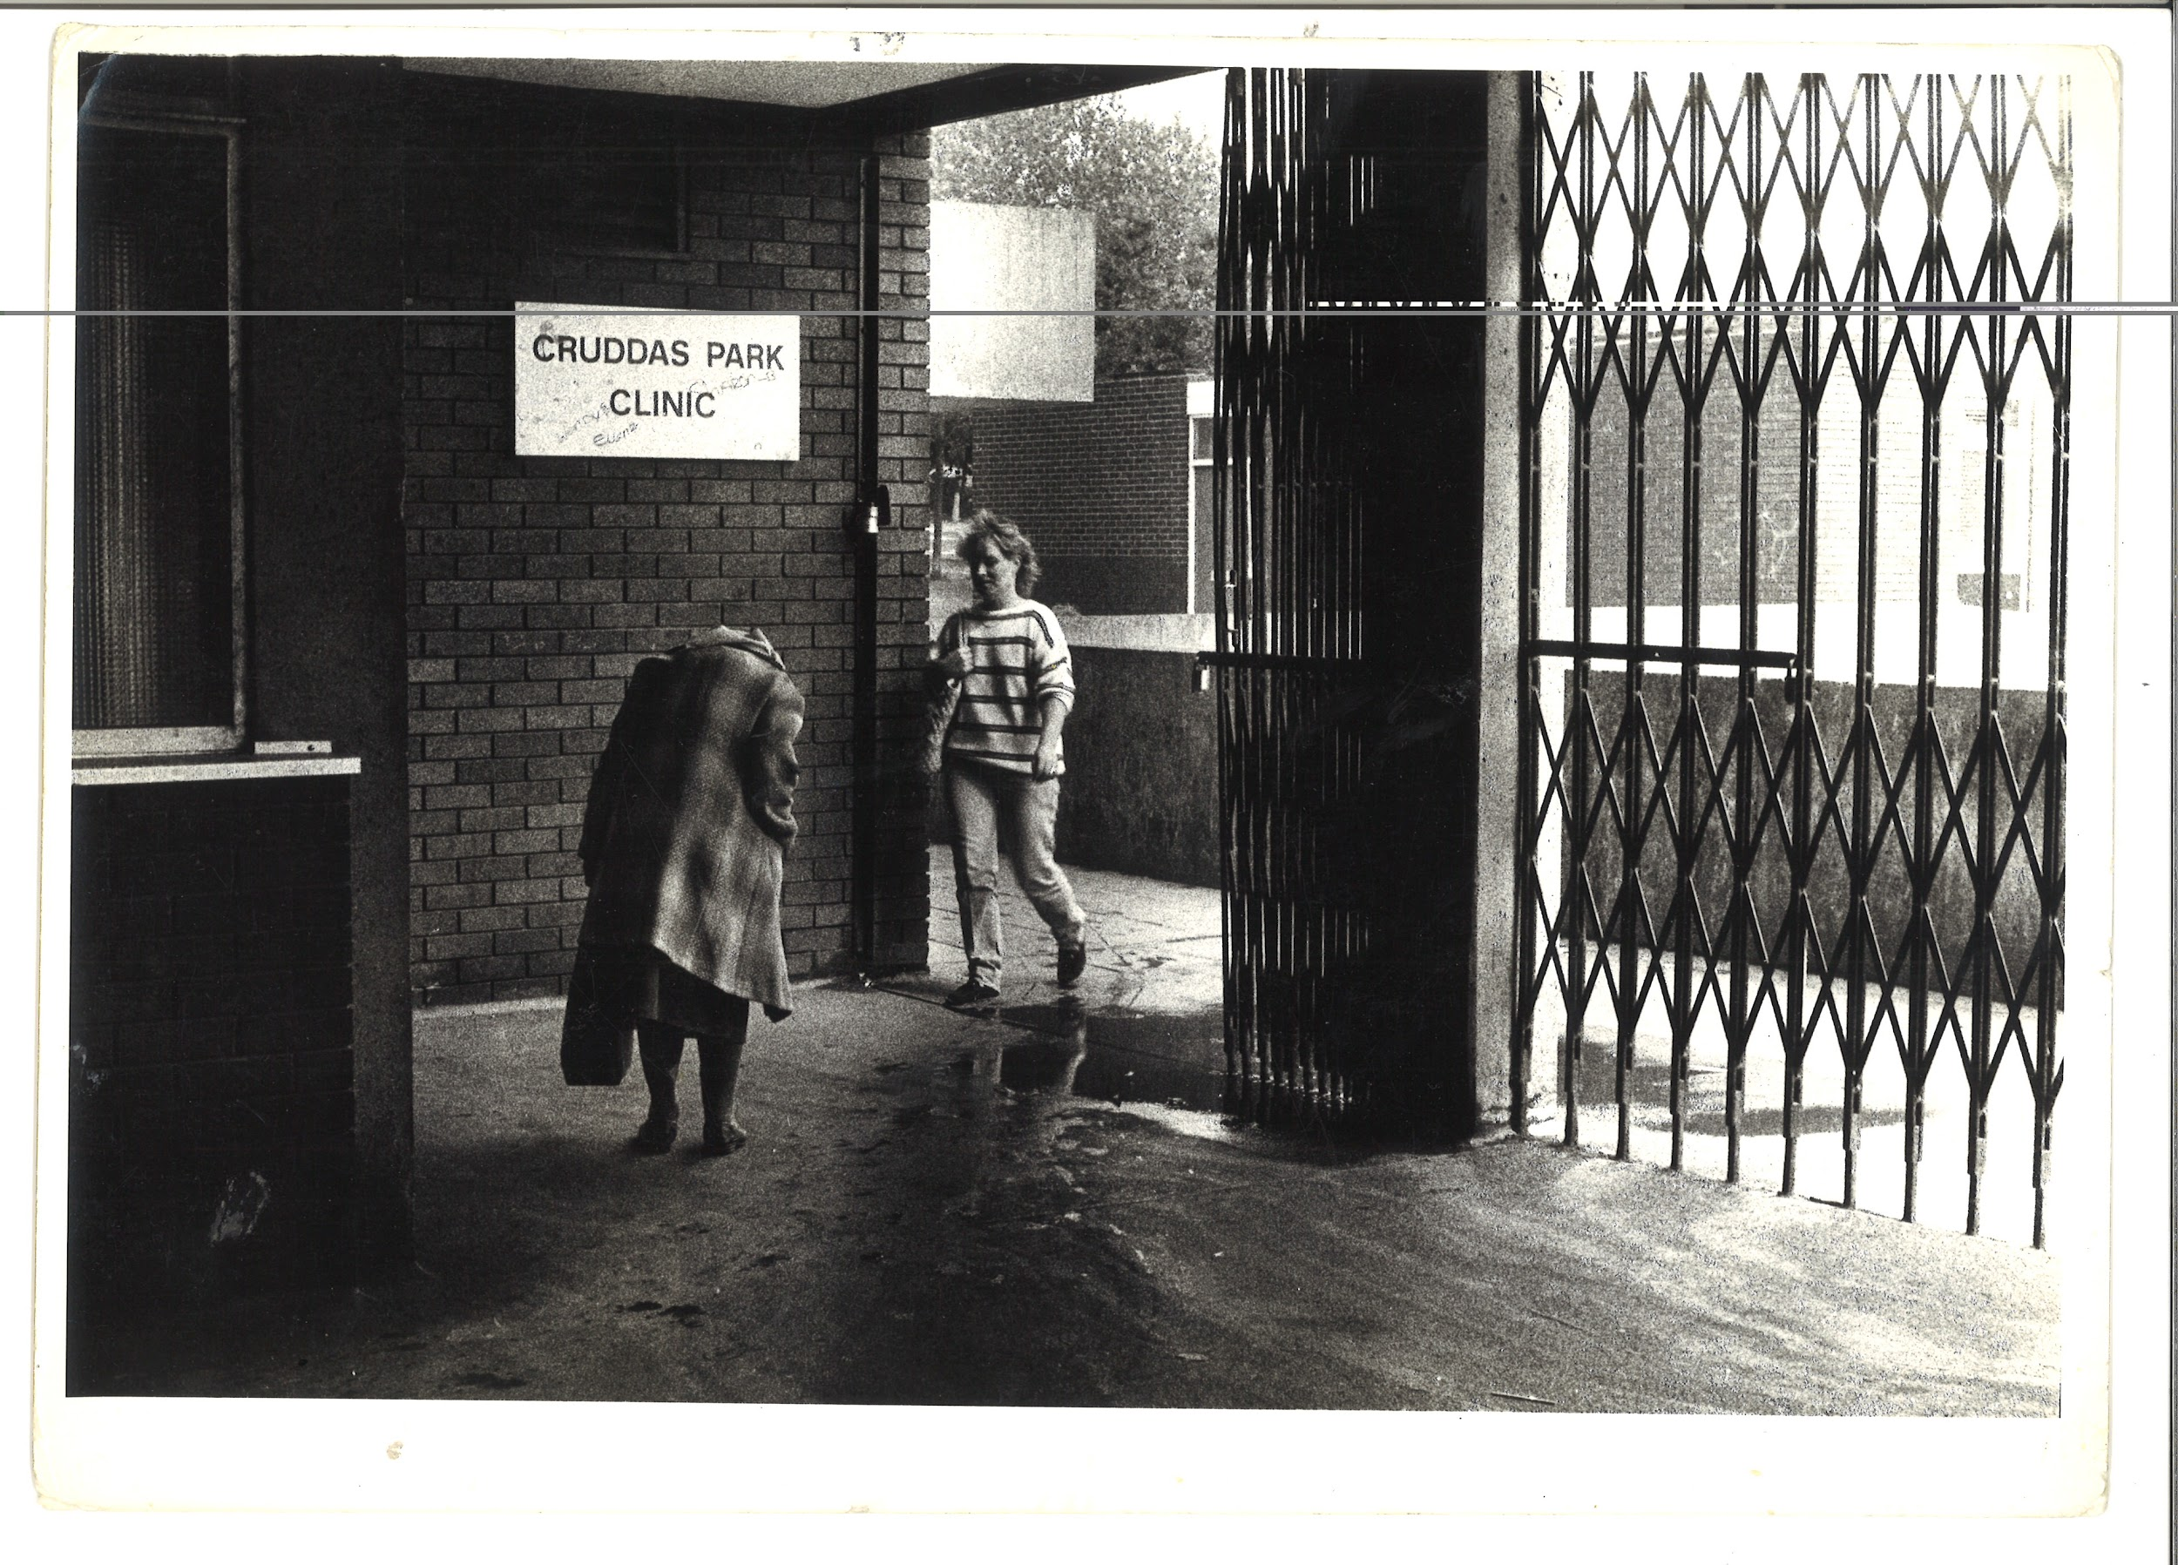 | TM_TPG_Elswick Revisited_20 | 310 x 215mm (approx) | Vintage print, loaned by Karen McQuaid / TPG on 08/05/18  From Ella Murtha material held at PARC | Elswick Revisited | 16
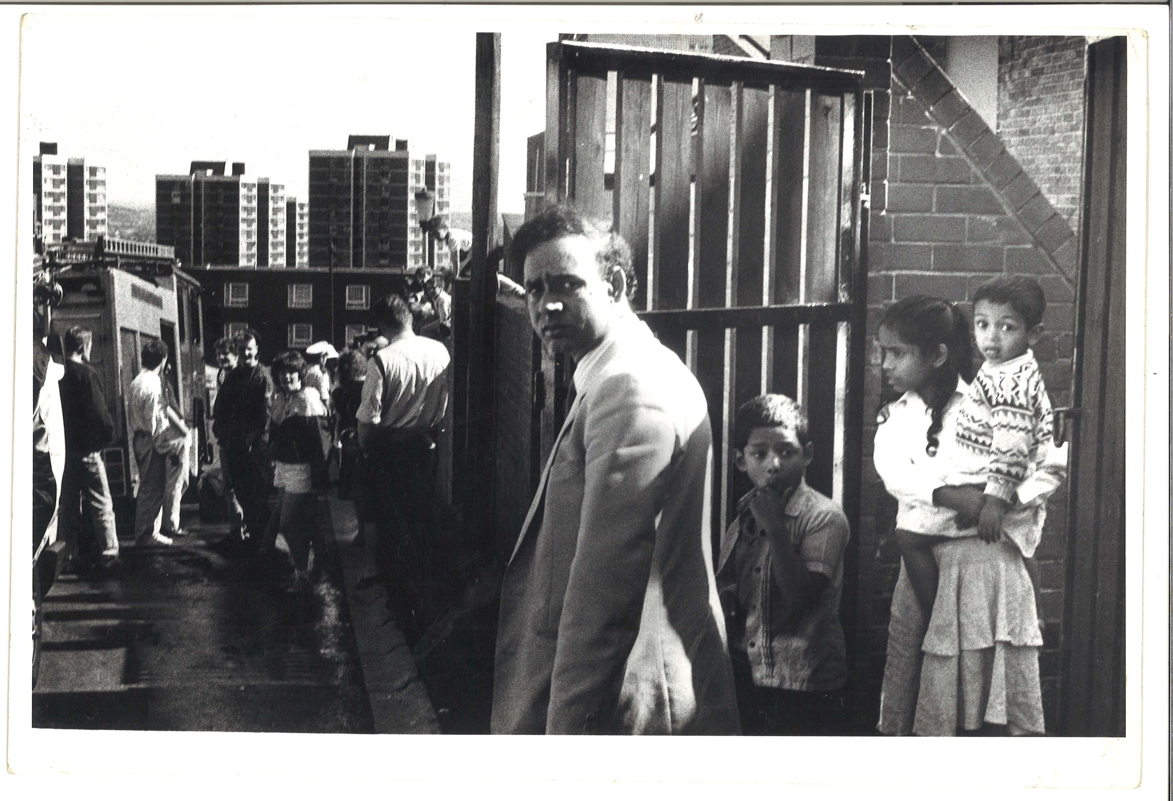 | TM_TPG_Elswick Revisited_22 | 310 x 215mm (approx) | Vintage print, loaned by Karen McQuaid / TPG on 08/05/18  From Ella Murtha material held at PARC | Elswick Revisited | 17
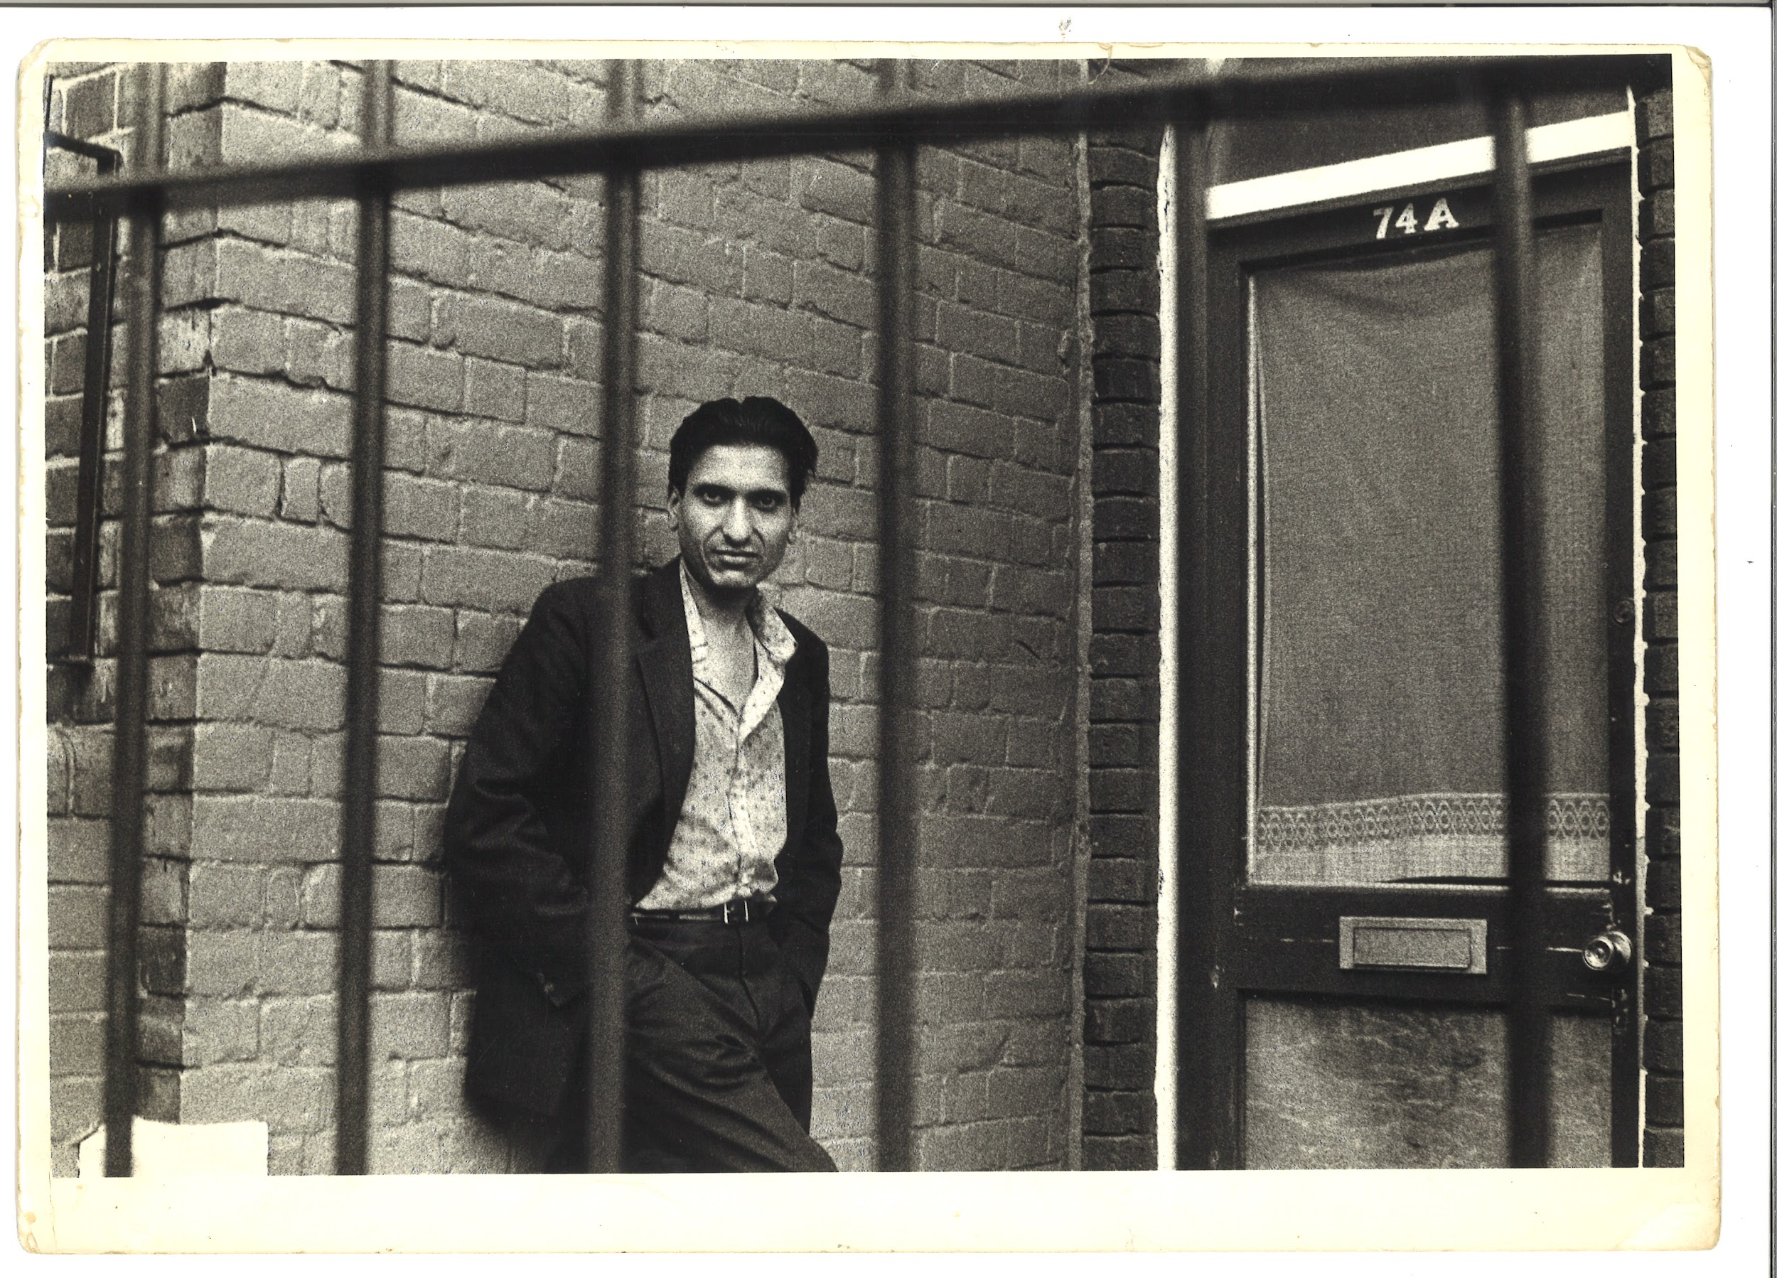 | TM_TPG_Elswick Revisited_24 | 310 x 215mm (approx) | Vintage print, loaned by Karen McQuaid / TPG on 08/05/18  From Ella Murtha material held at PARC | Elswick Revisited | 18
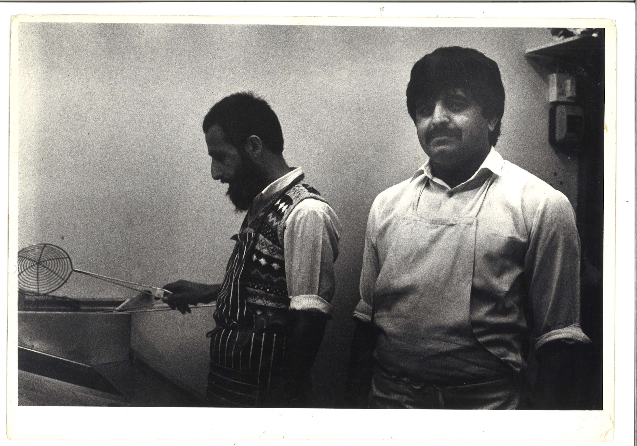 | TM_TPG_Elswick Revisited_25 | 310 x 215mm (approx) | Vintage print, loaned by Karen McQuaid / TPG on 08/05/18  From Ella Murtha material held at PARC | Elswick Revisited | 19
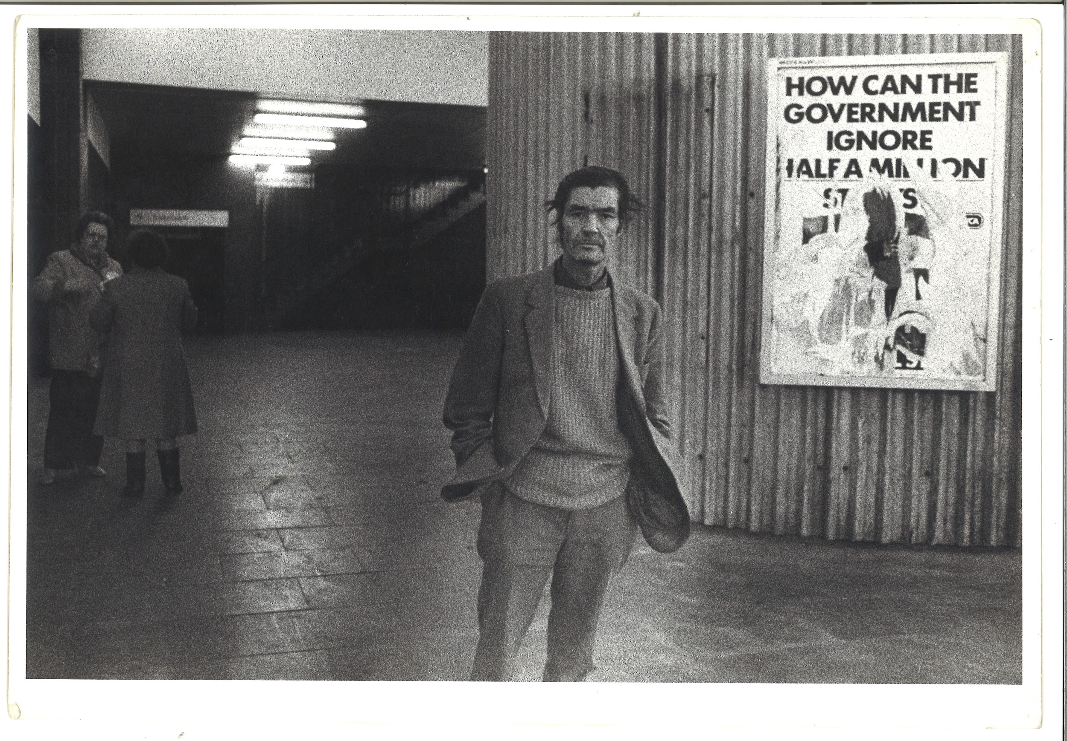 | TM_TPG_Elswick Revisited_28 | 310 x 215mm (approx) | Vintage print, loaned by Karen McQuaid / TPG on 08/05/18  From Ella Murtha material held at PARC | Elswick Revisited | 20

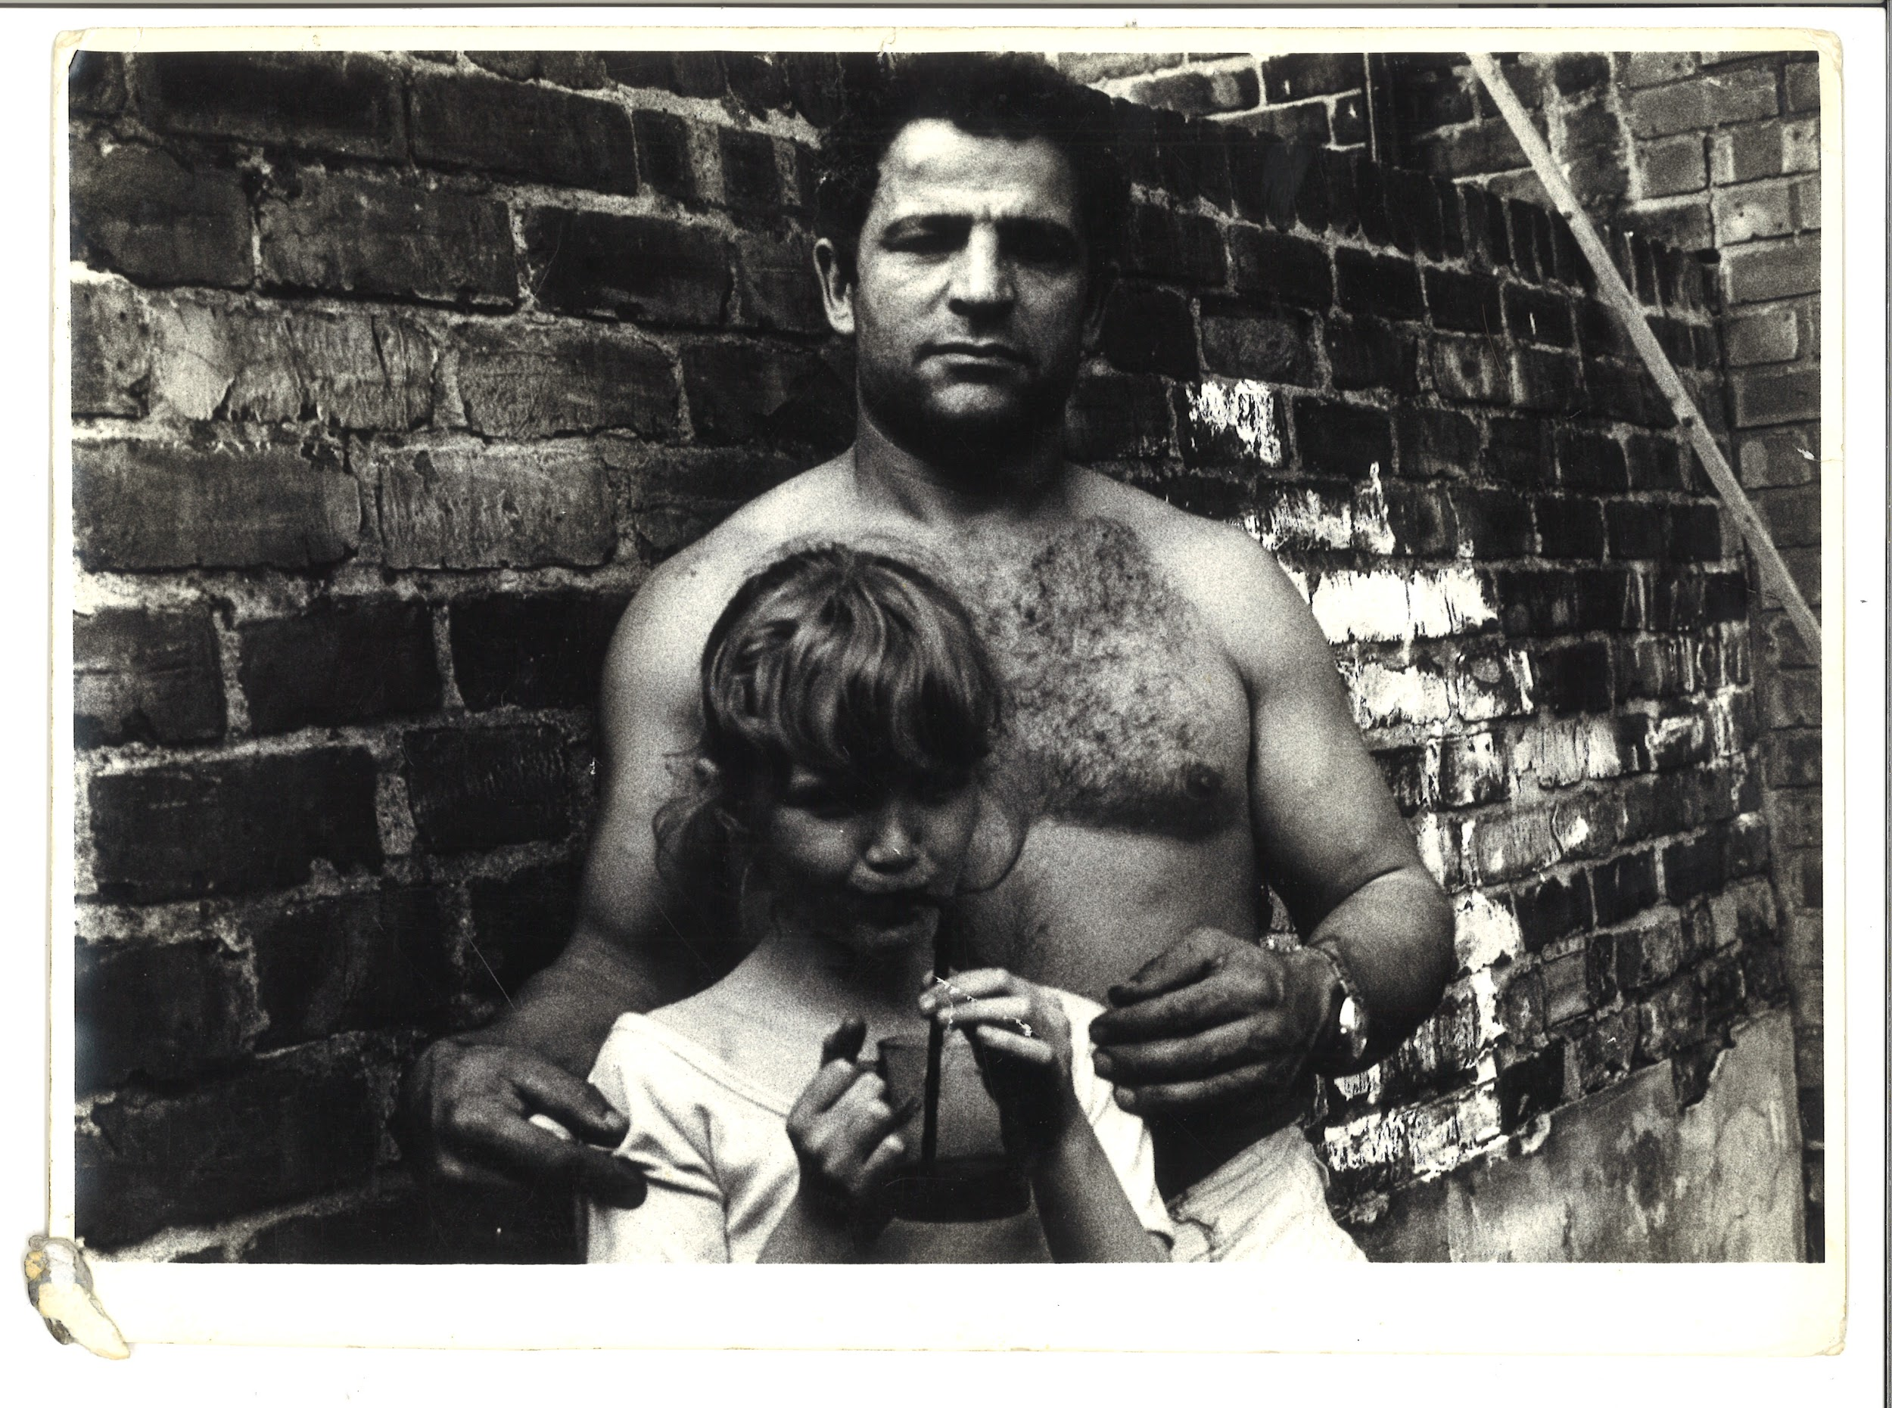 | TM_TPG_Elswick Revisited_29 | 310 x 215mm (approx) | Vintage print, loaned by Karen McQuaid / TPG on 08/05/18  From Ella Murtha material held at PARC | Elswick Revisited | 21
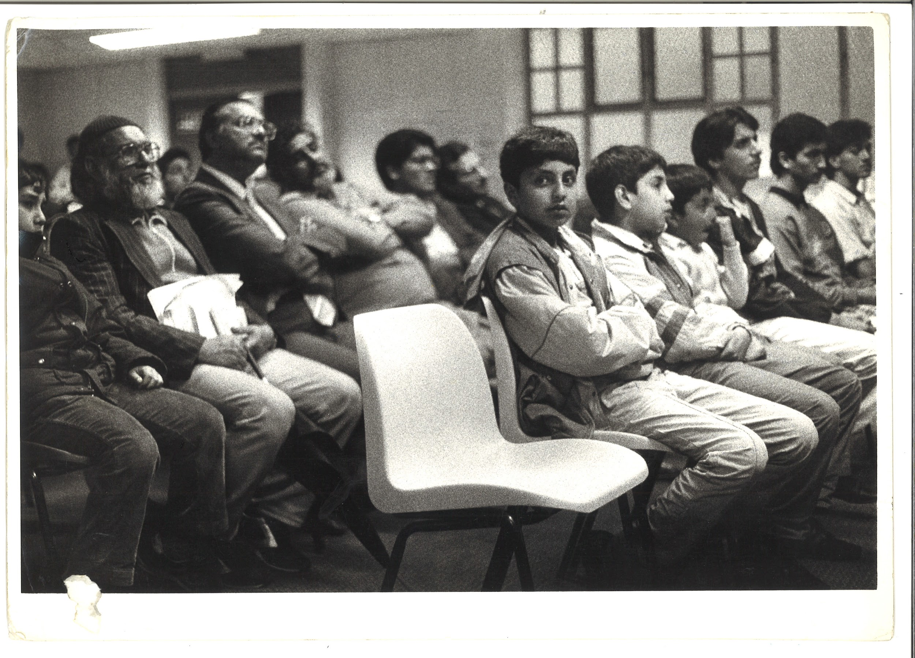 | TM_TPG_Elswick Revisited_30 | 310 x 215mm (approx) | Vintage print, loaned by Karen McQuaid / TPG on 08/05/18  From Ella Murtha material held at PARC | Elswick Revisited | 22
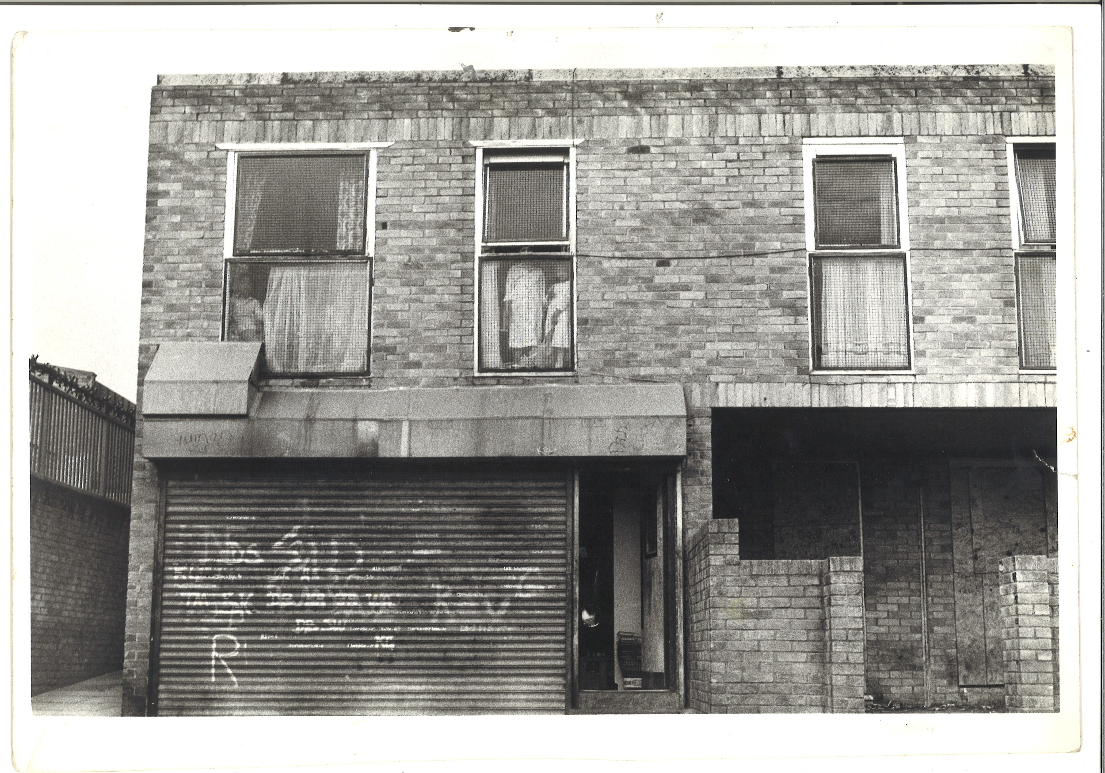 | TM_TPG_Elswick Revisited_31 | 310 x 215mm (approx) | Vintage print, loaned by Karen McQuaid / TPG on 08/05/18  From Ella Murtha material held at PARC | Elswick Revisited | 23
London By Night
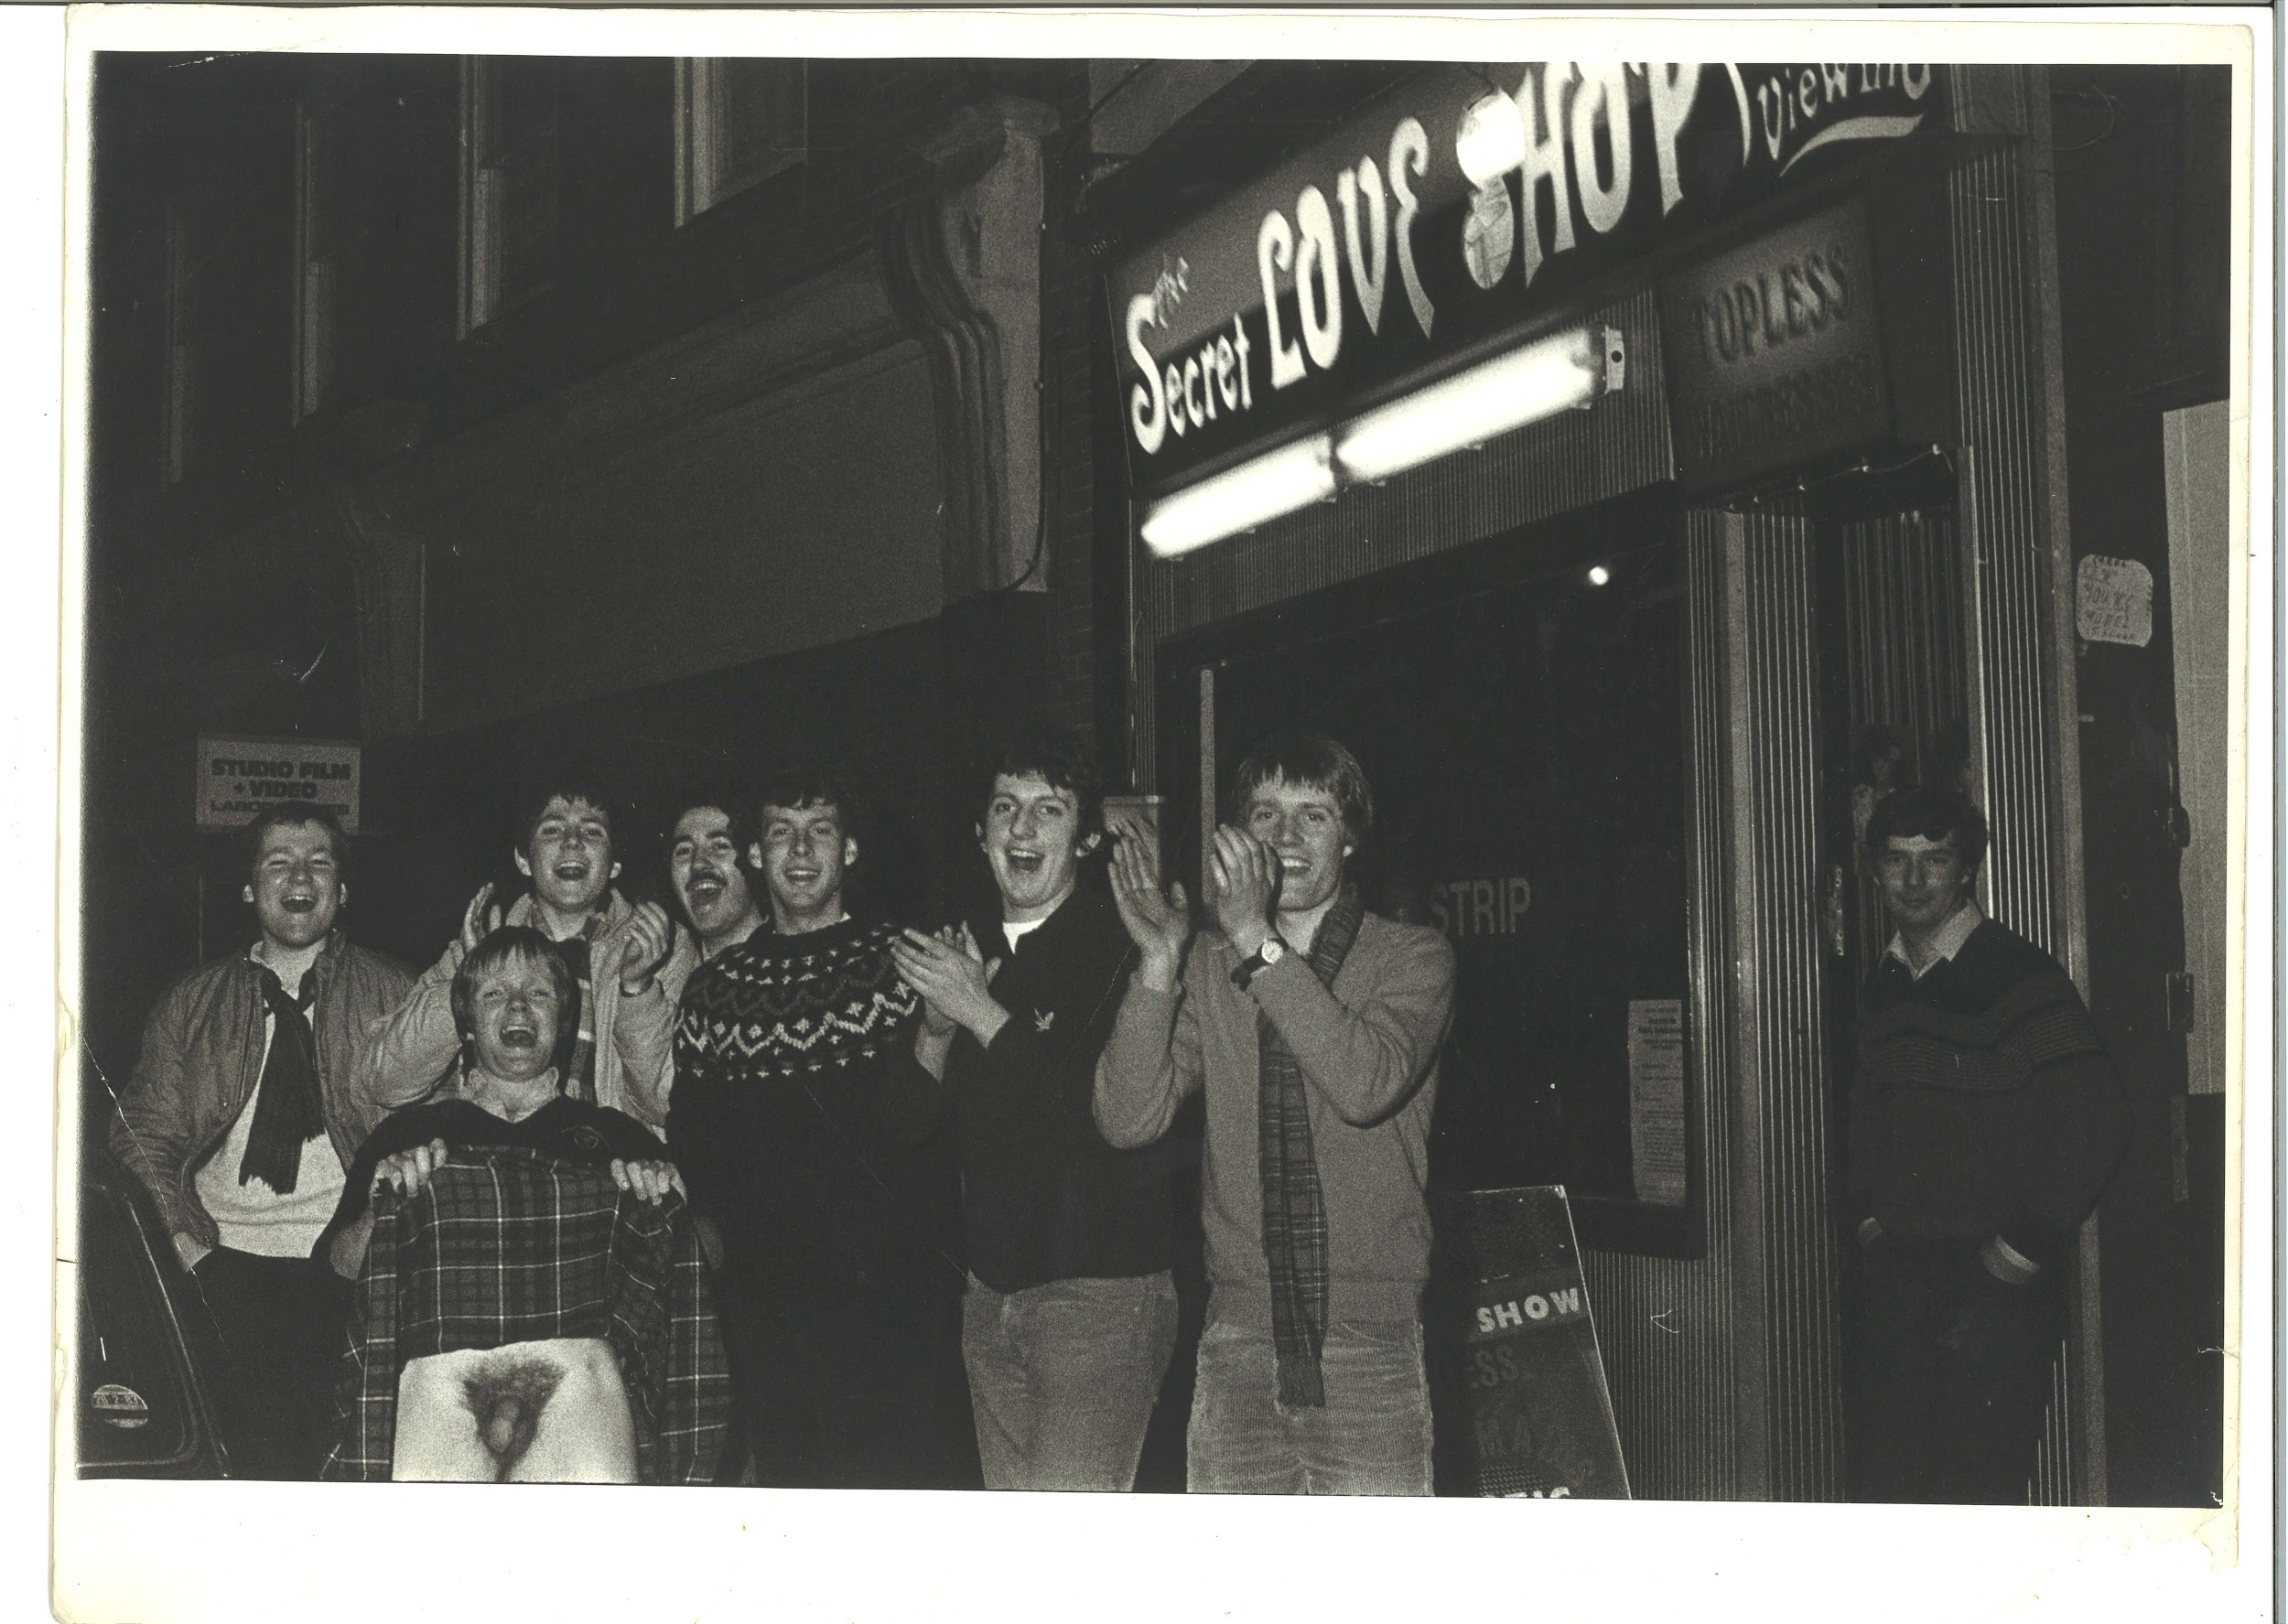 | TM_TPG_London By Night_1 | 404 x 302mm (approx) | Vintage print, loaned by Karen McQuaid / TPG on 08/05/18  From Ella Murtha material held at PARC | London By Night | 24
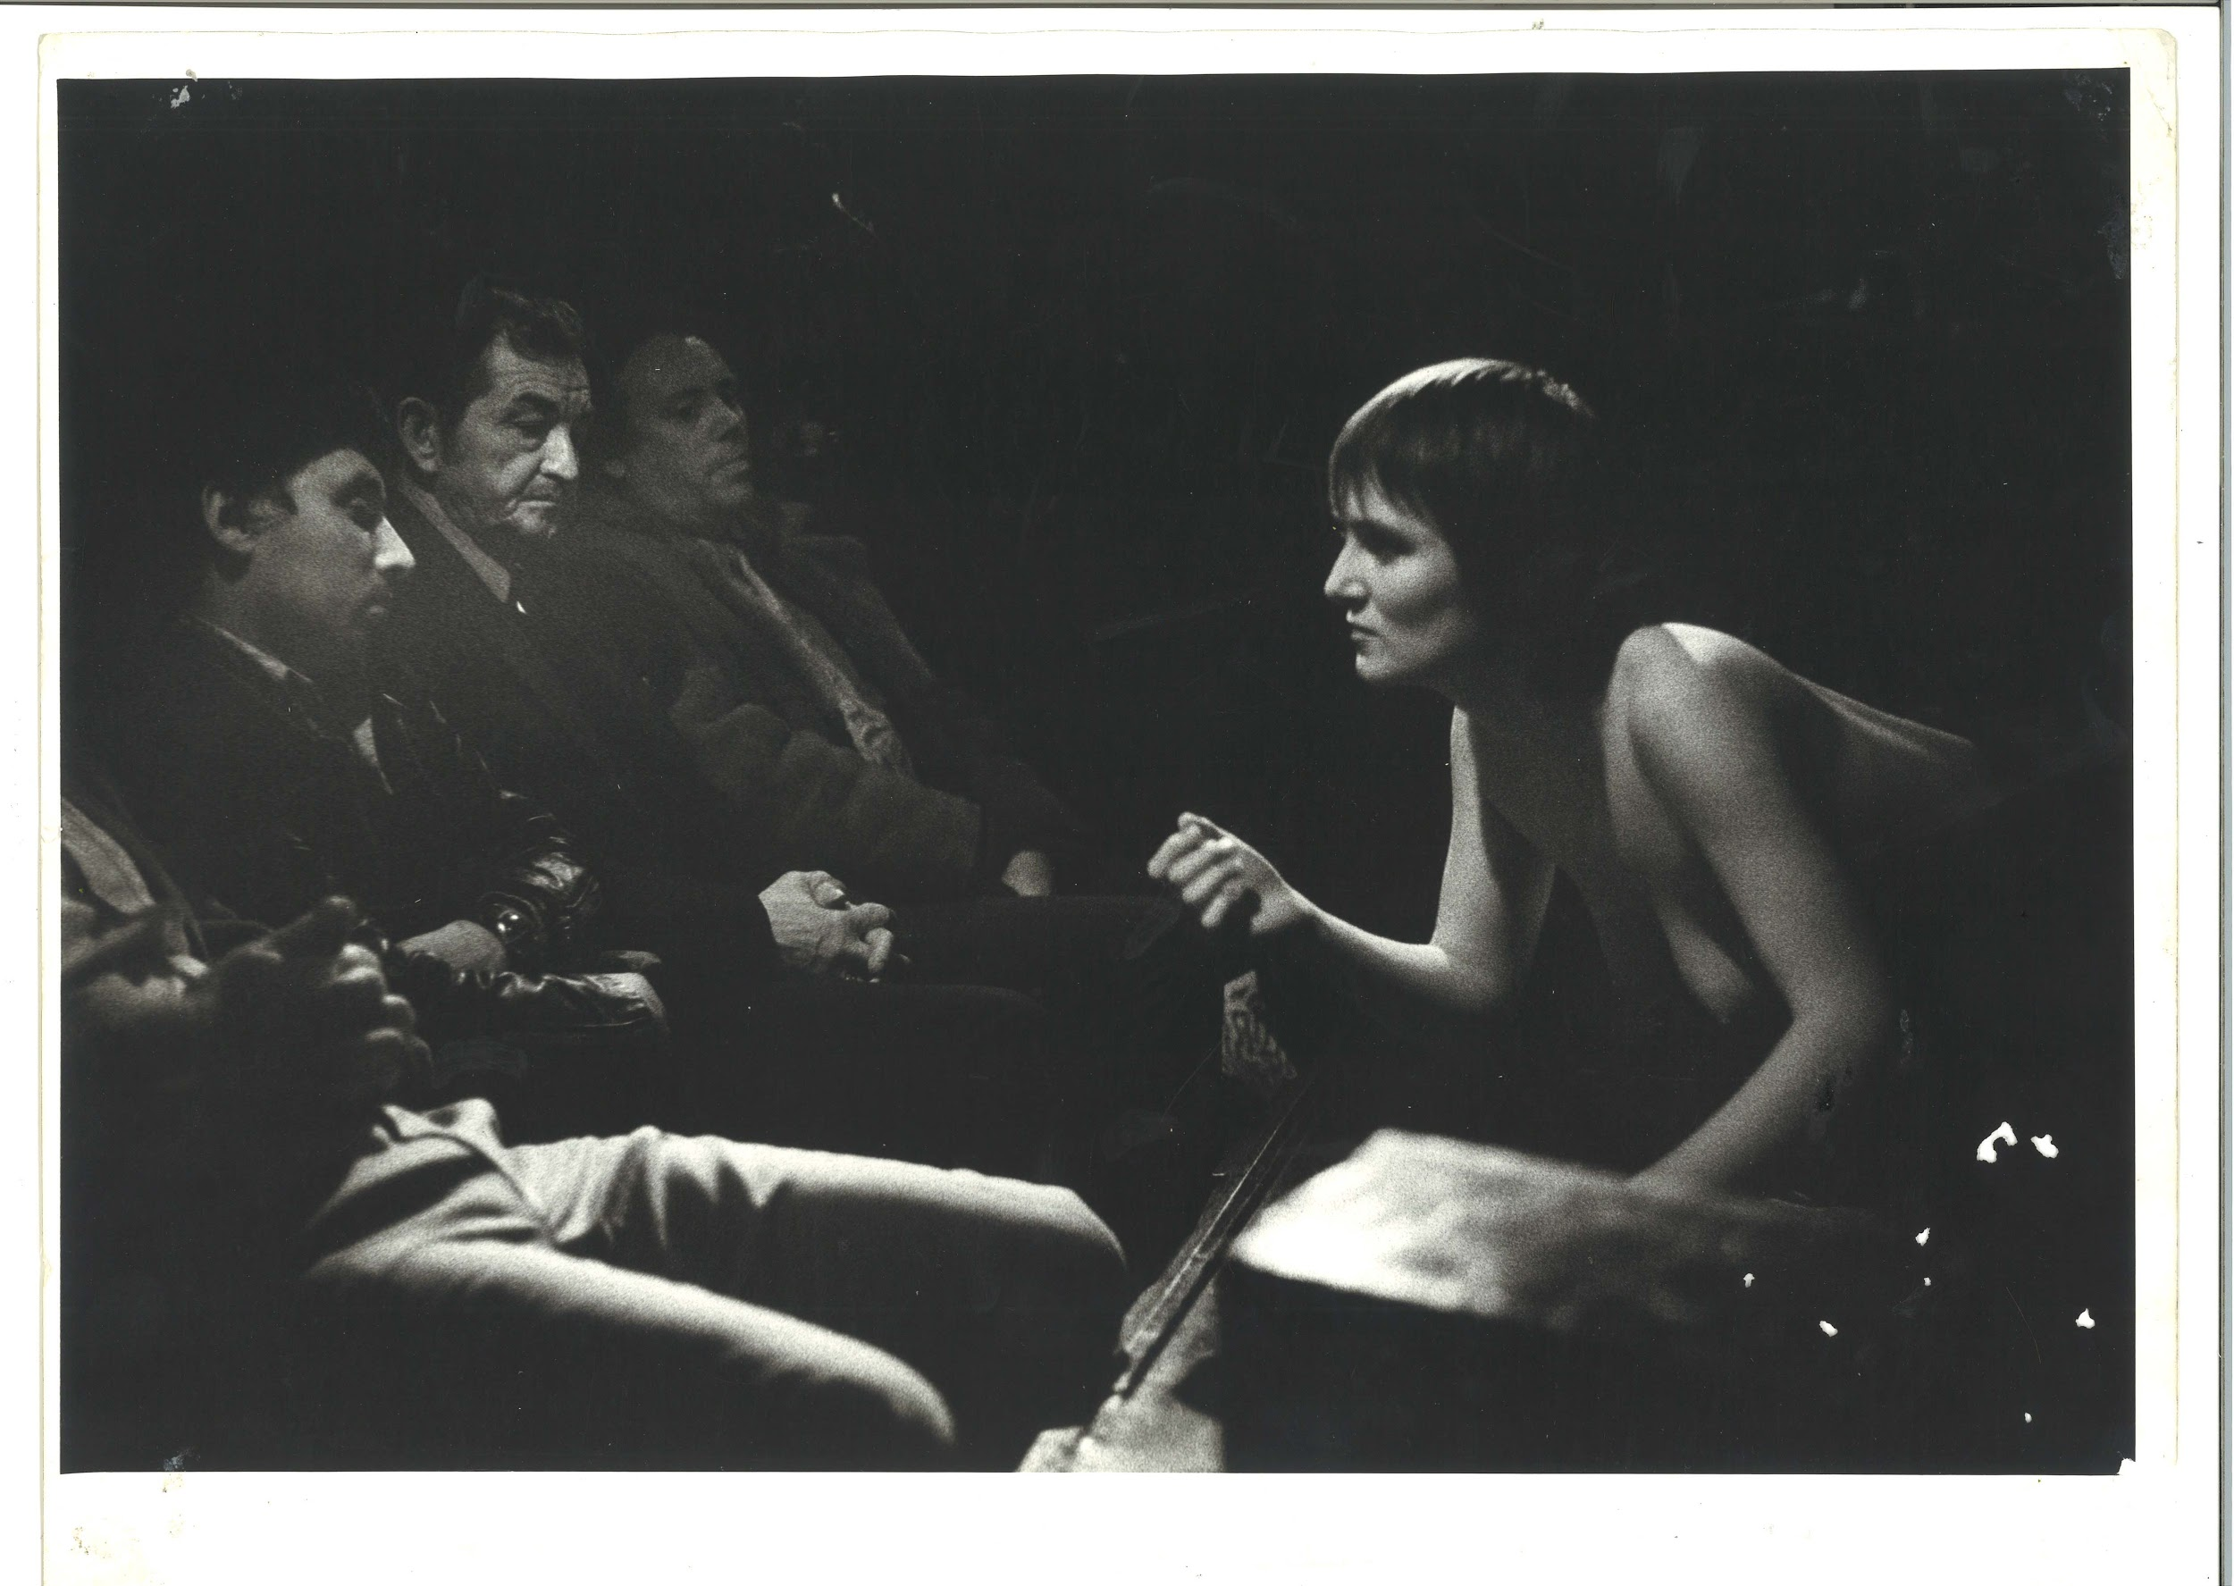 | TM_TPG_London By Night_2 | 404 x 302mm (approx) | Vintage print, loaned by Karen McQuaid / TPG on 08/05/18  From Ella Murtha material held at PARC | London By Night | 25
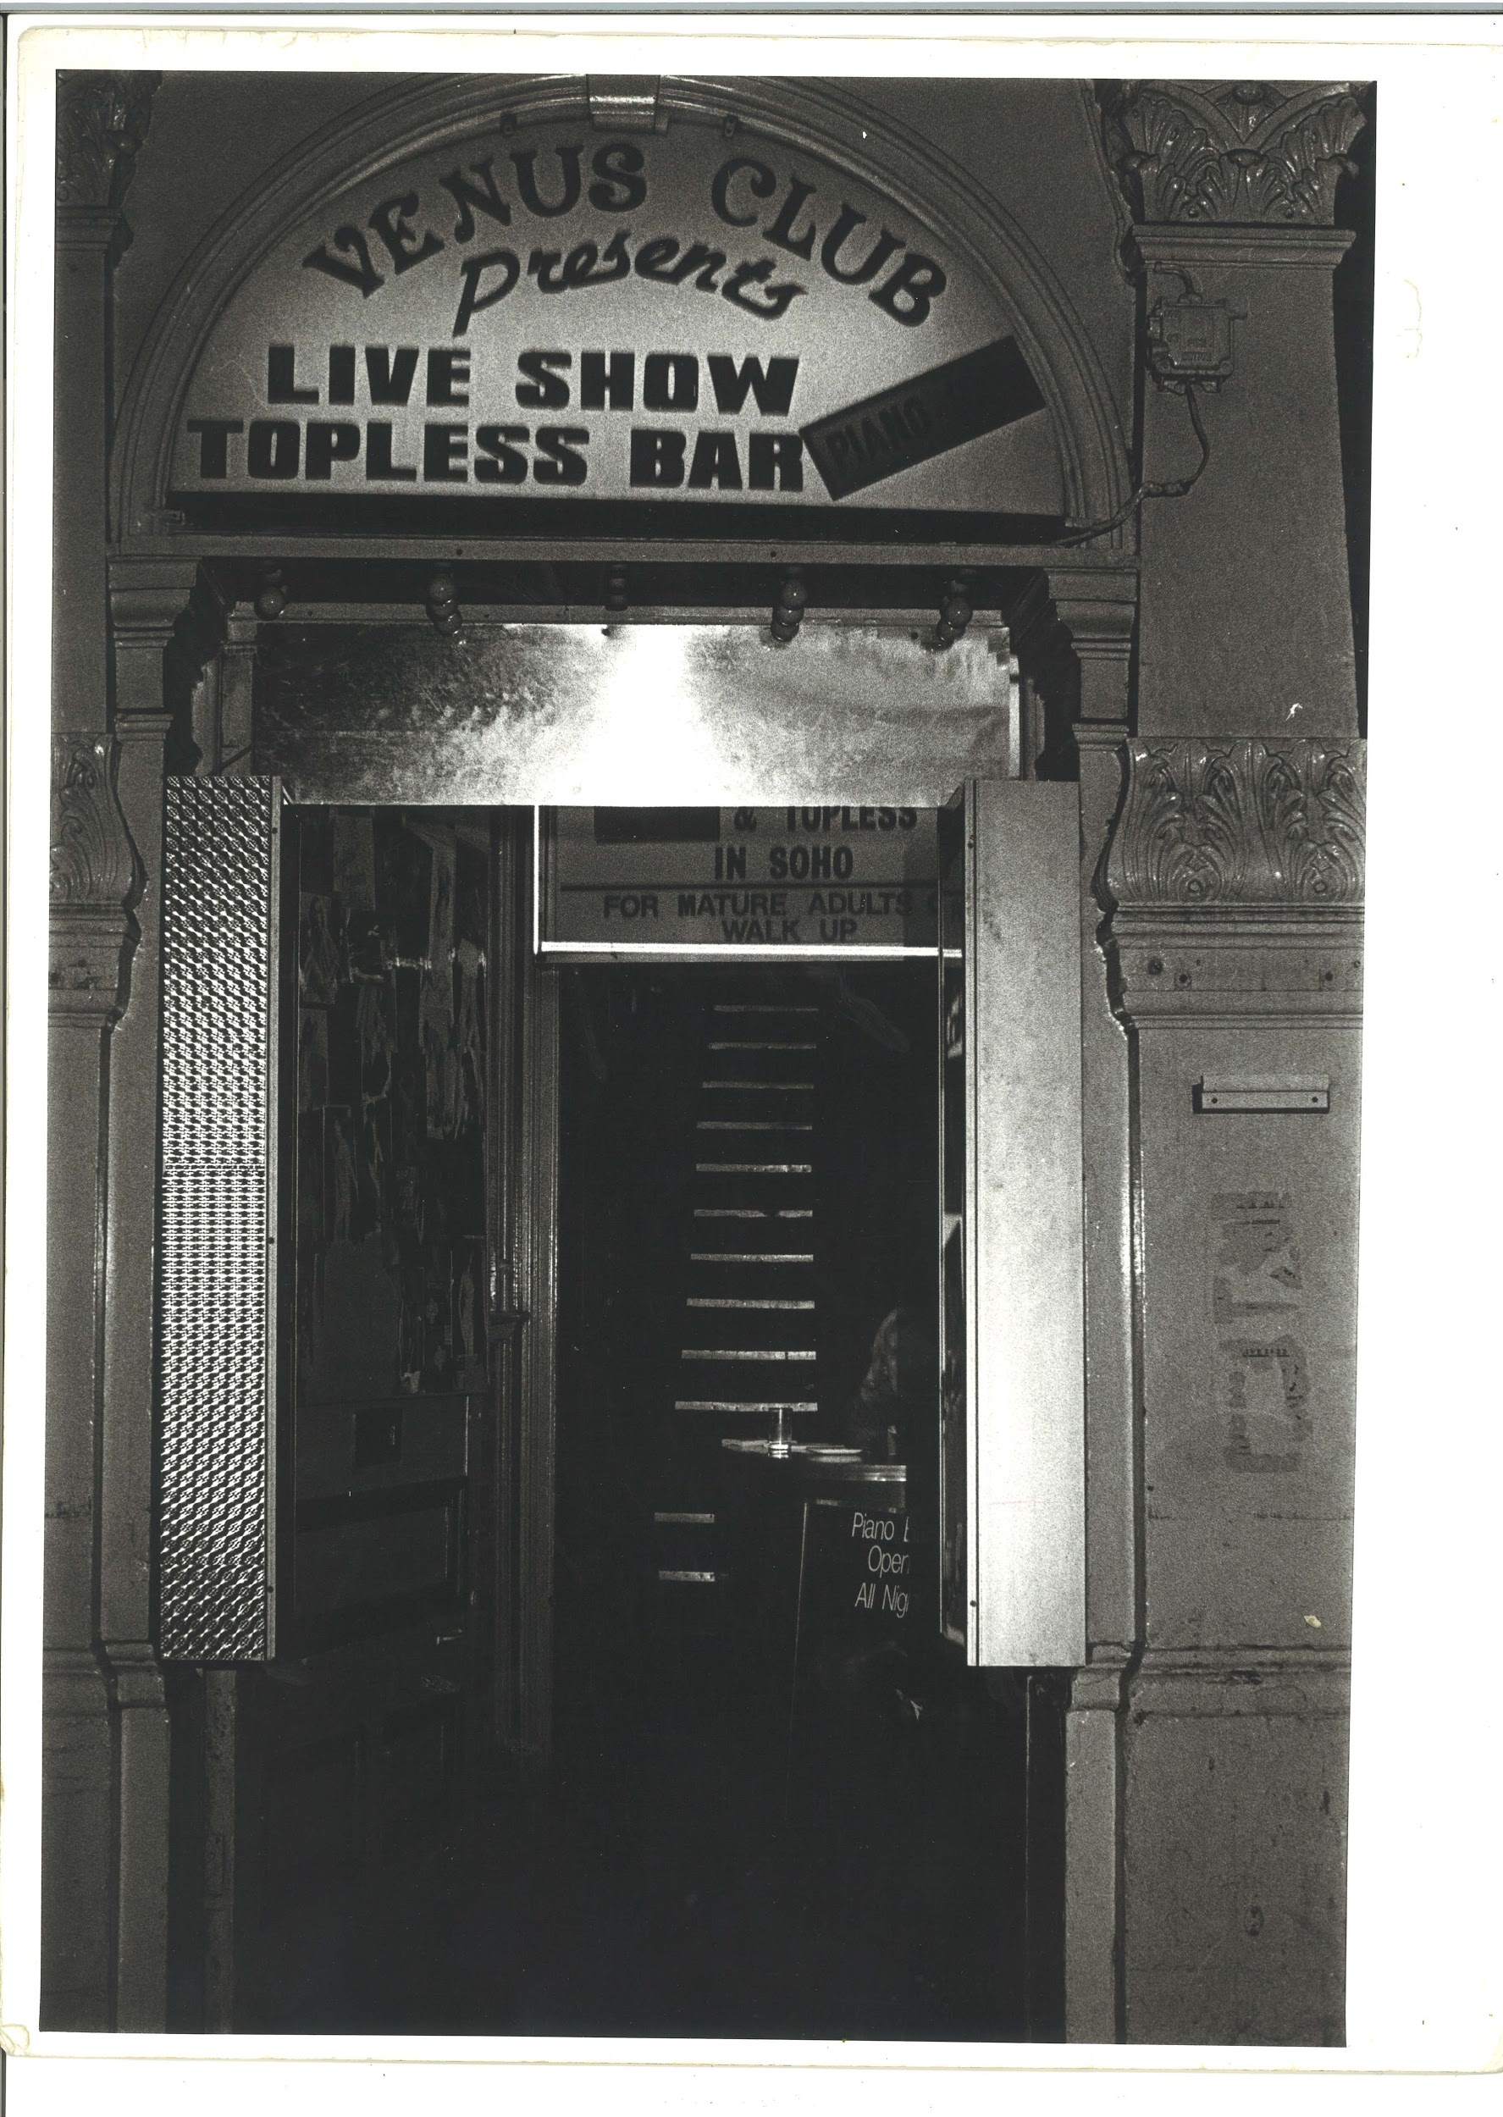 | TM_TPG_London By Night_3 | 302 x 404mm (approx) | Vintage print, loaned by Karen McQuaid / TPG on 08/05/18  From Ella Murtha material held at PARC | London By Night | 26
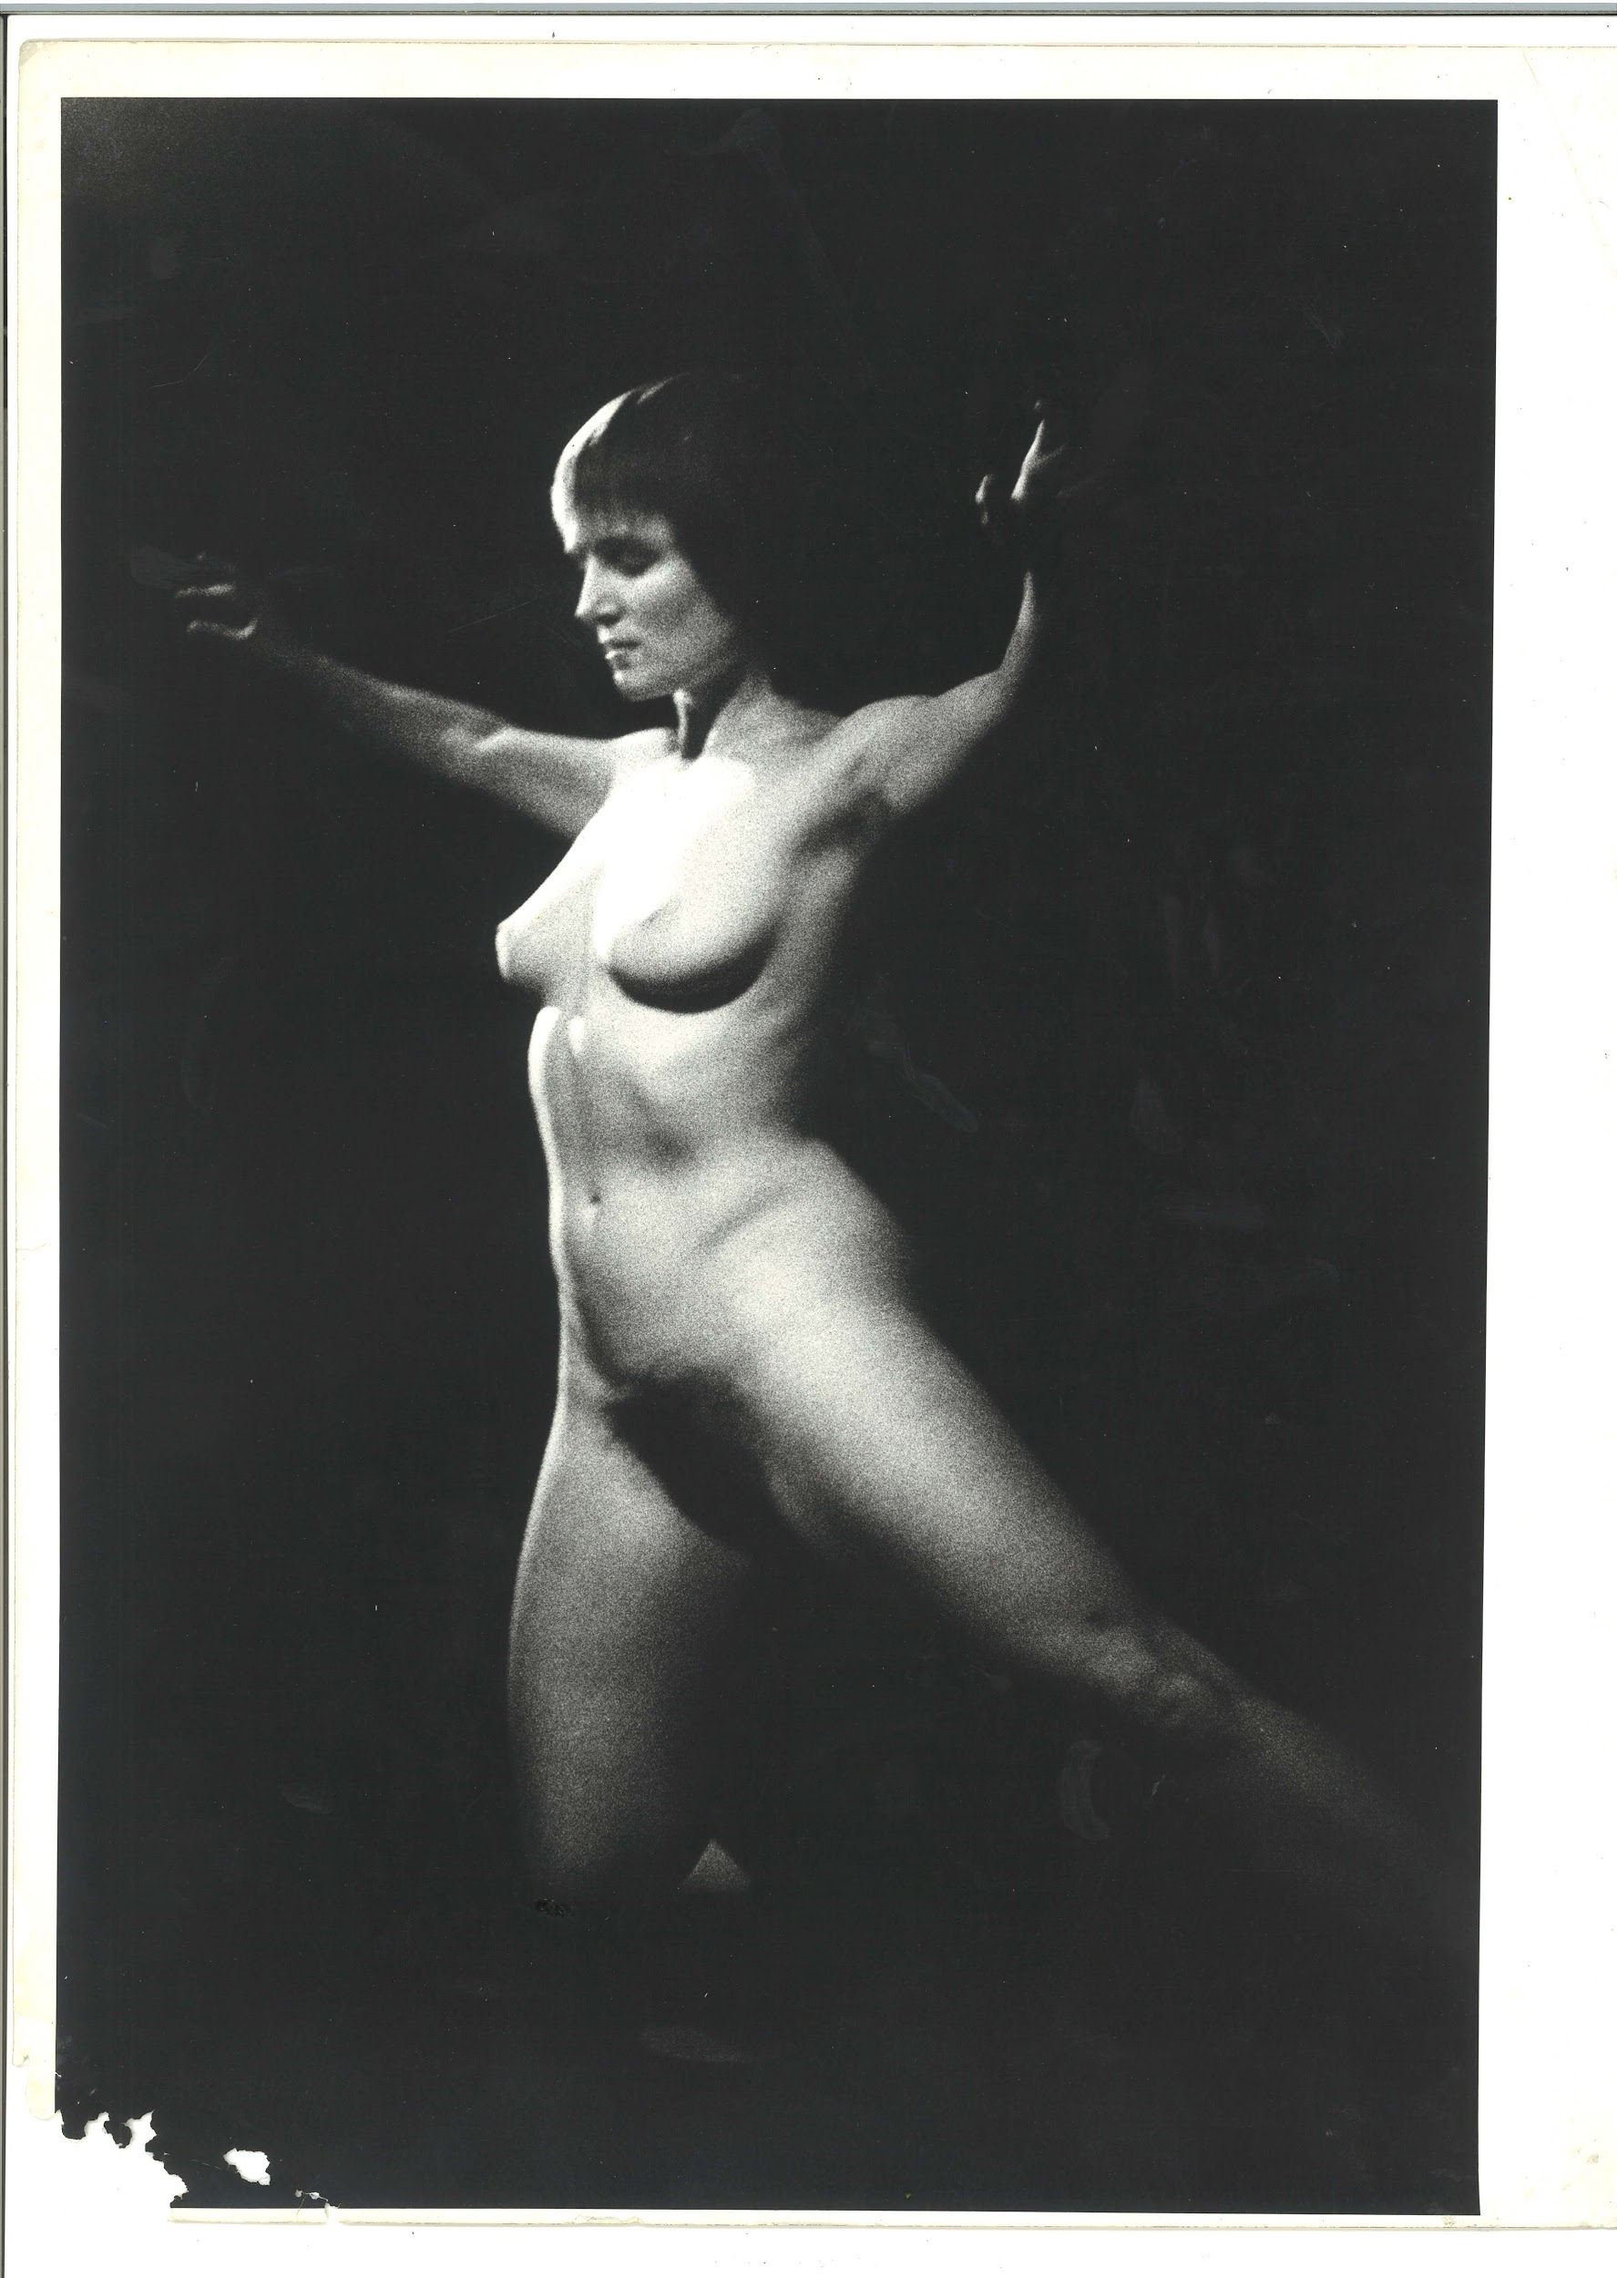 | TM_TPG_London By Night_4 | 302 x 404mm (approx) | Vintage print, loaned by Karen McQuaid / TPG on 08/05/18  From Ella Murtha material held at PARC | London By Night | 27
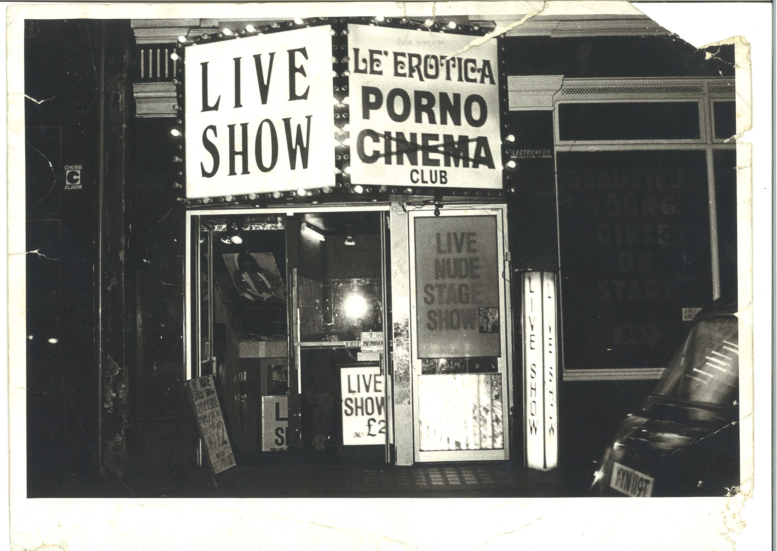 | TM_TPG_London By Night_5 | 404 x 302mm (approx) | Vintage print, loaned by Karen McQuaid / TPG on 08/05/18  From Ella Murtha material held at PARC | London By Night | 28
 | TM_TPG_London By Night_6 | 404 x 302mm (approx) | Vintage print, loaned by Karen McQuaid / TPG on 08/05/18  From Ella Murtha material held at PARC | London By Night | 29
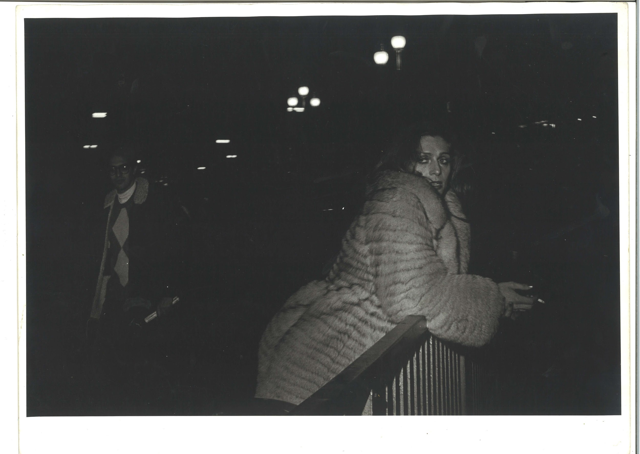 | TM_TPG_London By Night_7 | 404 x 302mm (approx) | Vintage print, loaned by Karen McQuaid / TPG on 08/05/18  From Ella Murtha material held at PARC | London By Night | 30
 | TM_TPG_London by Night_8 | 200 x 252mm (approx) | Vintage print, loaned by Karen McQuaid / TPG on 08/05/18  From Ella Murtha material held at PARC | London By Night | 31
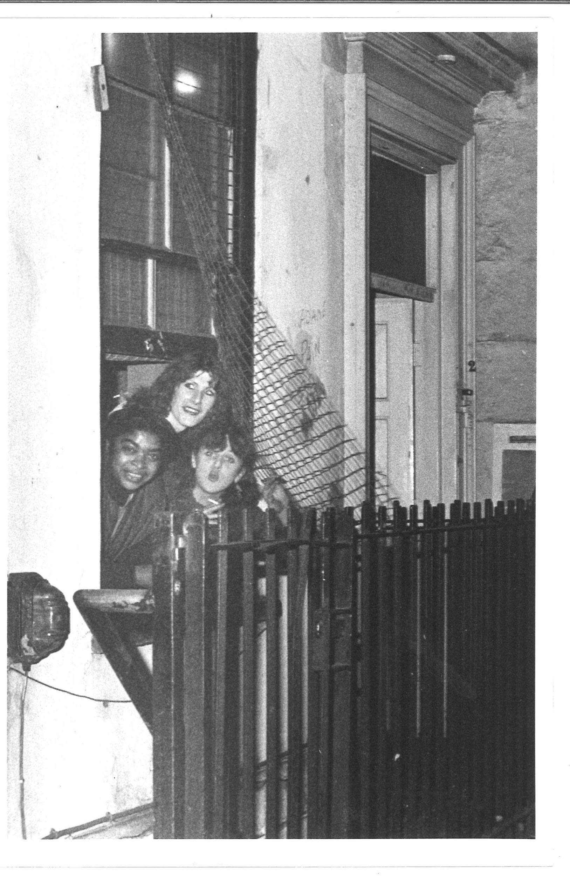 | TM_TPG_London by Night_9 | 200 x 252mm (approx) | Vintage print, loaned by Karen McQuaid / TPG on 08/05/18  From Ella Murtha material held at PARC | London By Night | 32
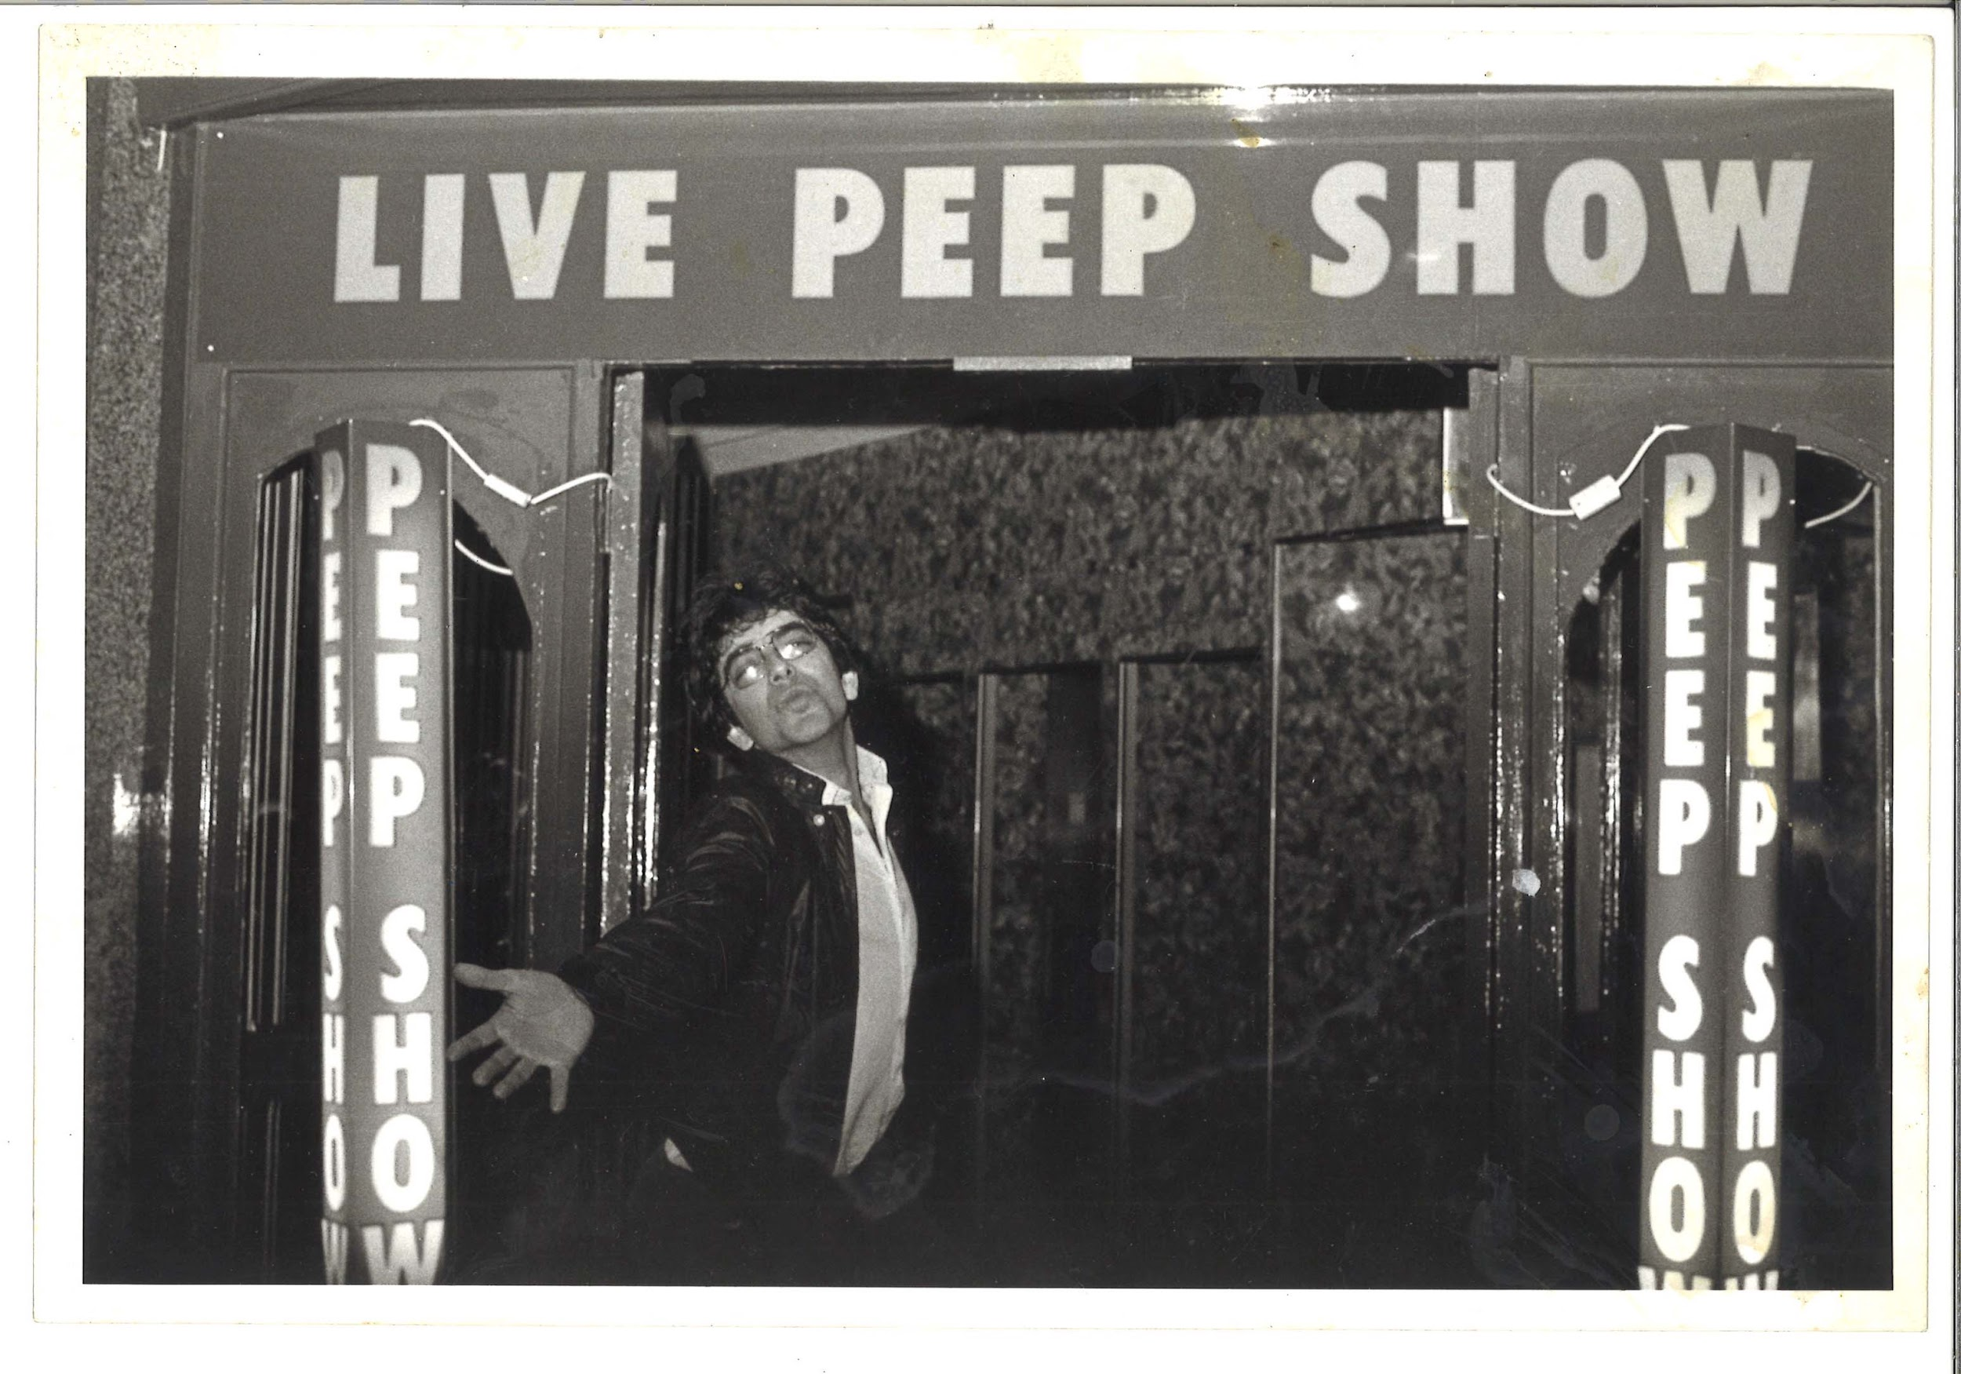 | TM_TPG_London by Night_10 | 254 x 171mm (approx) | Vintage print, loaned by Karen McQuaid / TPG on 08/05/18  From Ella Murtha material held at PARC | London By Night | 33
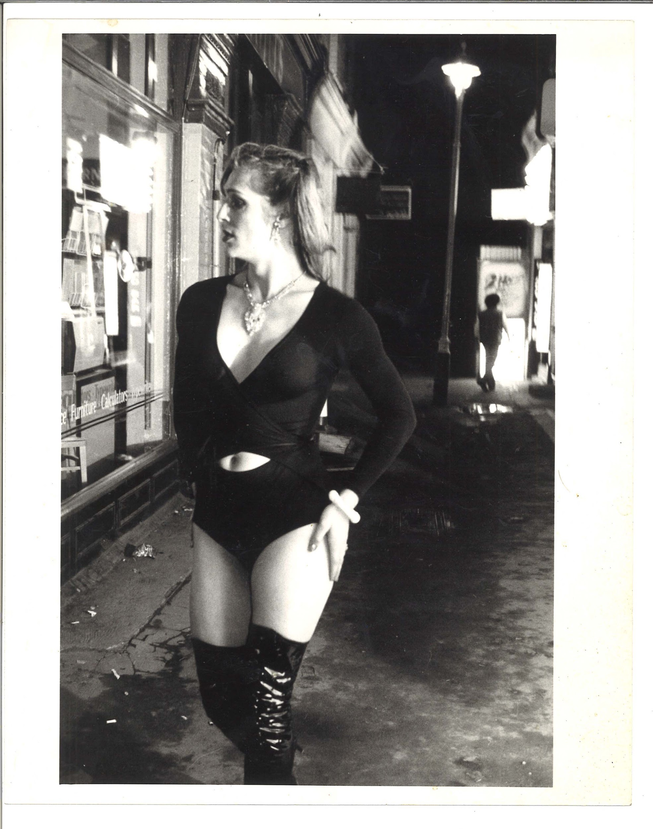 | TM_TPG_London by Night_11 | 200 x 252mm (approx) | Vintage print, loaned by Karen McQuaid / TPG on 08/05/18  From Ella Murtha material held at PARC | London By Night | 34
 | TM_TPG_London by Night_13 | 254 x 171mm (approx) | Vintage print, loaned by Karen McQuaid / TPG on 08/05/18  From Ella Murtha material held at PARC | London By Night | 35
 | TM_TPG_London by Night_14 | 200 x 252mm (approx) | Vintage print, loaned by Karen McQuaid / TPG on 08/05/18  From Ella Murtha material held at PARC | London By Night | 36
 | TM_TPG_London by Night_15 | 161 x 218mm (approx) | Vintage print, loaned by Karen McQuaid / TPG on 08/05/18  From Ella Murtha material held at PARC | London By Night | 37
 | TM_TPG_London by Night_16 | 200 x 252mm (approx) | Vintage print, loaned by Karen McQuaid / TPG on 08/05/18  From Ella Murtha material held at PARC | London By Night | 38
 | TM_TPG_London by Night_17 | 200 x 252mm (approx) | Vintage print, loaned by Karen McQuaid / TPG on 08/05/18  From Ella Murtha material held at PARC | London By Night | 39
 | TM_TPG_London by Night_18 | 200 x 252mm (approx) | Vintage print, loaned by Karen McQuaid / TPG on 08/05/18  From Ella Murtha material held at PARC | London By Night | 40
 | TM_TPG_London by Night_19 | 200 x 252mm (approx) | Vintage print, loaned by Karen McQuaid / TPG on 08/05/18  From Ella Murtha material held at PARC | London By Night | 41
 | TM_TPG_London by Night_20 | 161 x 218mm (approx) | Vintage print, loaned by Karen McQuaid / TPG on 08/05/18  From Ella Murtha material held at PARC | London By Night | 42

 | TM_TPG_London by Night_21 | 161 x 218mm (approx) | Vintage print, loaned by Karen McQuaid / TPG on 08/05/18  From Ella Murtha material held at PARC | London By Night | 43
 | TM_TPG_London by Night_22 | 161 x 248mm (approx) | Vintage print, loaned by Karen McQuaid / TPG on 08/05/18  From Ella Murtha material held at PARC | London By Night | 44
 | TM_TPG_London by Night_23 | 128 x 201mm (approx) | Vintage print, loaned by Karen McQuaid / TPG on 08/05/18  From Ella Murtha material held at PARC | London By Night | 45
 | TM_TPG_London by Night_24  This print is attached to a piece of tracing paper that has been marked up for printing | 161 x 218mm (approx) | Vintage print, loaned by Karen McQuaid / TPG on 08/05/18  From Ella Murtha material held at PARC | London By Night | 46
 | TM_TPG_London by Night_25 | 161 x 218mm (approx) | Vintage print, loaned by Karen McQuaid / TPG on 08/05/18  From Ella Murtha material held at PARC | London By Night | 47
Newport Pub
 | TM_TPG_Newport Pub__1 | 242 x 178mm (approx) | Vintage print, loaned by Karen McQuaid / TPG on 08/05/18  From Ella Murtha material held at PARC | Newport Pub | 48
 | TM_TPG_Newport Pub__2 | 242 x 178mm (approx) | Vintage print, loaned by Karen McQuaid / TPG on 08/05/18  From Ella Murtha material held at PARC | Newport Pub | 49
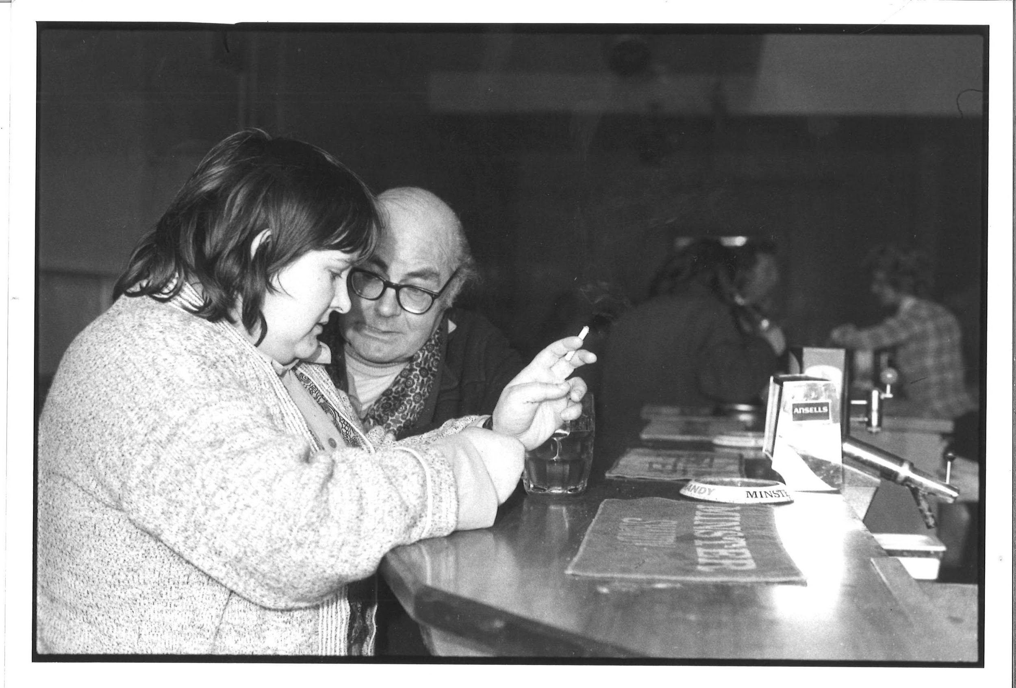 | TM_TPG_Newport Pub__4 | 242 x 178mm (approx) | Vintage print, loaned by Karen McQuaid / TPG on 08/05/18  From Ella Murtha material held at PARC | Newport Pub | 50
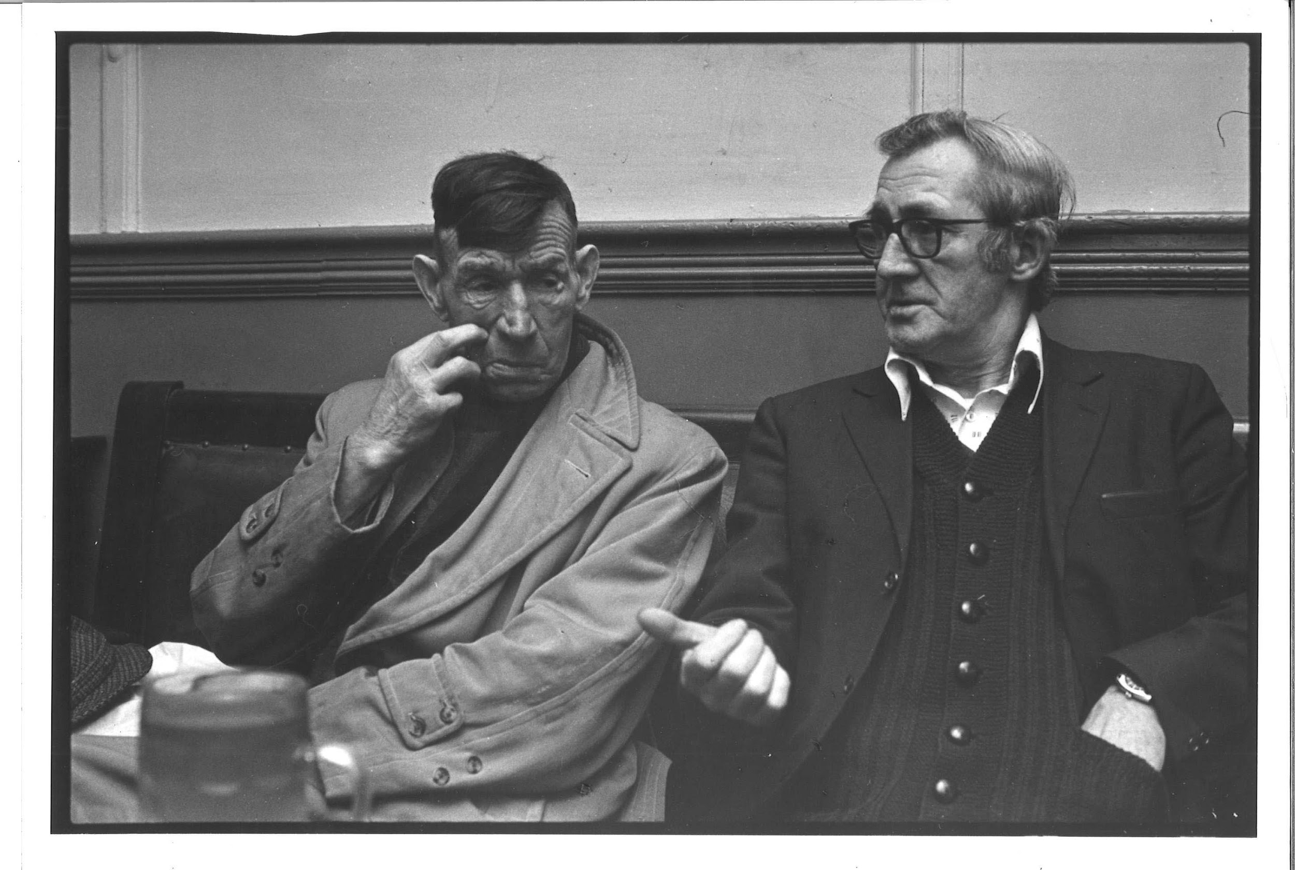 | TM_TPG_Newport Pub__7 | 242 x 178mm (approx) | Vintage print, loaned by Karen McQuaid / TPG on 08/05/18  From Ella Murtha material held at PARC | Newport Pub | 51
 | TM_TPG_Newport Pub__9 | 242 x 178mm (approx) | Vintage print, loaned by Karen McQuaid / TPG on 08/05/18  From Ella Murtha material held at PARC | Newport Pub | 52
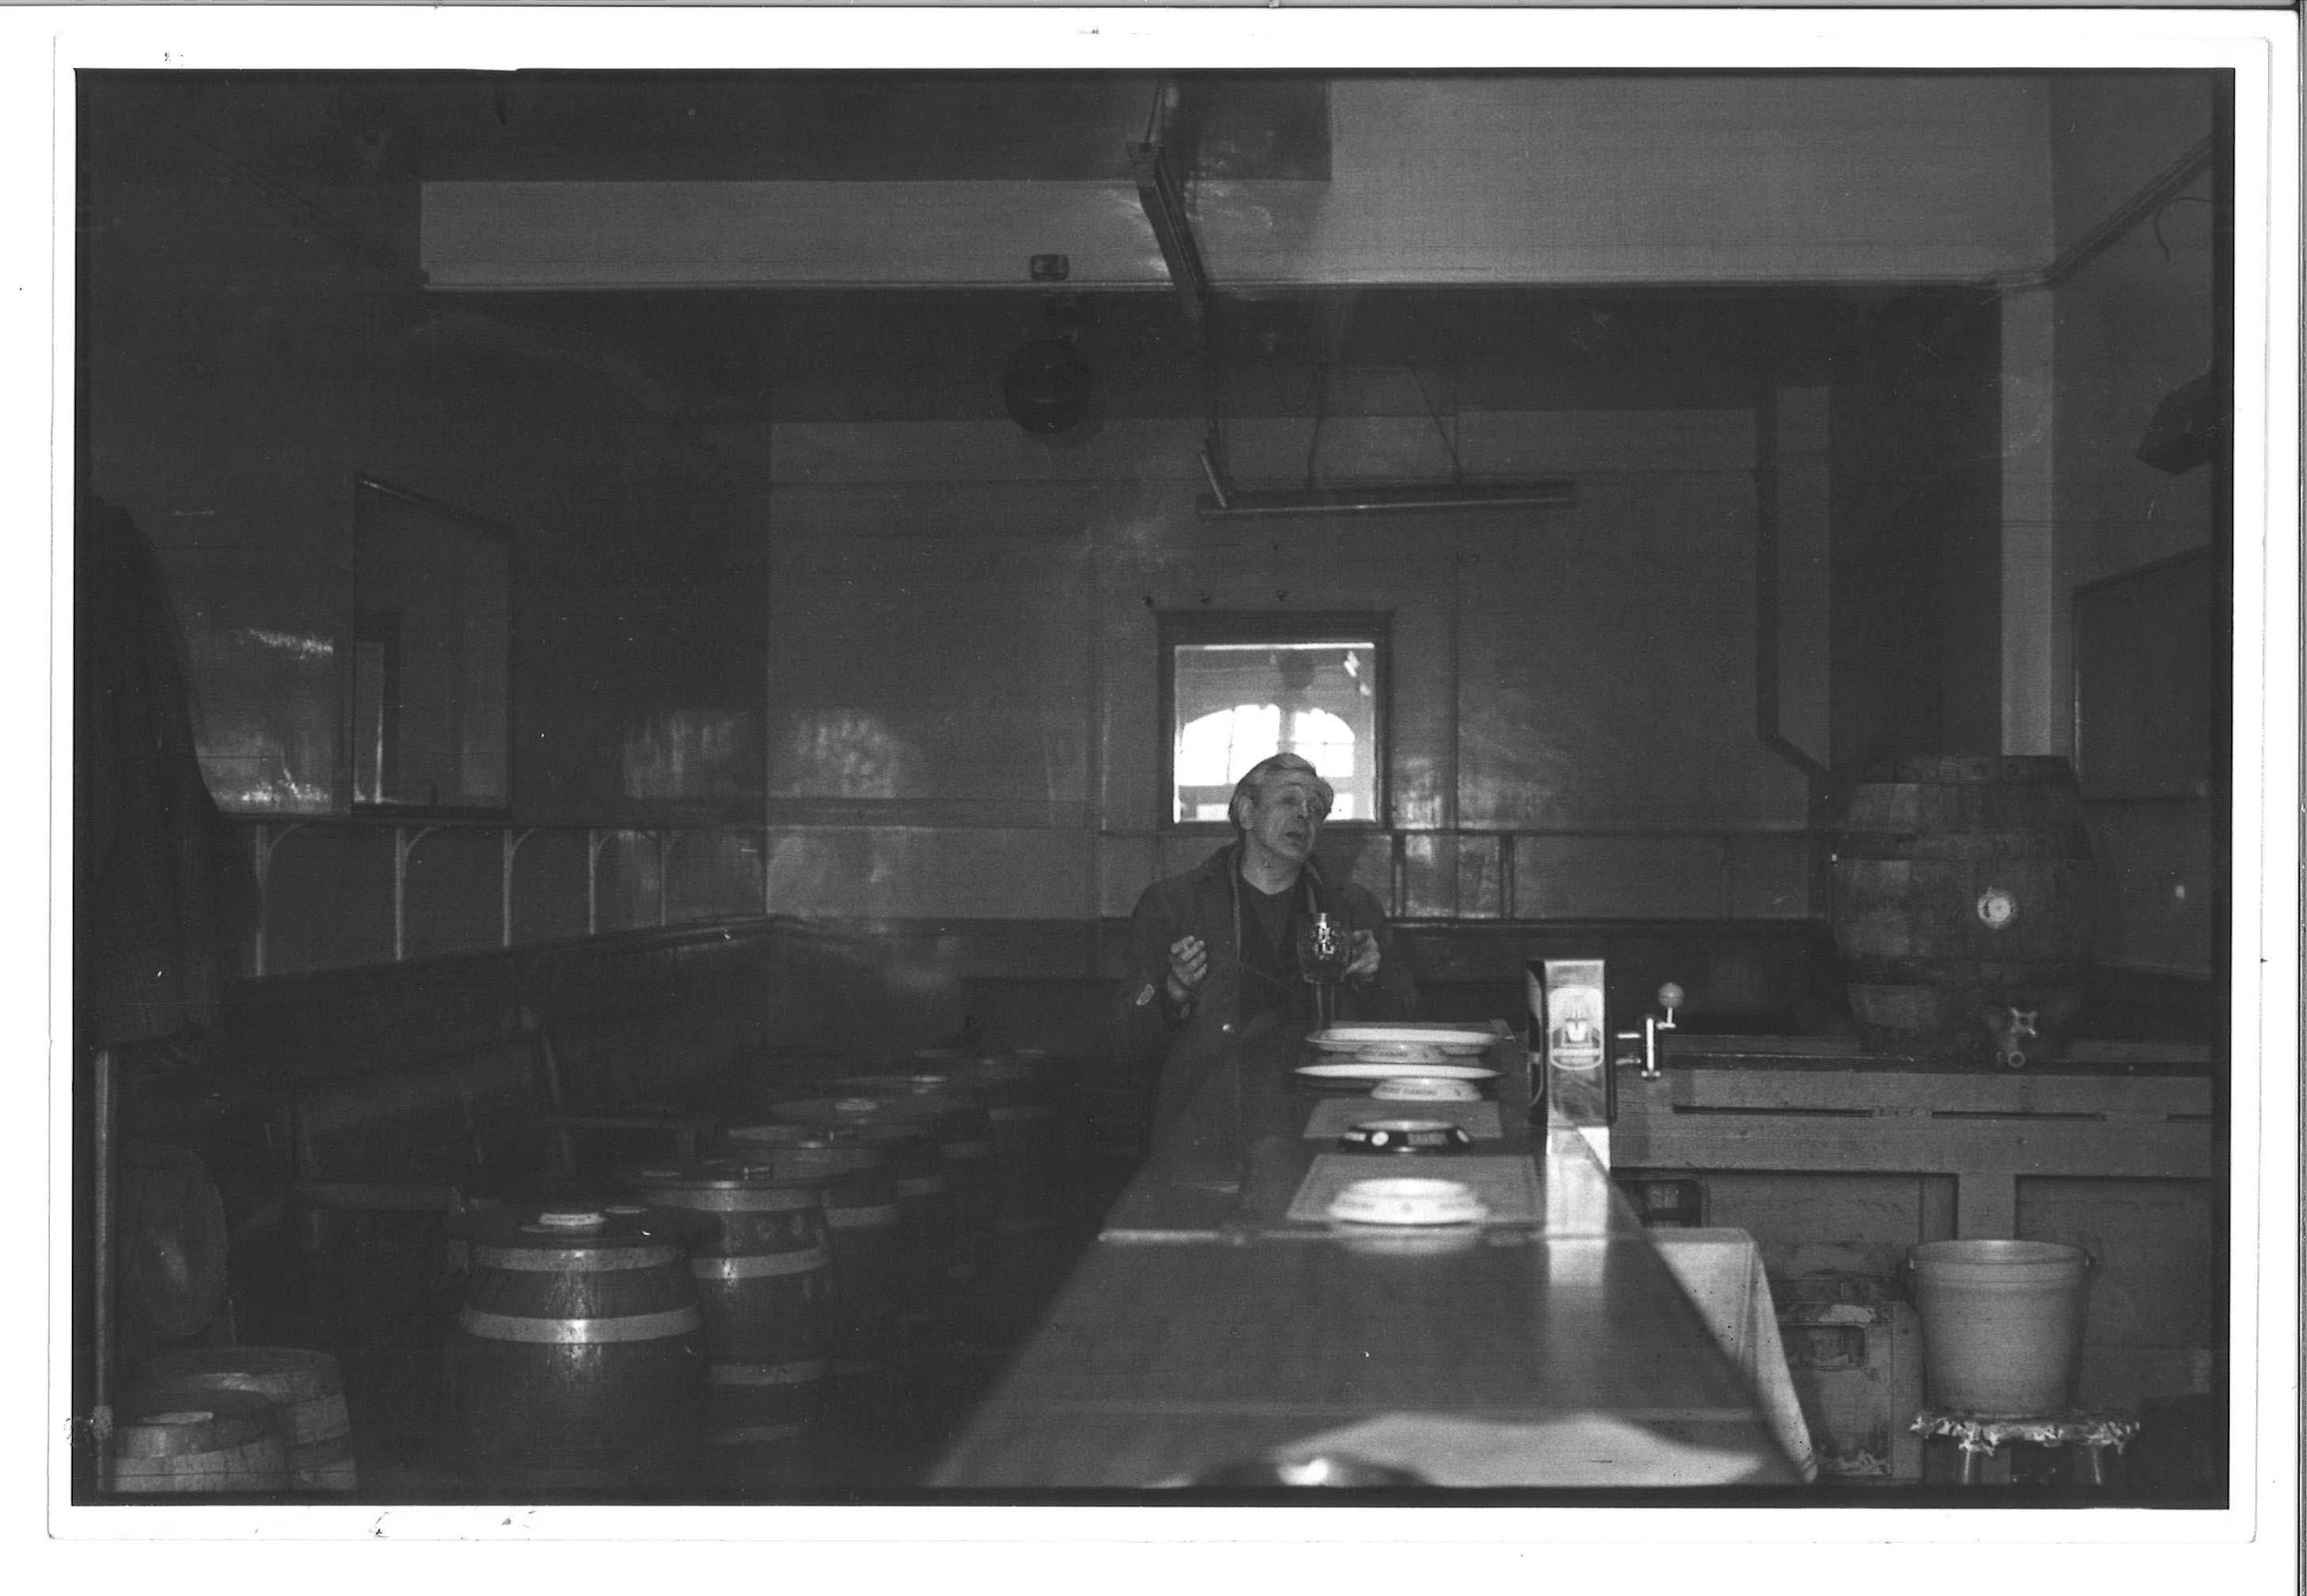 | TM_TPG_Newport Pub__10 | 242 x 178mm (approx) | Vintage print, loaned by Karen McQuaid / TPG on 08/05/18  From Ella Murtha material held at PARC | Newport Pub | 53
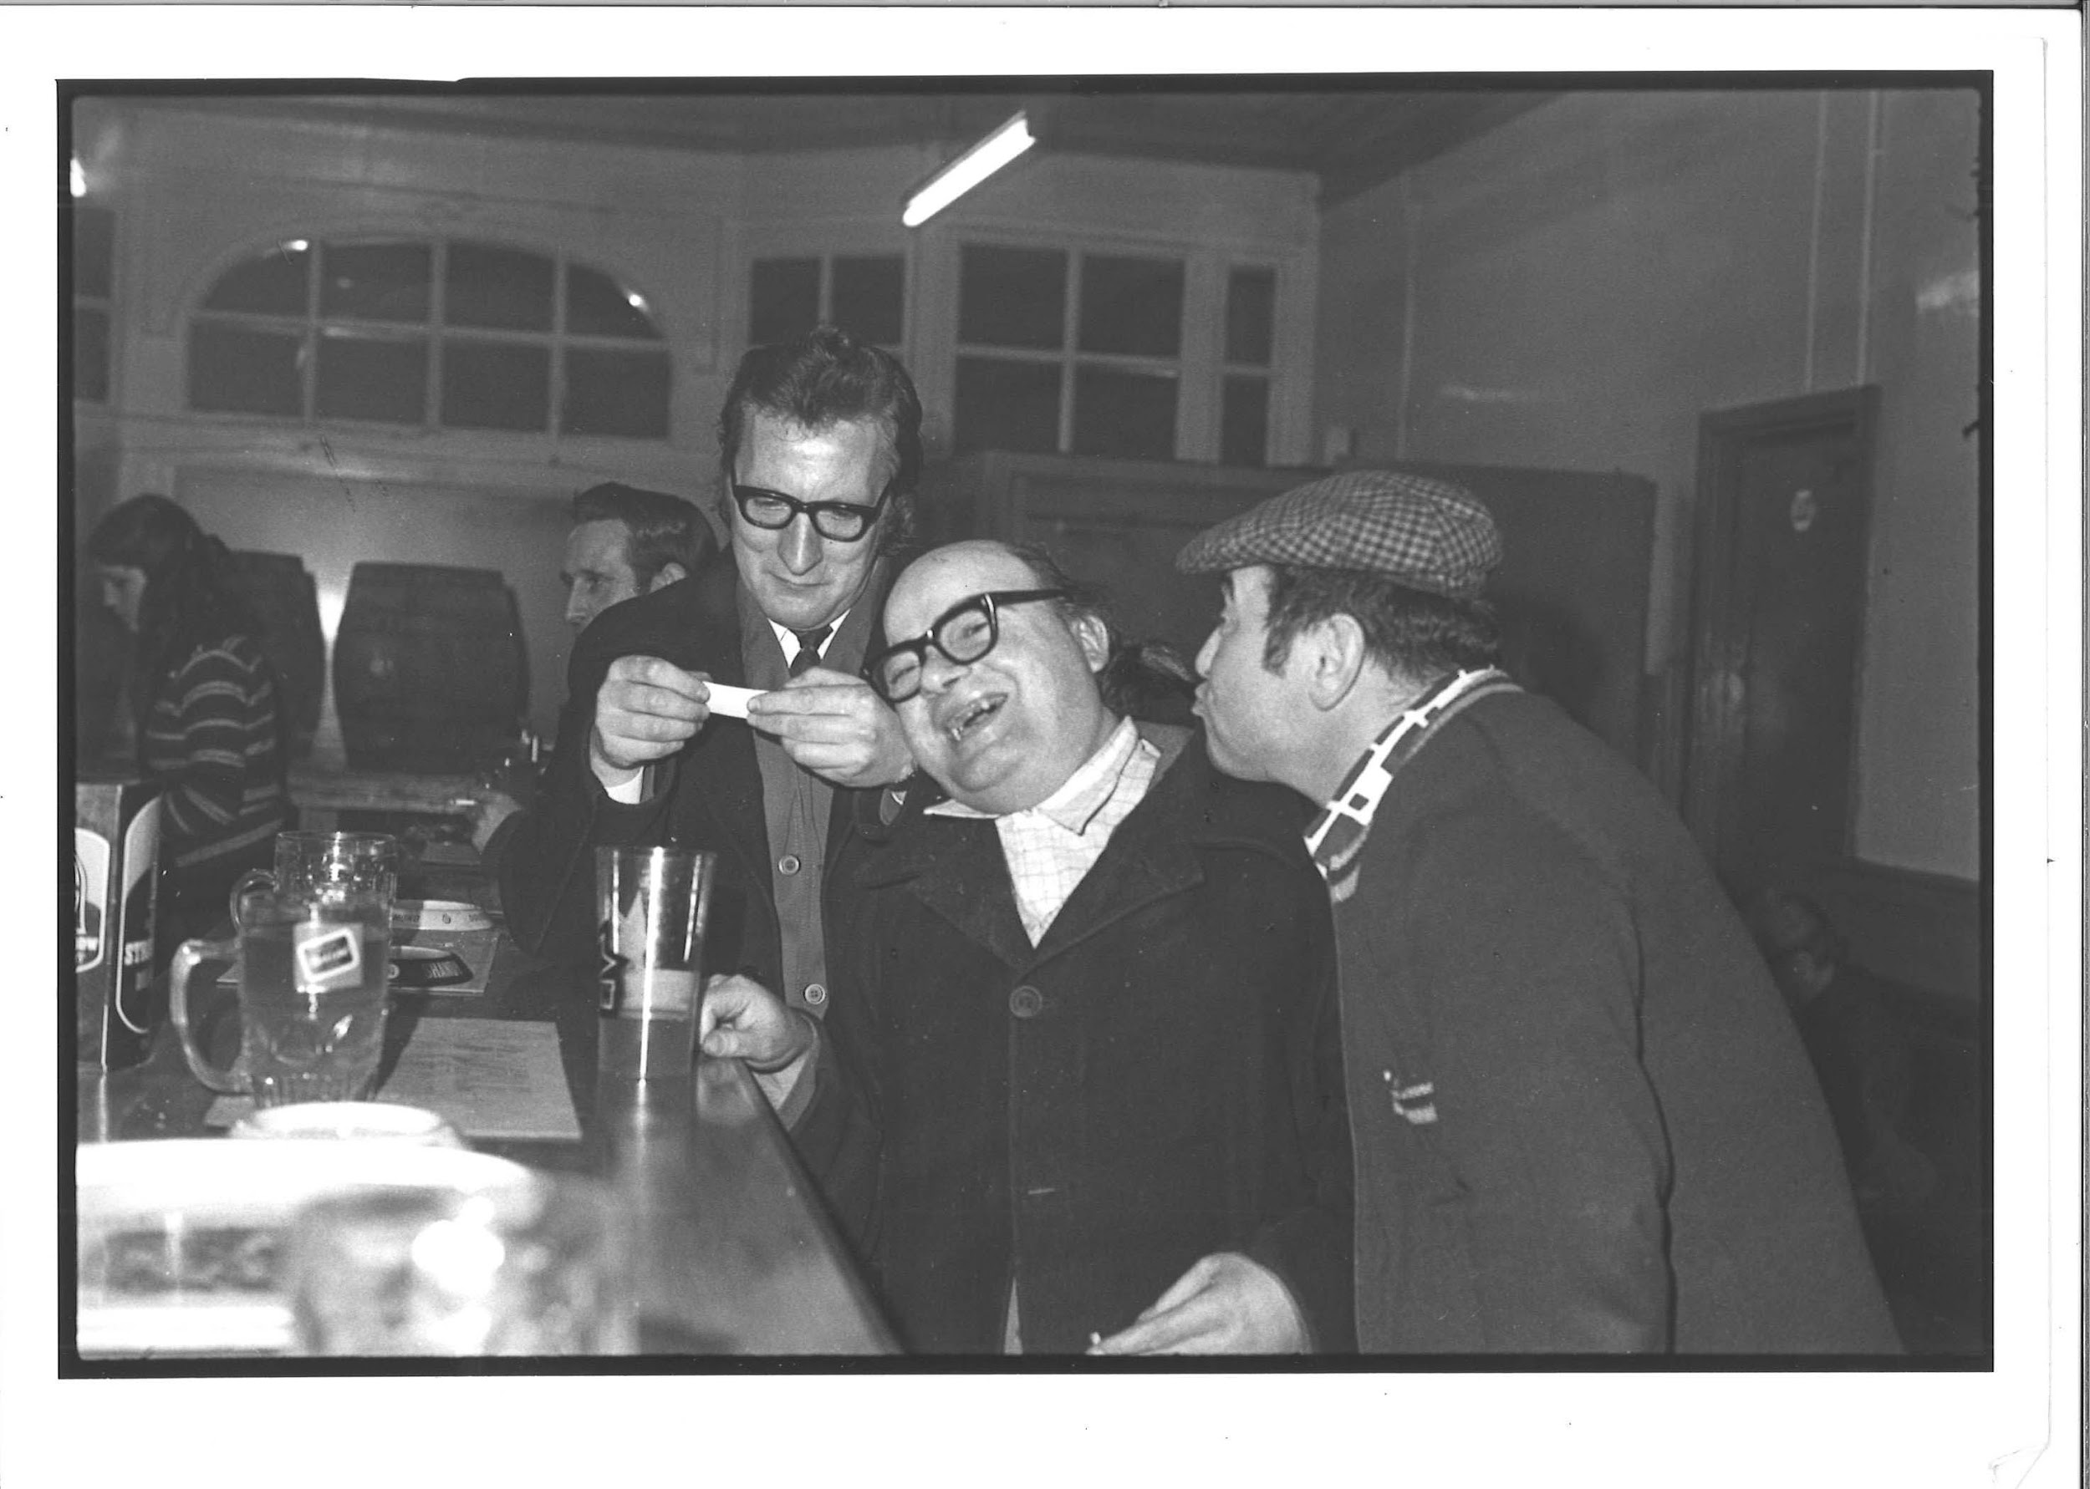 | TM_TPG_Newport Pub__11 | 242 x 178mm (approx) | Vintage print, loaned by Karen McQuaid / TPG on 08/05/18  From Ella Murtha material held at PARC | Newport Pub | 54
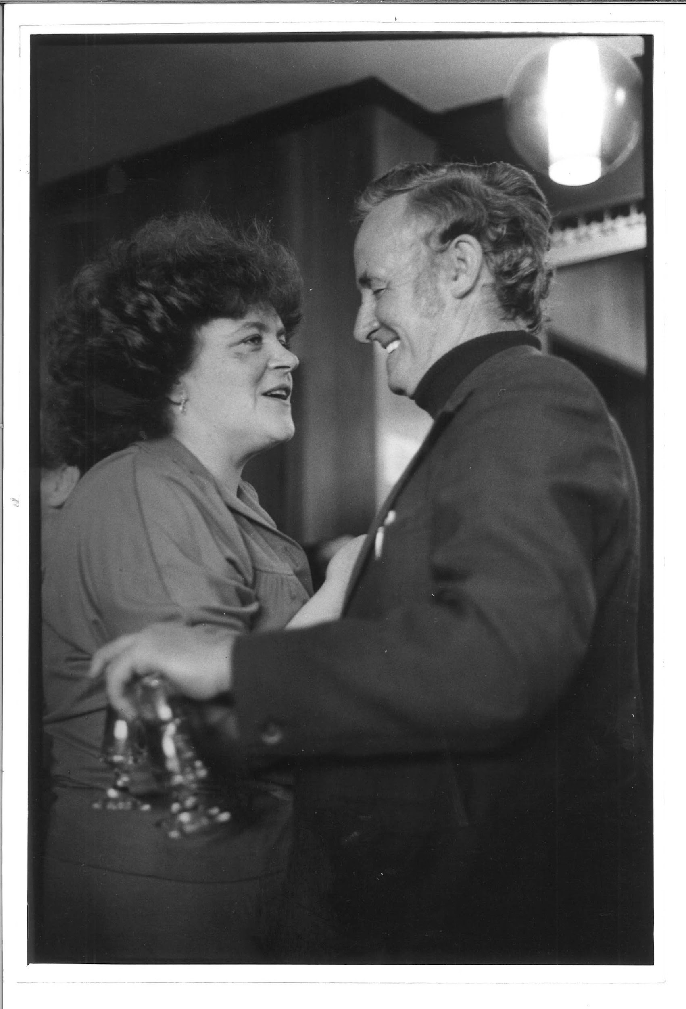 | TM_TPG_Newport Pub__12 | 178 x 242mm (approx) | Vintage print, loaned by Karen McQuaid / TPG on 08/05/18  From Ella Murtha material held at PARC | Newport Pub | 55
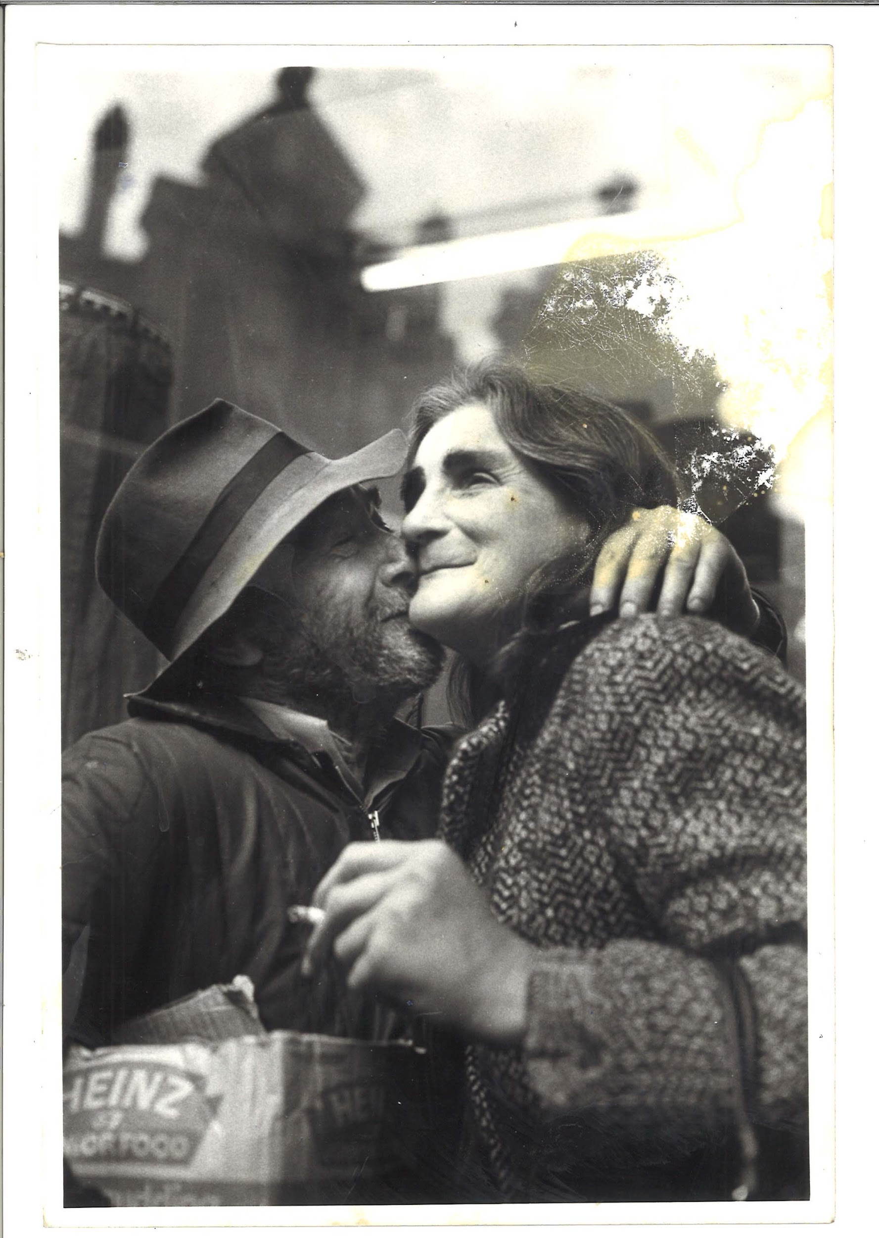 | TM_TPG_Newport Pub__13 | 158 x 233mm (approx) | Vintage print, loaned by Karen McQuaid / TPG on 08/05/18  From Ella Murtha material held at PARC | Newport Pub | 56
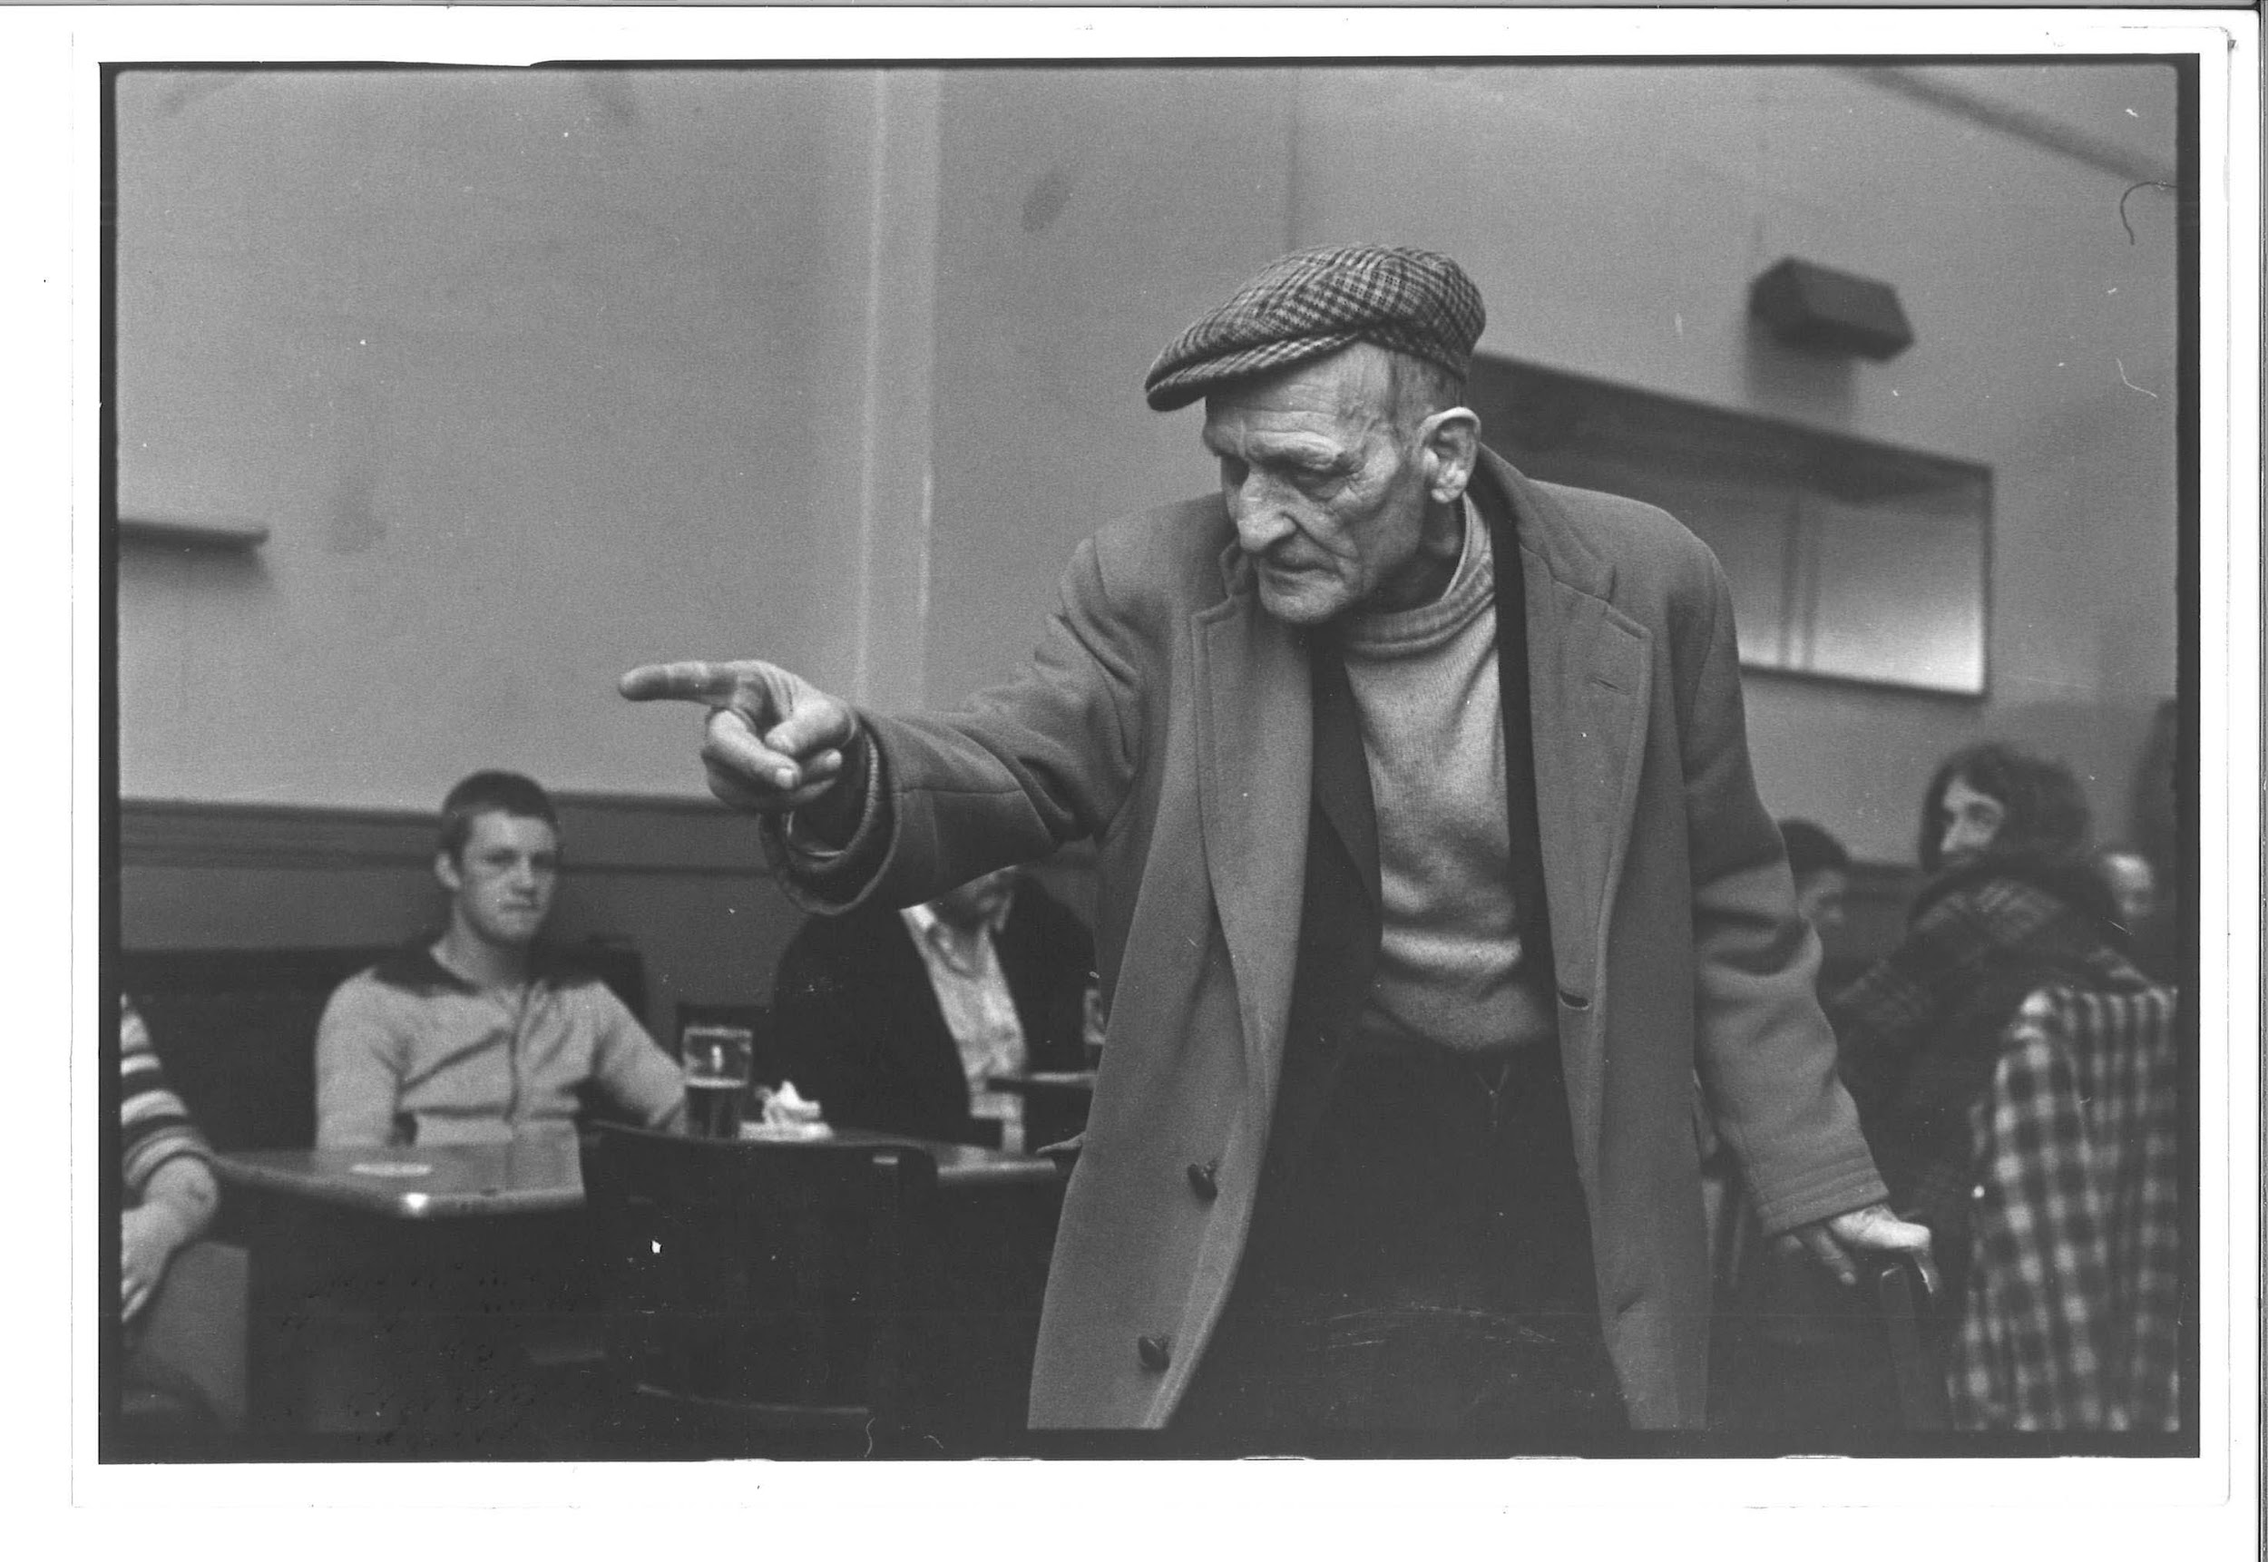 | TM_TPG_Newport Pub__15 | 236 x 163mm (approx) | Vintage print, loaned by Karen McQuaid / TPG on 08/05/18  From Ella Murtha material held at PARC | Newport Pub | 57
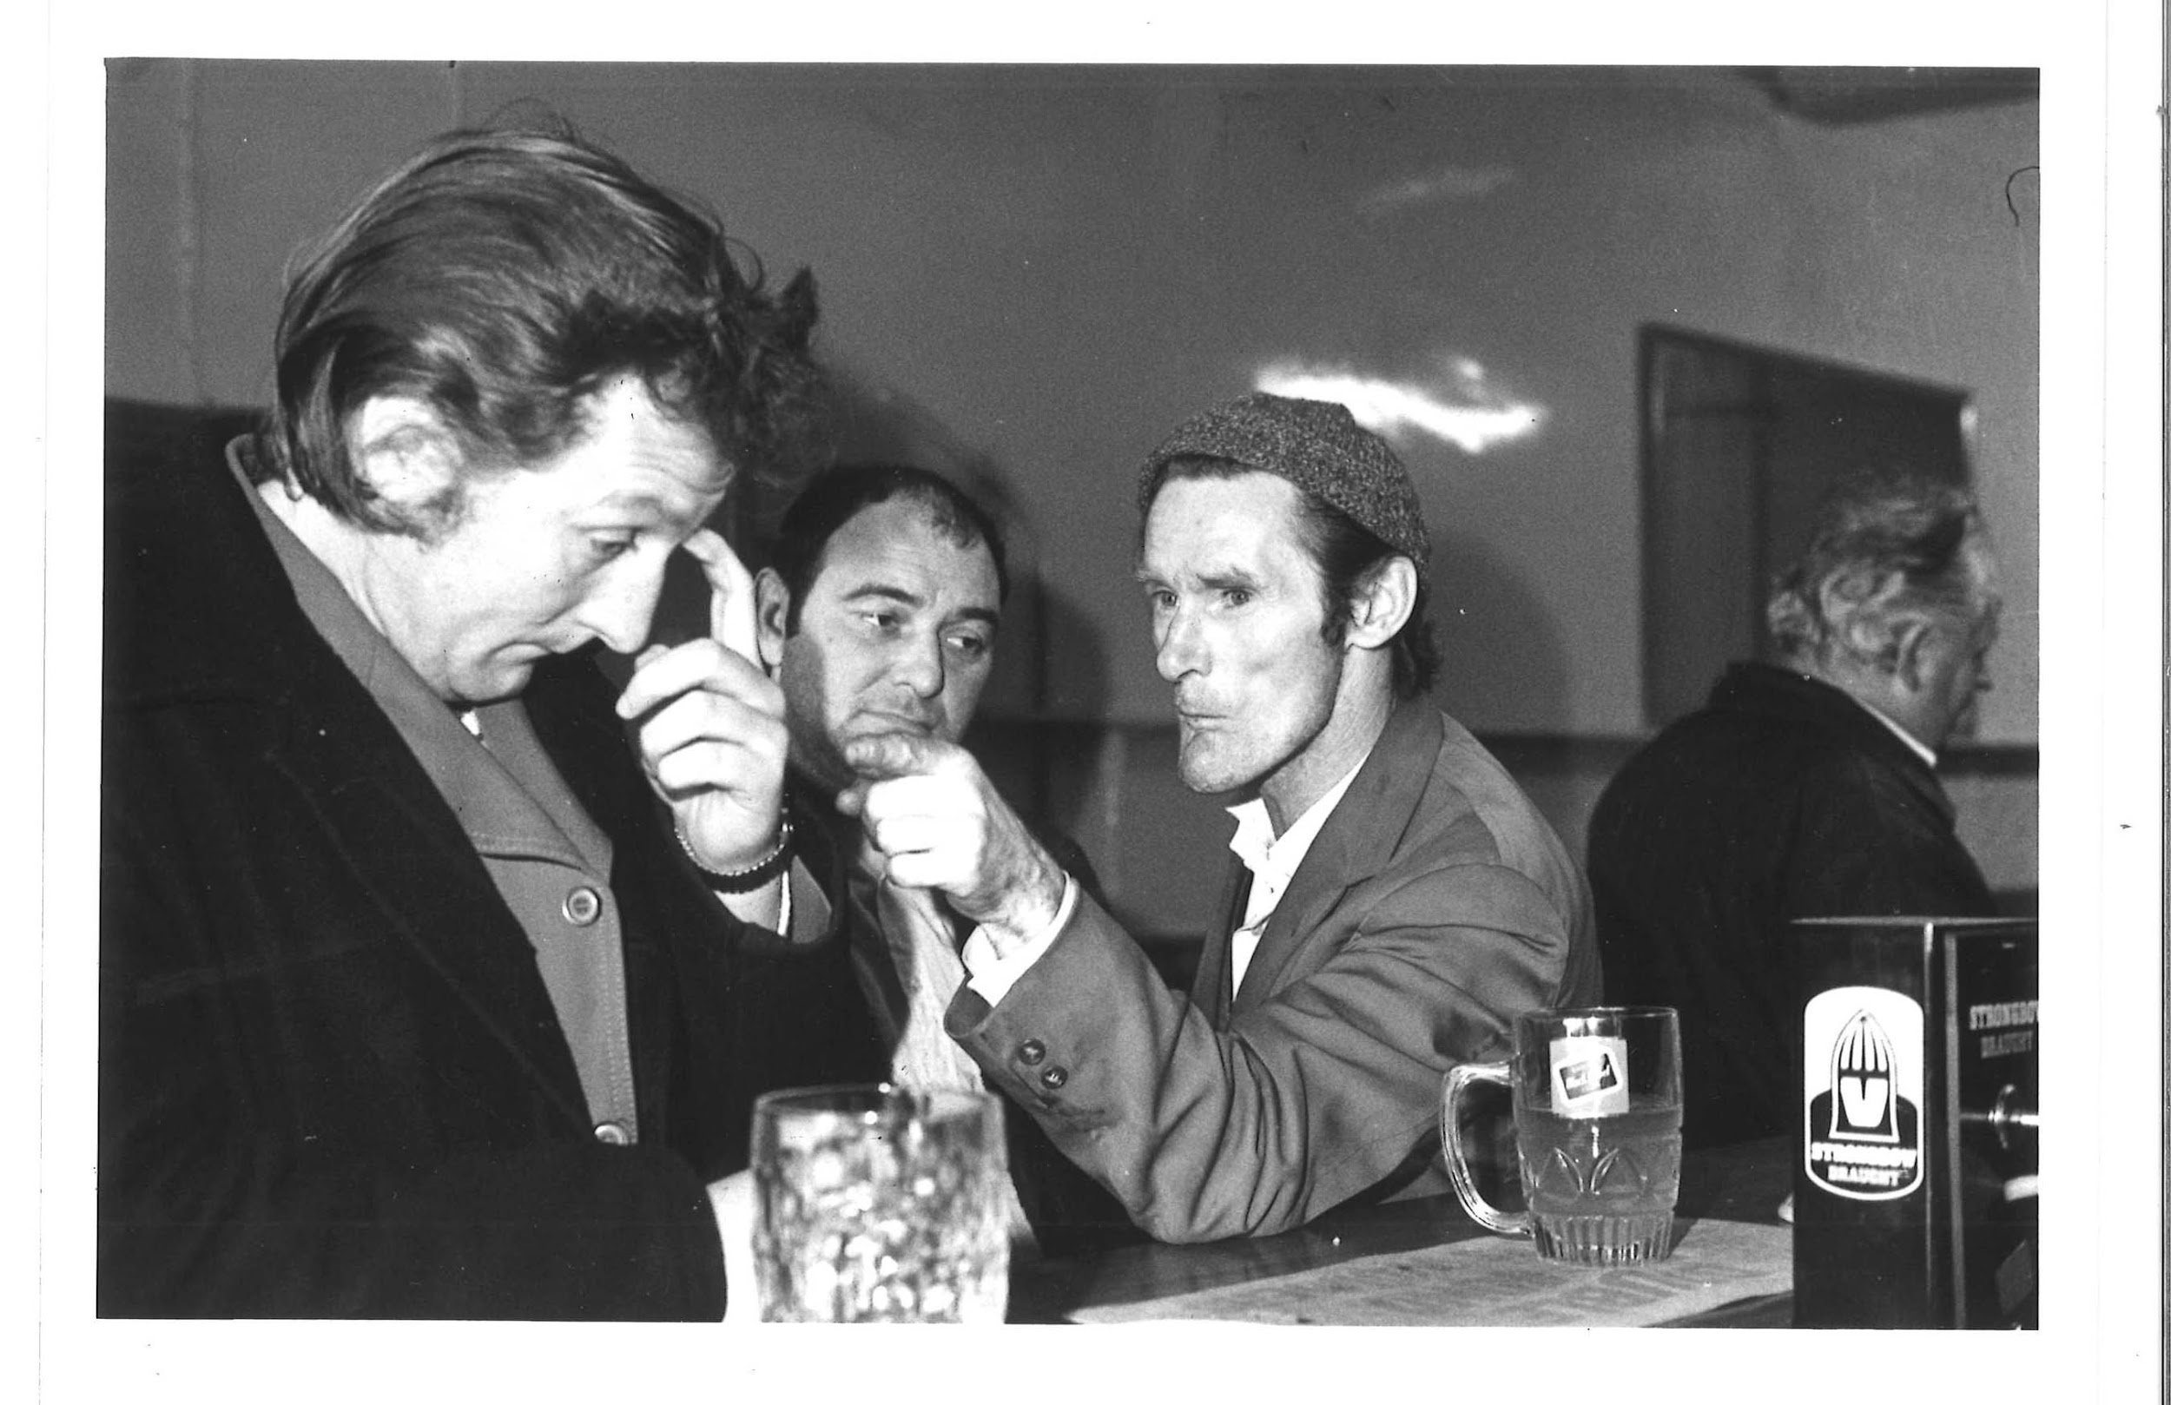 | TM_TPG_Newport Pub__16 | 215 x 164mm (approx) | Vintage print, loaned by Karen McQuaid / TPG on 08/05/18  From Ella Murtha material held at PARC | Newport Pub | 58
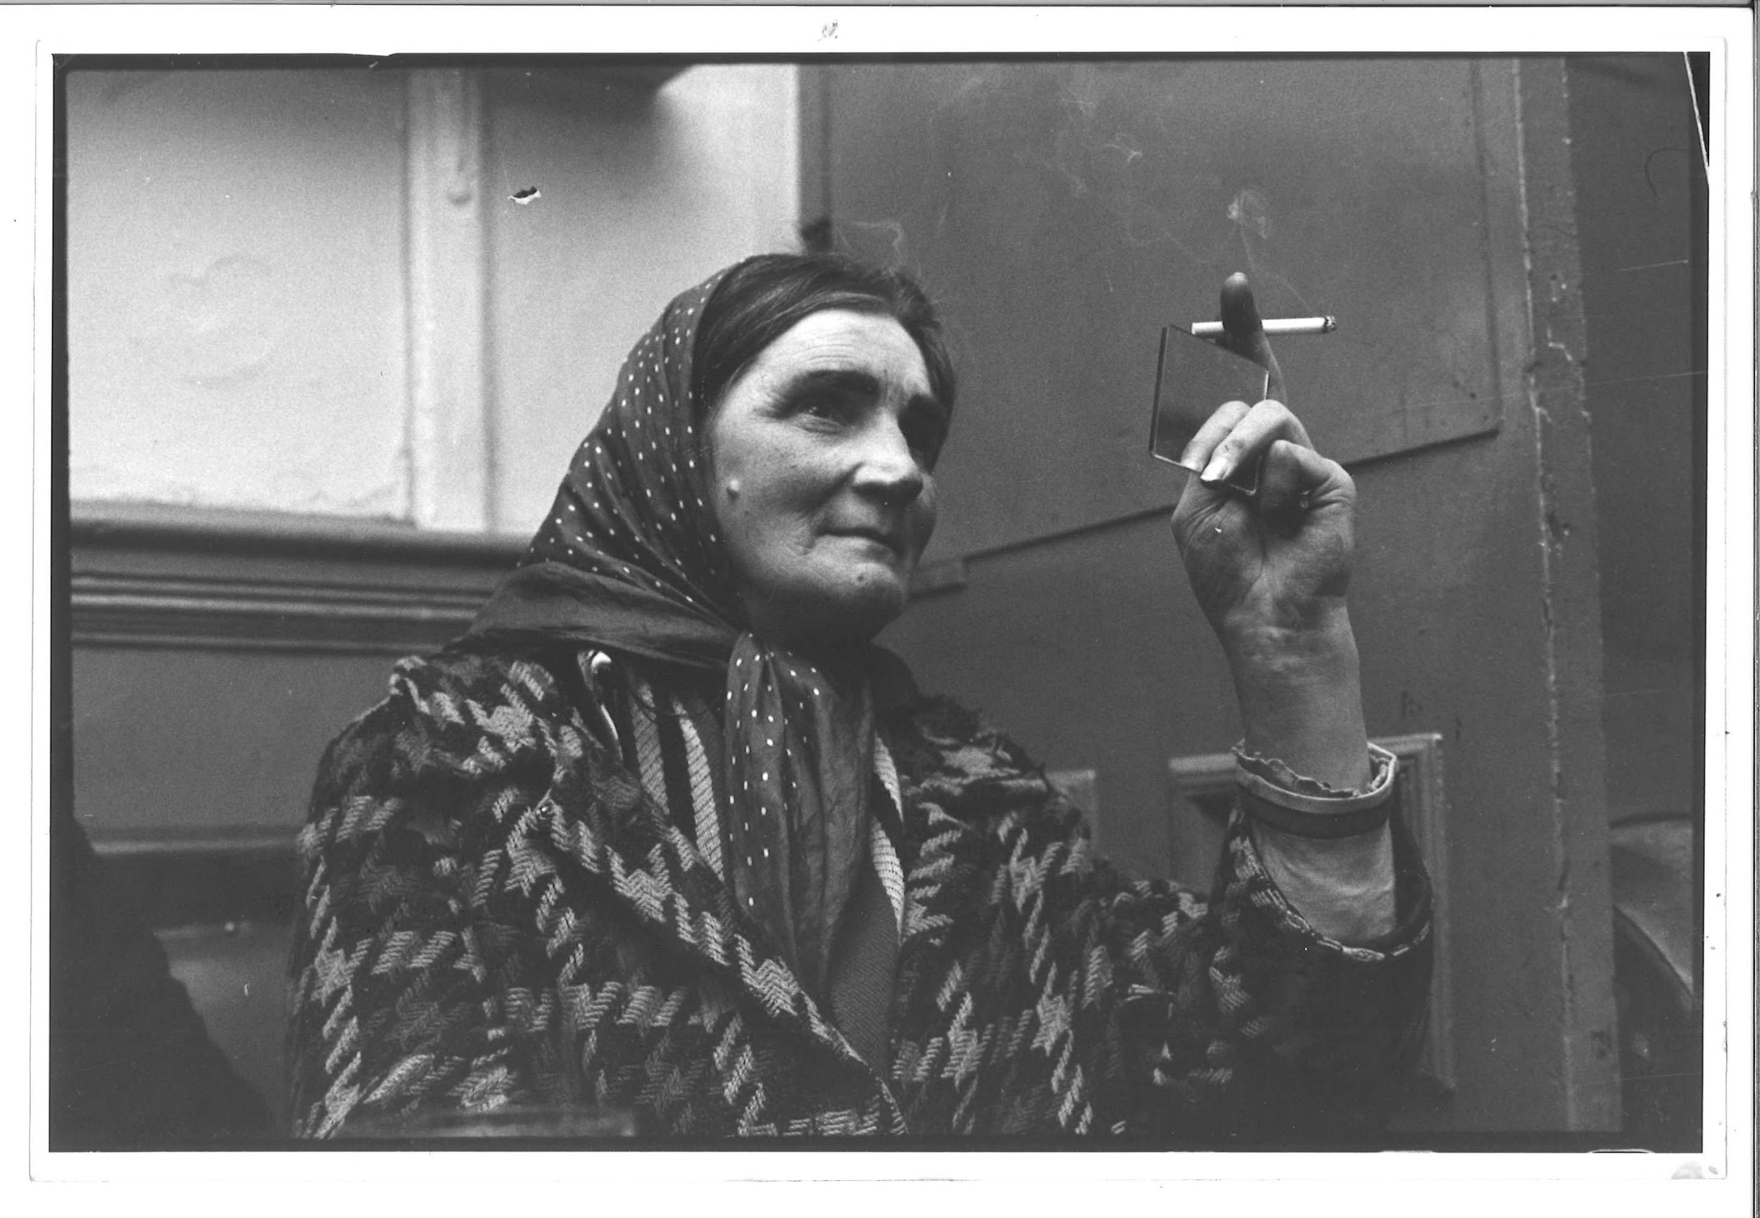 | TM_TPG_Newport Pub__17 | 234 x 159mm (approx) | Vintage print, loaned by Karen McQuaid / TPG on 08/05/18  From Ella Murtha material held at PARC | Newport Pub | 59
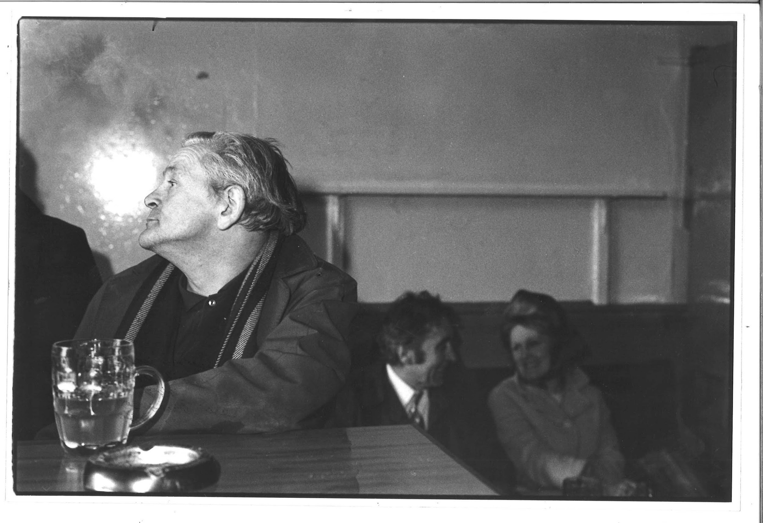 | TM_TPG_Newport Pub__18 | 229 x 156mm (approx) | Vintage print, loaned by Karen McQuaid / TPG on 08/05/18  From Ella Murtha material held at PARC | Newport Pub | 60
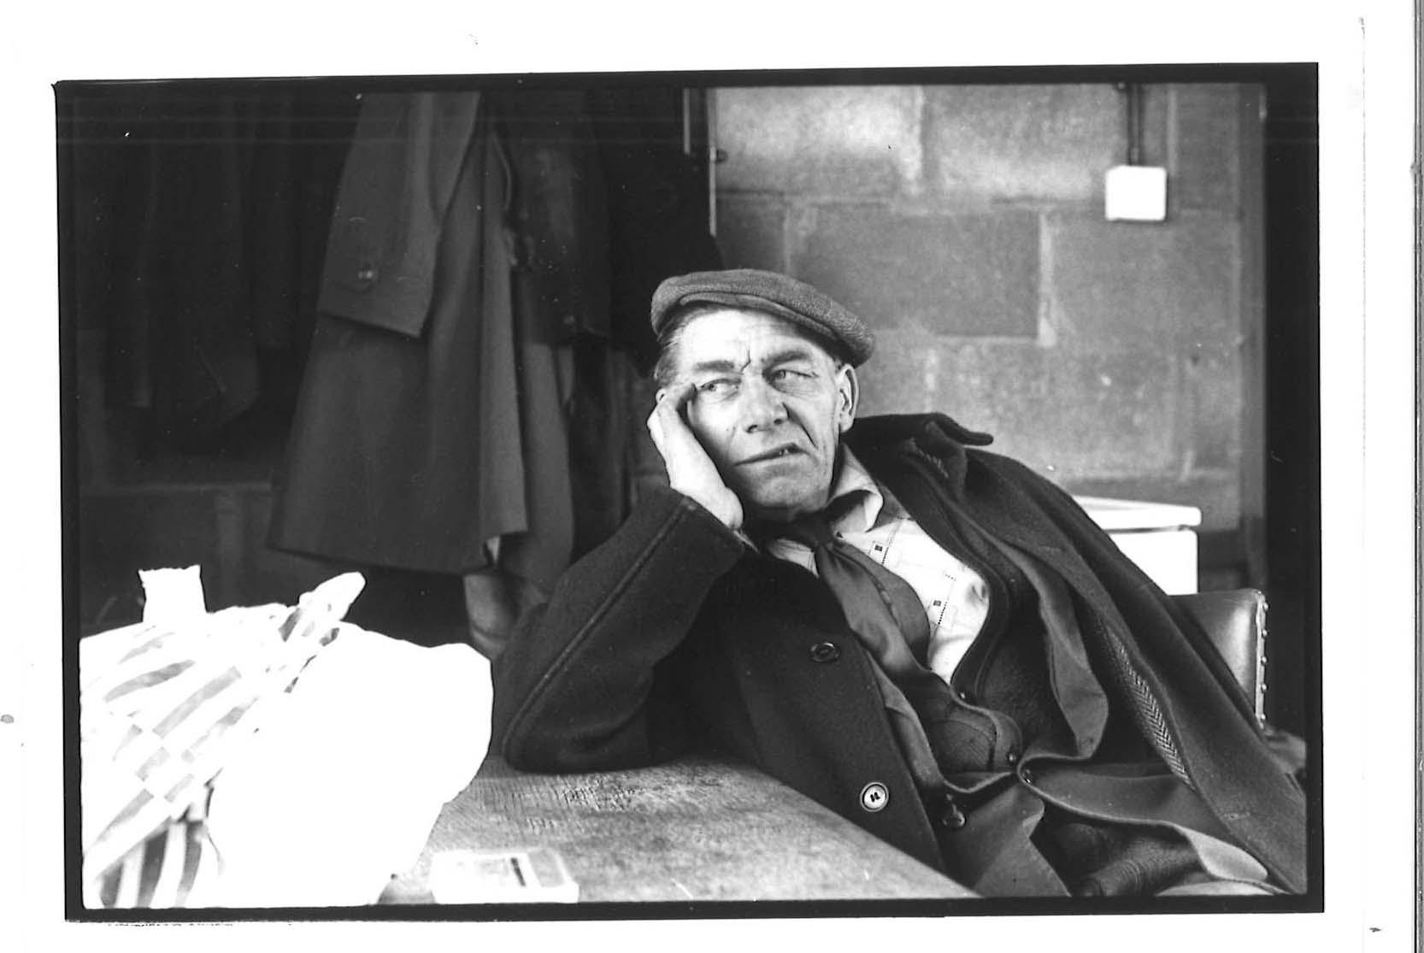 | TM_TPG_Newport Pub__19 | 133 x 94mm (approx) | Vintage print, loaned by Karen McQuaid / TPG on 08/05/18  From Ella Murtha material held at PARC | Newport Pub | 61
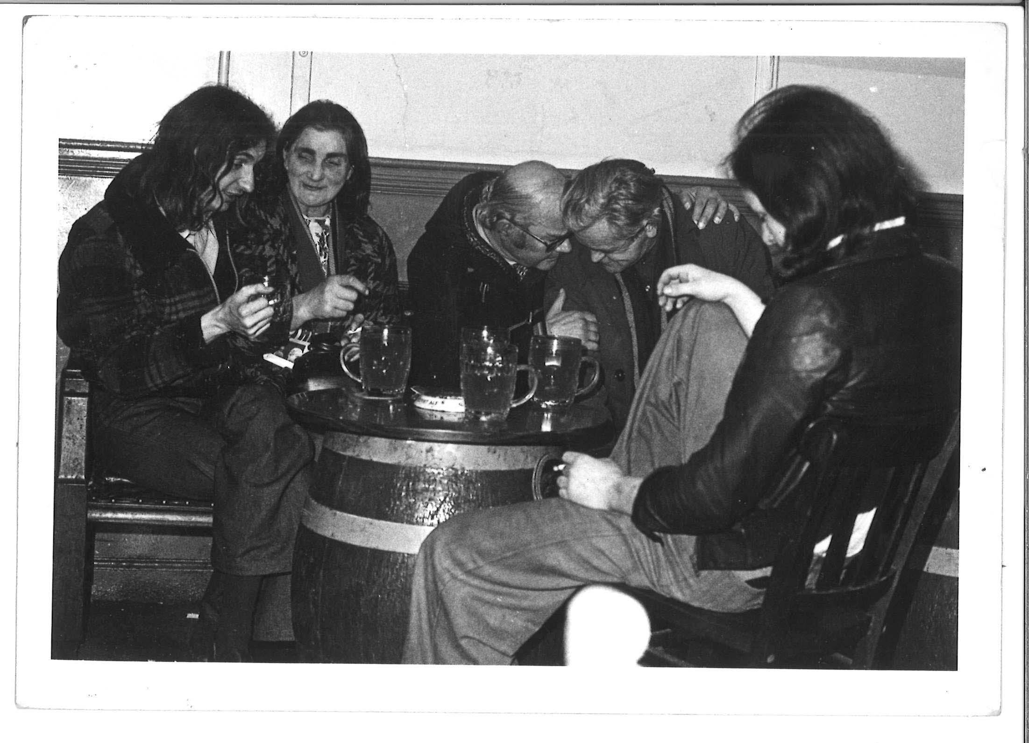 | TM_TPG_Newport Pub__20 | 178 x 126mm (approx) | Vintage print, loaned by Karen McQuaid / TPG on 08/05/18  From Ella Murtha material held at PARC | Newport Pub | 62
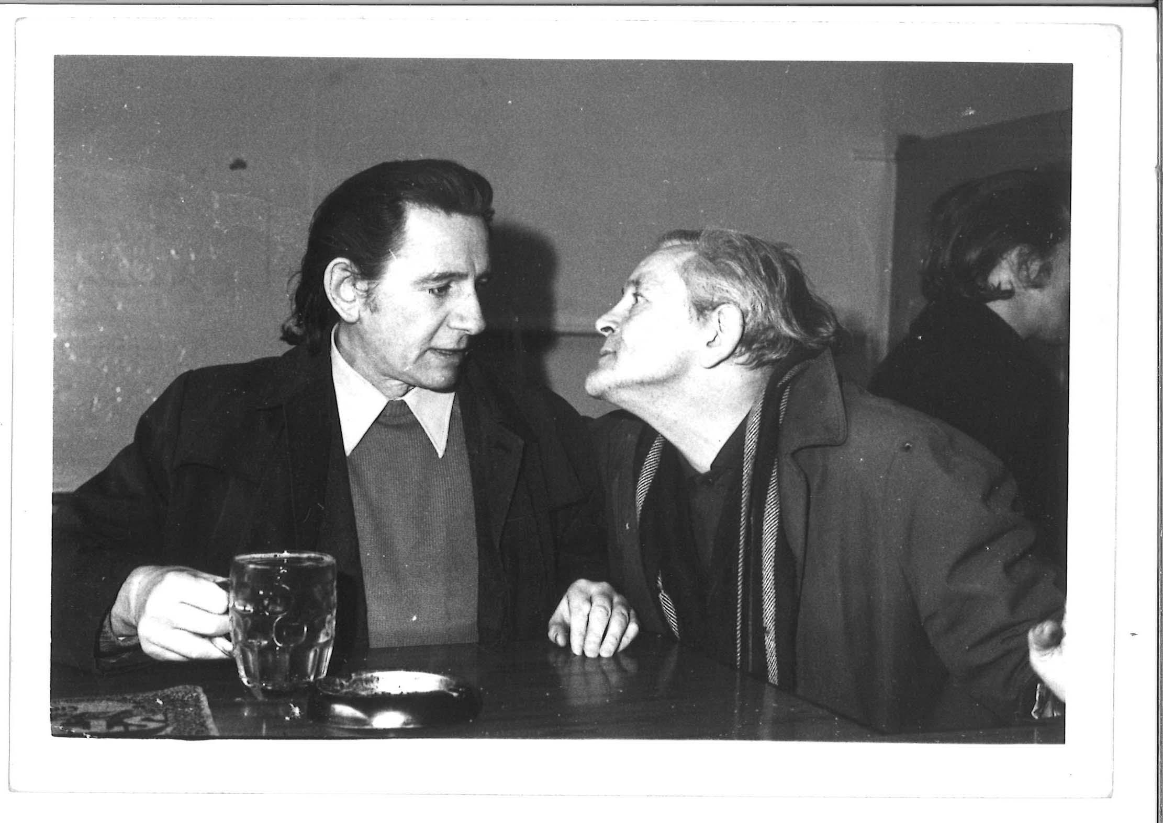 | TM_TPG_Newport Pub__21 | 178 x 126mm (approx) | Vintage print, loaned by Karen McQuaid / TPG on 08/05/18  From Ella Murtha material held at PARC | Newport Pub | 63
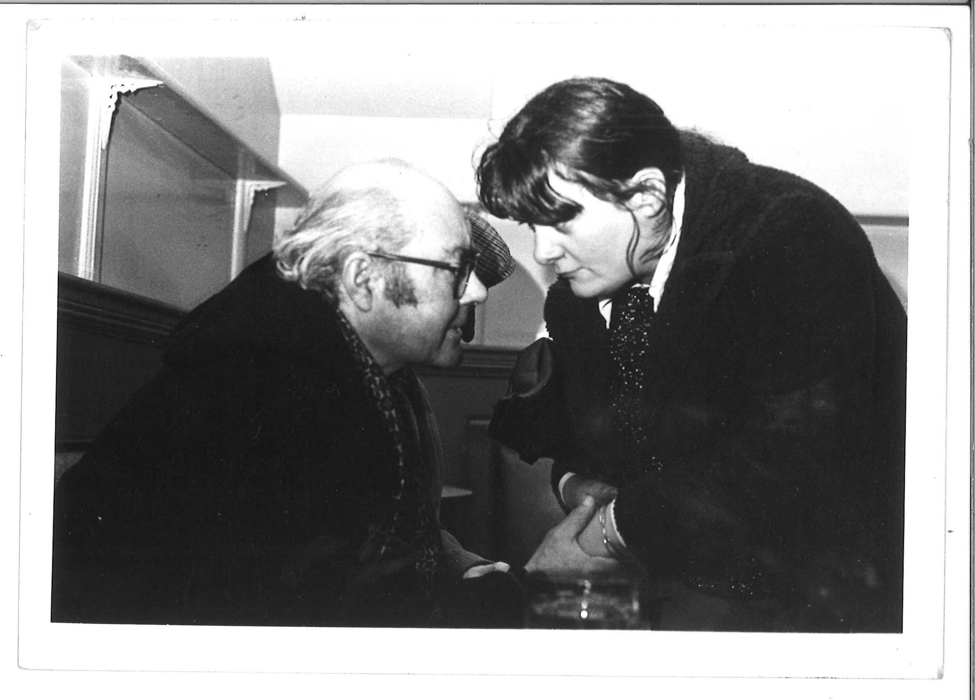 | TM_TPG_Newport Pub__22 | 178 x 126mm (approx) | Vintage print, loaned by Karen McQuaid / TPG on 08/05/18  From Ella Murtha material held at PARC | Newport Pub | 64

Elwick Kids
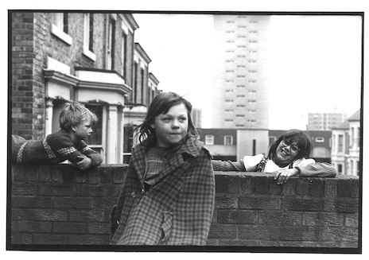 | TM_TPG_ElswickKids_1 | 10x12. | Scanning& printing by Metro. Contemporary Print. | Elswick Kids | 65
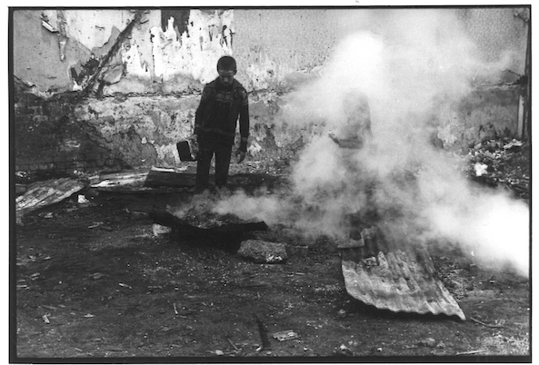 | TM_TPG_ElswickKids_2 | 10x12. | Scanning& printing by Metro. Contemporary Print. | Elswick Kids | 66
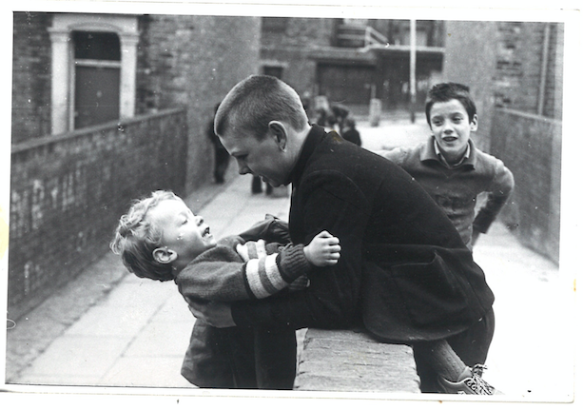 | TM_TPG_ElswickKids_3 | 10x12. | Scanning& printing by Metro Contemporary Print. | Elswick Kids | 67
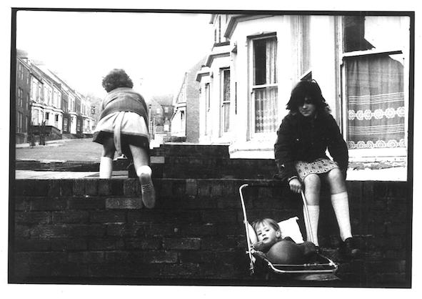 | TM_TPG_ElswickKids_4 | 10x12. | Scanning& printing by Metro Contemporary Print. | Elswick Kids | 68
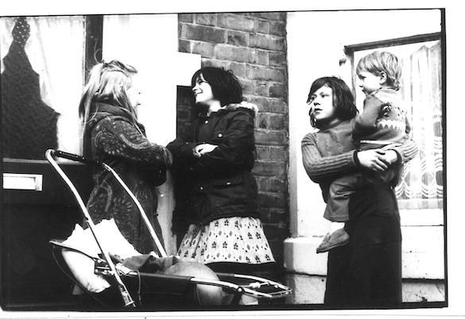 | TM_TPG_ElswickKids_5 | 10x12 | Scanning& printing by Metro Contemporary Print. | Elswick Kids | 69
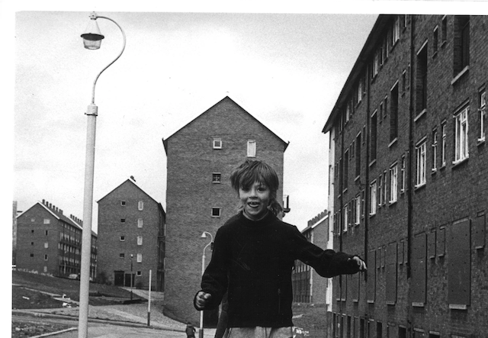 | TM_TPG_ElswickKids_6 | 10x12 | Scanning& printing by Metro Contemporary Print. | Elswick Kids | 70
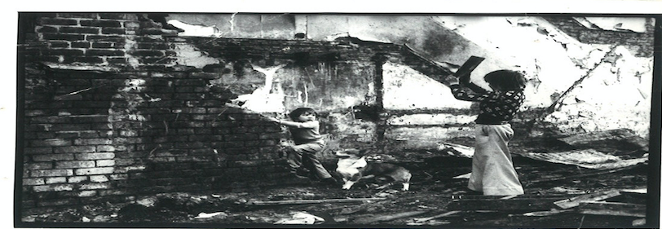 | TM_TPG_ElswickKids_7 | 10x12 | Scanning& printing by Metro Contemporary Print. | Elswick Kids | 71
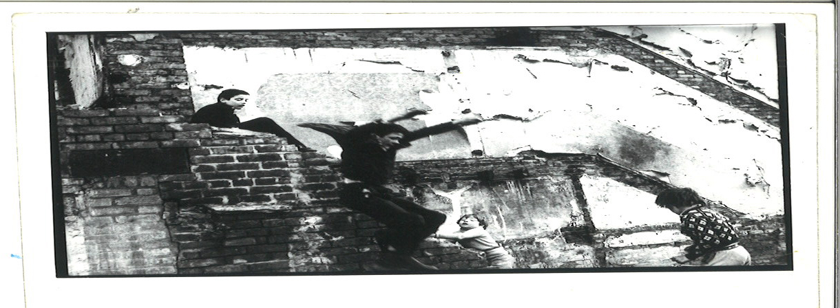 | TM_TPG_ElswickKids_8 | 10x12 | Scanning& printing by Metro Contemporary Print. | Elswick Kids | 72
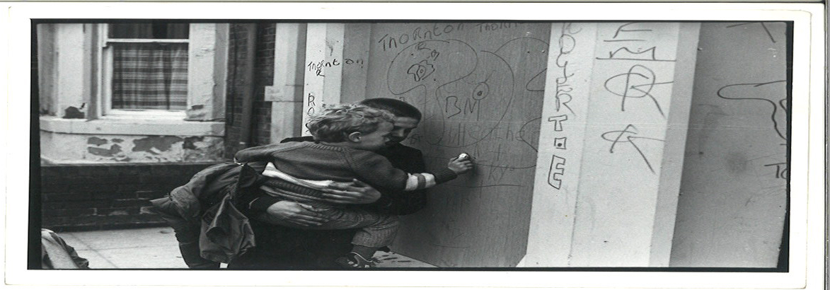 | TM_TPG_ElswickKids_9 | 10x12 | Scanning& printing by Metro Contemporary Print. | Elswick Kids | 73
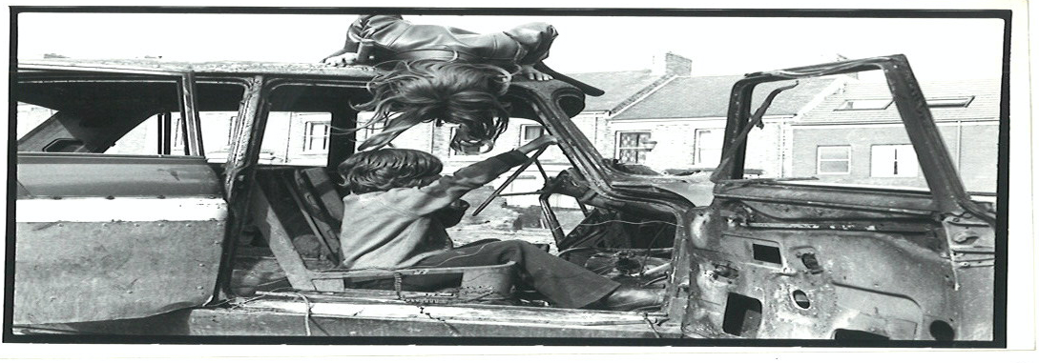 | TM_TPG_ElswickKids_10 | 10x12 | Scanning& printing by Metro Contemporary Print. | Elswick Kids | 74
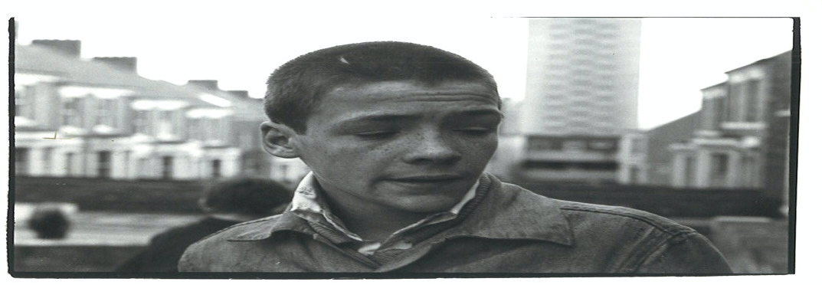 | TM_TPG_ElswickKids_11 | 10x12 | Scanning& printing by Metro Contemporary Print. | Elswick Kids | 75
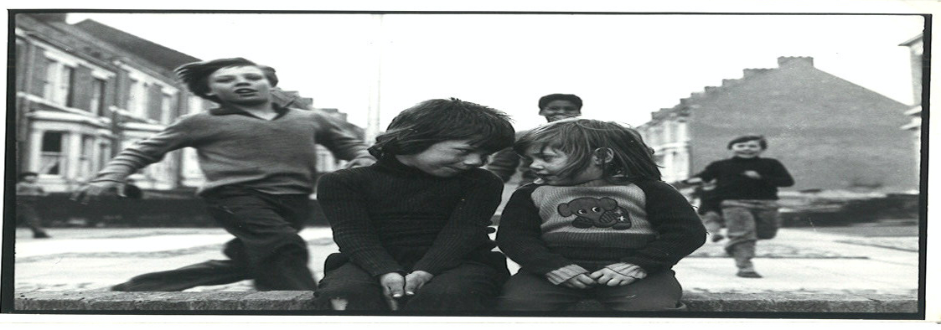 | TM_TPG_ElswickKids_12 | 10x12 | Scanning& printing by Metro Contemporary Print. | Elswick Kids | 76
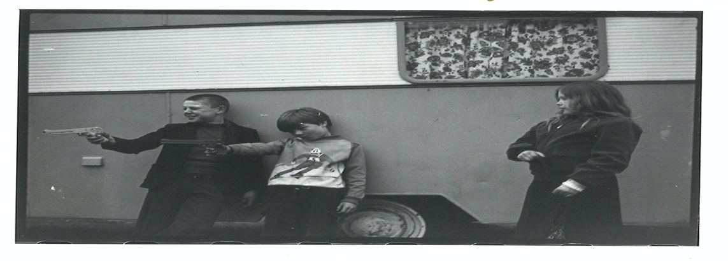 | TM_TPG_ElswickKids_13 | 10x12 | Scanning& printing by Metro Contemporary Print | Elswick Kids | 77
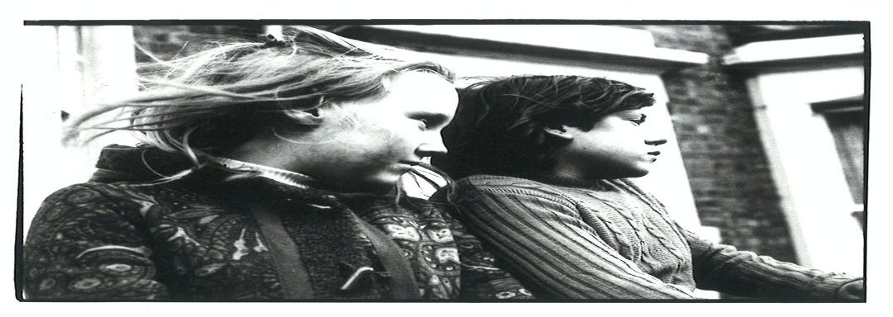 | TM_TPG_ElswickKids_14 | 10x12 | Scanning& printing by Metro Contemporary Print | Elswick Kids | 78
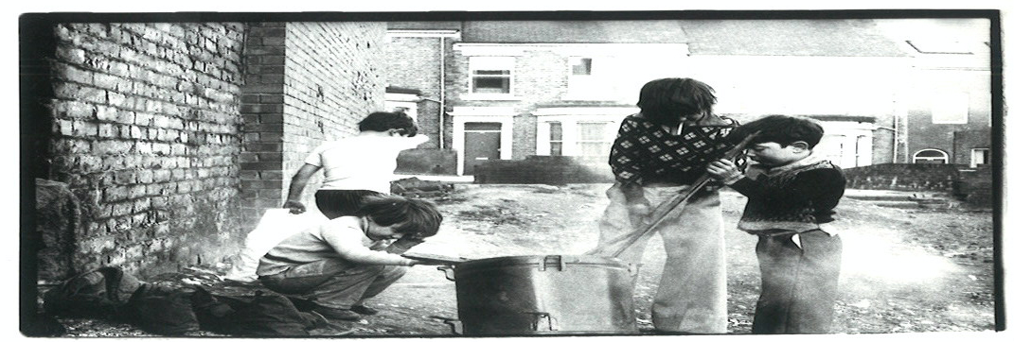 | TM_TPG_ElswickKids_15 | 10x12 | Scanning& printing by Metro Contemporary Print | Elswick Kids | 79
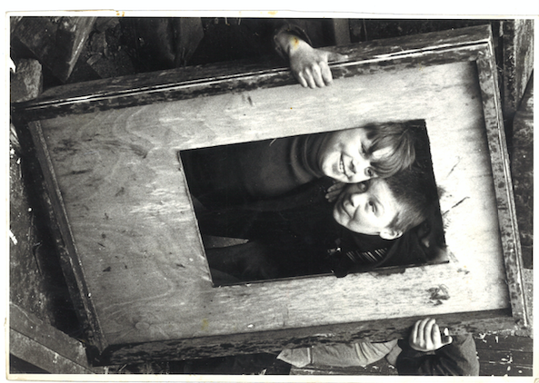 | TM_TPG_ElswickKids_16 | 12x10 | Scanning& printing by Metro Contemporary Print | Elswick Kids | 80
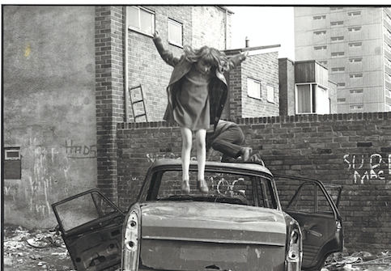 | TM_TPG_ElswickKids_17 | 10x12 | Scanning& printing by Metro Contemporary Print | Elswick Kids | 81
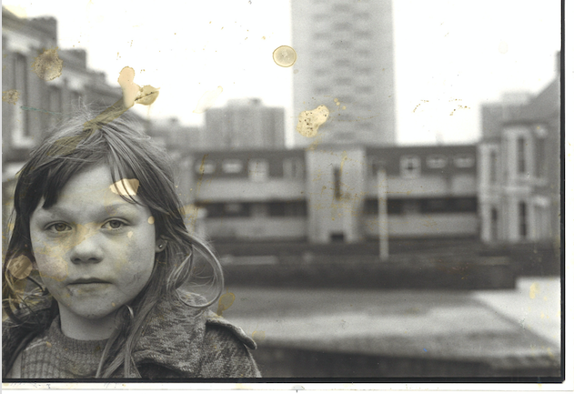 | TM_TPG_ElswickKids_18 | 10x12 | Scanning& printing by Metro Contemporary Print | Elswick Kids | 82
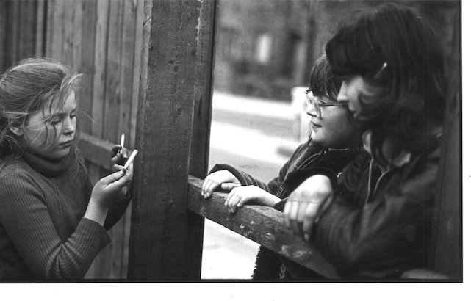 | TM_TPG_ElswickKids_19 | 10x12 | Scanning& printing by Metro Contemporary Print | Elswick Kids | 83
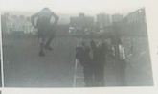 | TM_TPG_ElswickKids_20 | 10x12 | Scanning& printing by Metro Contemporary Print | Elswick Kids | 84
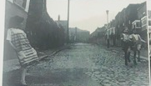 | TM_TPG_ElswickKids_21 | 10x12 | Scanning& printing by Metro Contemporary Print | Elswick Kids | 85
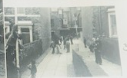 | TM_TPG_ElswickKids_22 | 10x12 | Scanning& printing by Metro Contemporary Print | Elswick Kids | 86
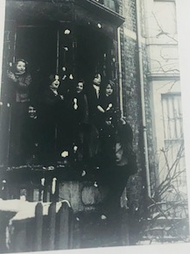 | TM_TPG_ElswickKids_23 | 12x10 | Scanning& printing by Metro Contemporary Print | Elswick Kids | 87
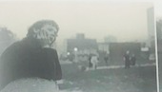 | TM_TPG_ElswickKids_24 | 12x10 | Already scanned/printing by metro | Elswick Kids | 88

Youth Unemployment Vintage Prints
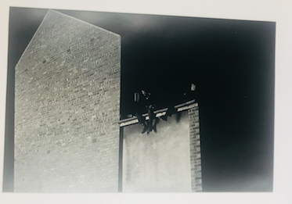 | TM_TPG_YU(Vint)_1 |  | Original: on loan from Side | Youth Unemplyment | 89
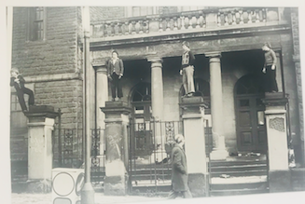 | TM_TPG_YU(Vint)_2 |  | Original: on loan from Side | Youth Unemplyment | 90
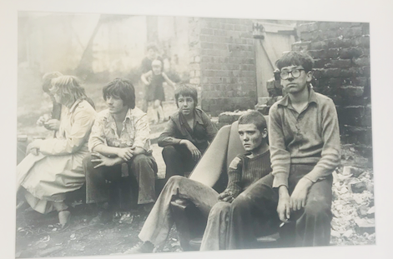 | TM_TPG_YU(Vint)_3 |  | Original: on loan from Side | Youth Unemplyment | 91
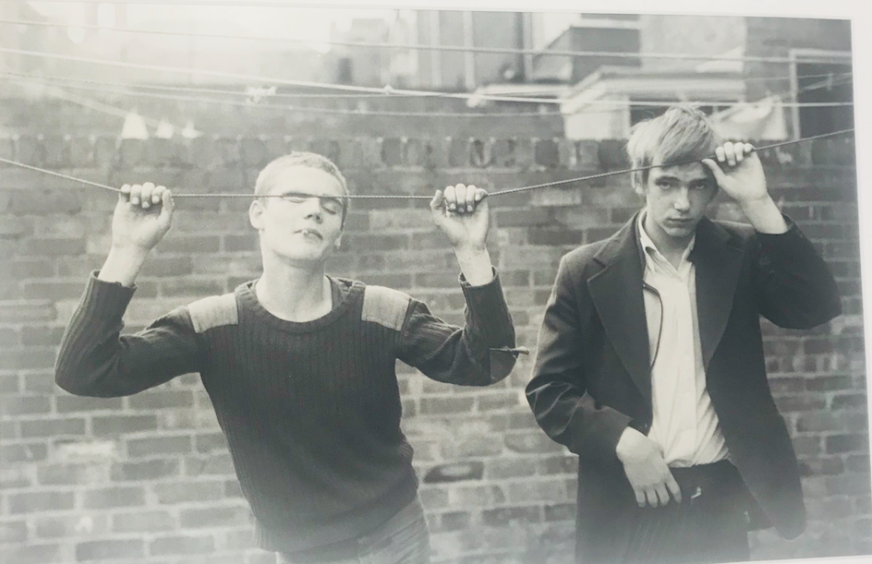 | TM_TPG_YU(Vint)_4 |  | Original: on loan from Side | Youth Unemplyment | 92
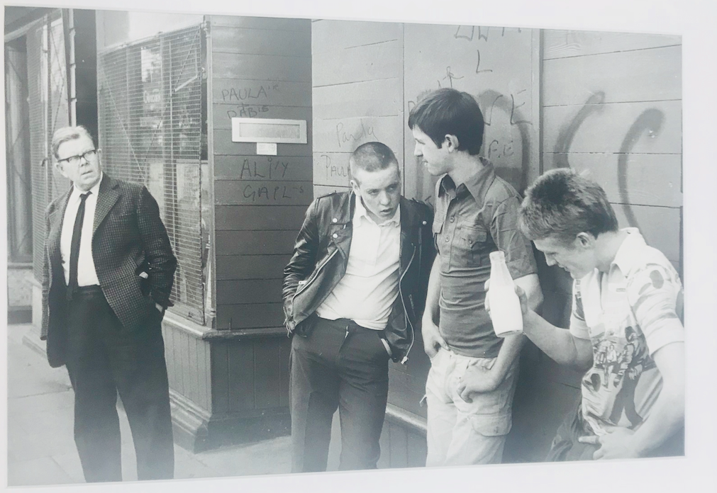 | TM_TPG_YU(Vint)_5 |  | Original: on loan from Side | Youth Unemplyment | 93
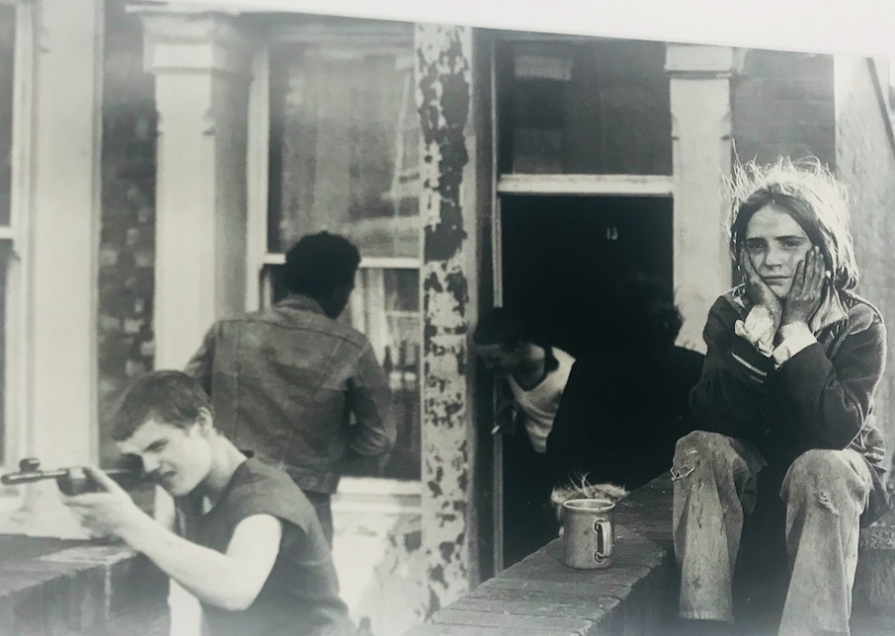 | TM_TPG_YU(Vint)_6 |  | Original: on loan from Side | Youth Unemplyment | 94
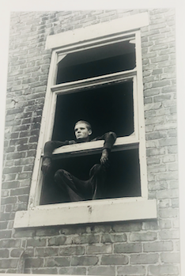 | TM_TPG_YU(Vint)_7 |  | Original: on loan from Side | Youth Unemplyment | 95
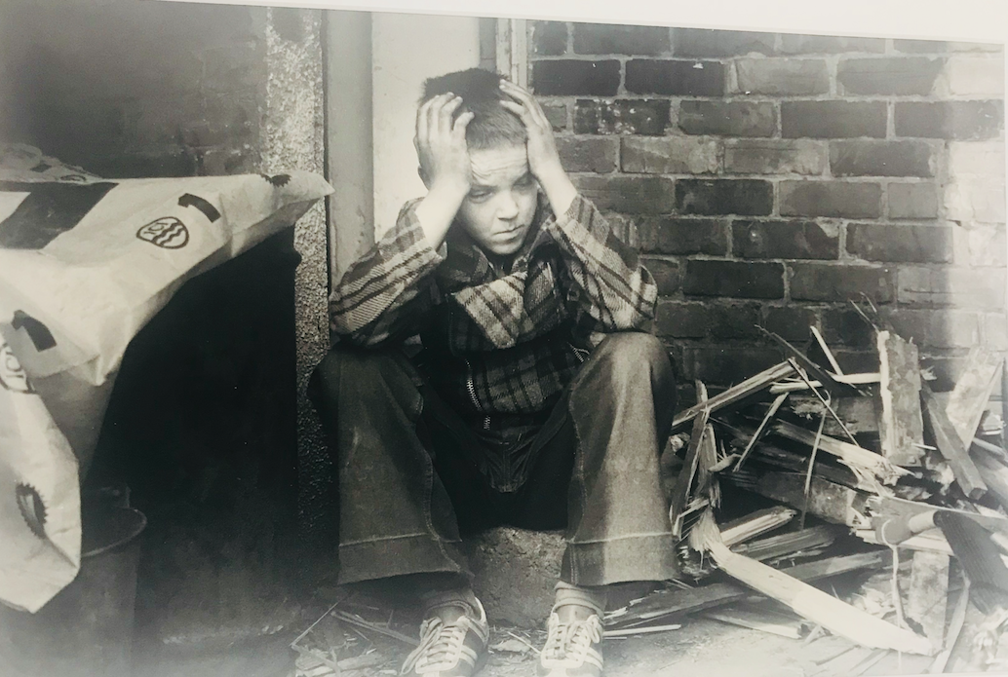 | TM_TPG_YU(Vint)_8 |  | Original: on loan from Side | Youth Unemplyment | 96
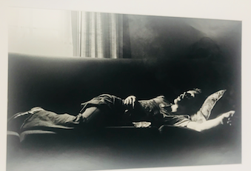 | TM_TPG_YU(Vint)_9 |  | Original: on loan from Side | Youth Unemplyment | 97
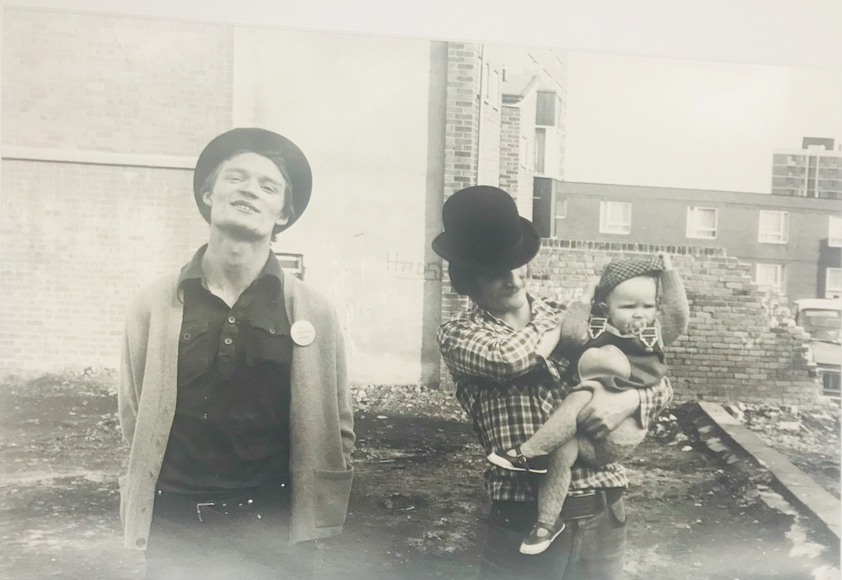 | TM_TPG_YU(Vint)_10 |  | Original: on loan from Side | Youth Unemplyment | 98
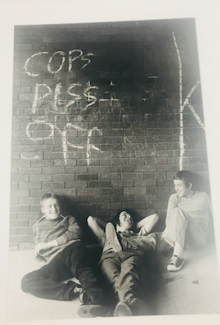 | TM_TPG_YU(Vint)_11 |  | Original: on loan from Side | Youth Unemplyment | 99
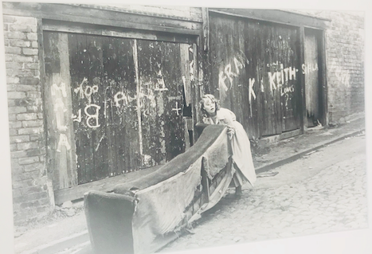 | TM_TPG_YU(Vint)_12 |  | Original: on loan from Side | Youth Unemplyment | 100
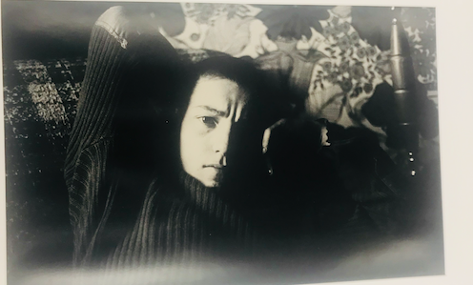 | TM_TPG_YU(Vint)_13 |  | Original: on loan from Side | Youth Unemplyment | 101
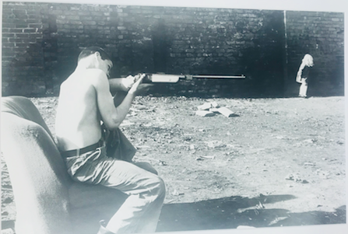 | TM_TPG_YU(Vint)_14 |  | Original: on loan from Side | Youth Unemplyment | 102
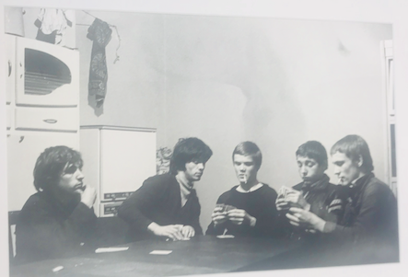 | TM_TPG_YU(Vint)_15 |  | Original: on loan from Side | Youth Unemplyment | 103
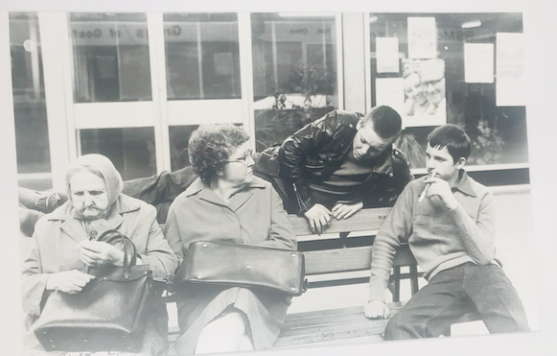 | TM_TPG_YU(Vint)_16 |  | Original: on loan from Side | Youth Unemplyment | 104

Youth Unemplyment Contemp Prints
 | TM_TPG_YU(contemp)_1 |  | Already scanned/printing by metro | Youth Unemployment | 105
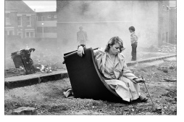 | TM_TPG_YU(contemp)_2 |  | Already scanned/printing by metro | Youth Unemployment | 106
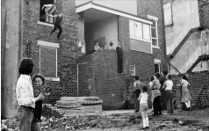 | TM_TPG_YU(contemp)_3 |  | Already scanned/printing by metro | Youth Unemployment | 107
Juvenile Jazz Bands
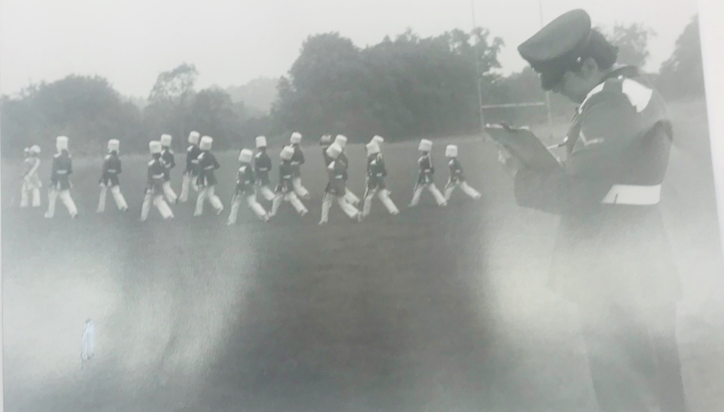 | TM_TPG_JJB_1 |  | Original: on loan from Side | Juvenile Jazz Bands | 108
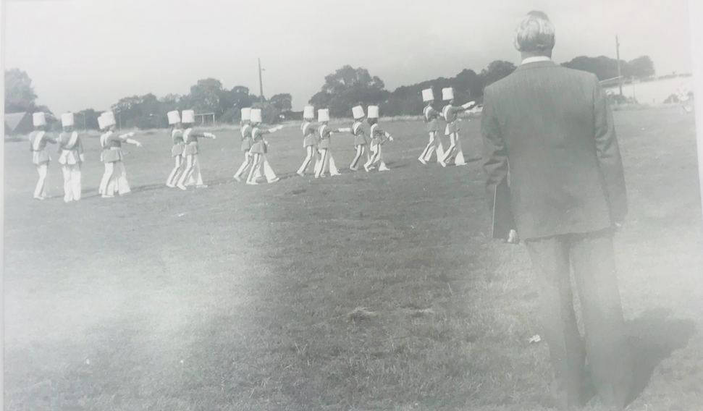 | TM_TPG_JJB_2 |  | Original: on loan from Side | Juvenile Jazz Bands | 109
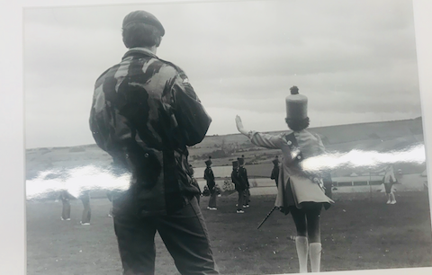 | TM_TPG_JJB_3 |  | Original: on loan from Side | Juvenile Jazz Bands | 110
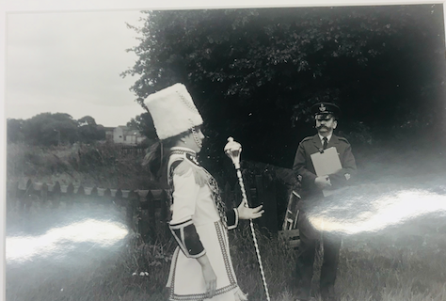 | TM_TPG_JJB_4 |  | Original: on loan from Side | Juvenile Jazz Bands | 111
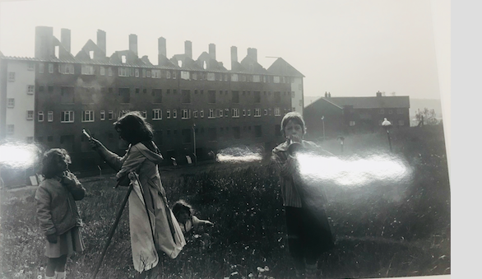 | TM_TPG_JJB_5 |  | Original: on loan from Side | Juvenile Jazz Bands | 112
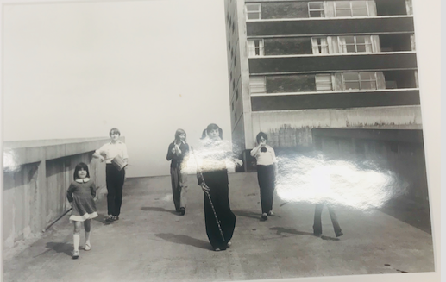 | TM_TPG_JJB_6 |  | Original: on loan from Side | Juvenile Jazz Bands | 113
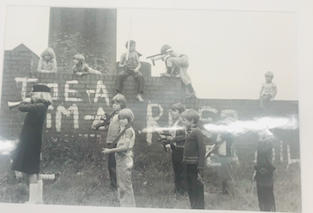 | TM_TPG_JJB_7 |  | Original: on loan from Side | Juvenile Jazz Bands | 114
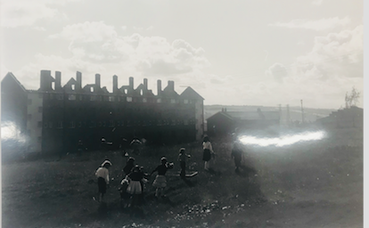 | TM_TPG_JJB_8 |  | Original: on loan from Side | Juvenile Jazz Bands | 115
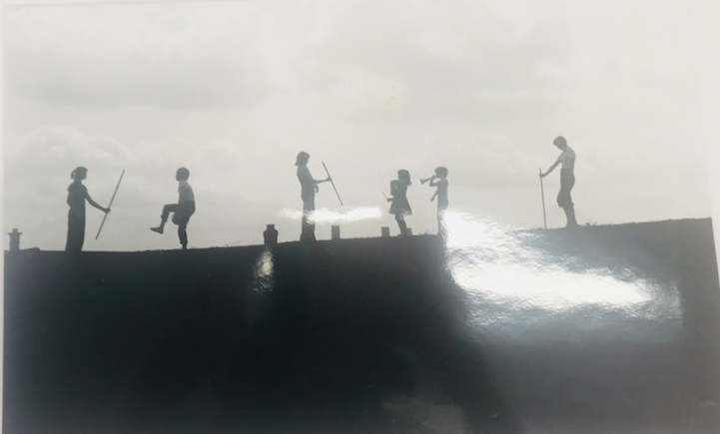 | TM_TPG_JJB_9 |  | Original: on loan from Side | Juvenile Jazz Bands | 116
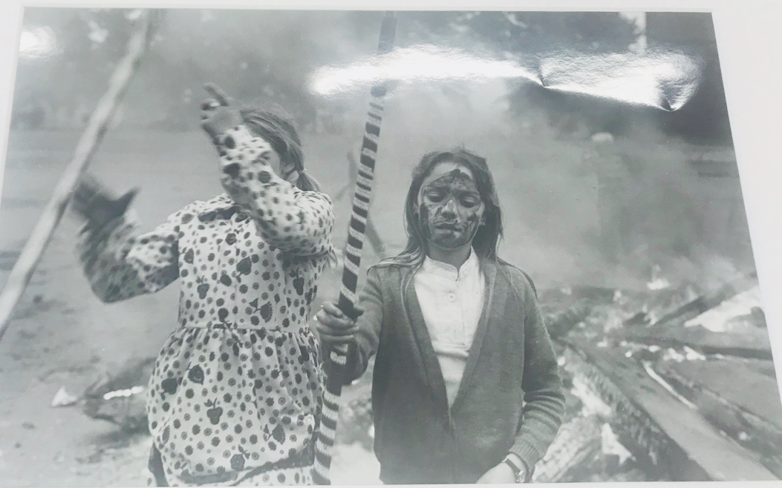 | TM_TPG_JJB_10 |  | Original: on loan from Side | Juvenile Jazz Bands | 117
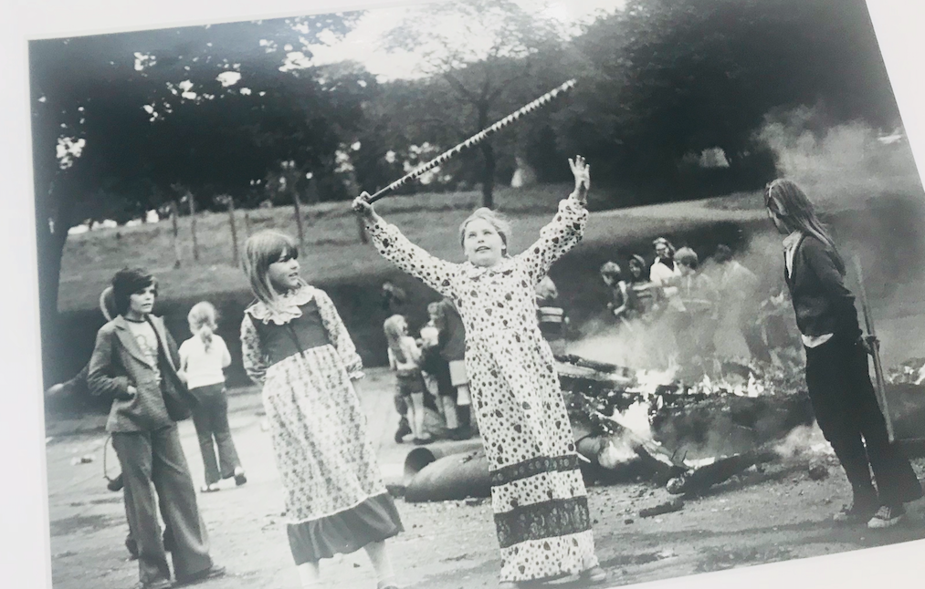 | TM_TPG_JJB_11 |  | Original: on loan from Side | Juvenile Jazz Bands | 118
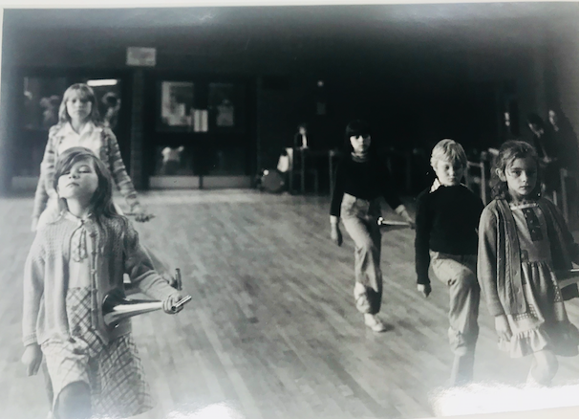 | TM_TPG_JJB_12 |  | Original: on loan from Side | Juvenile Jazz Bands | 119
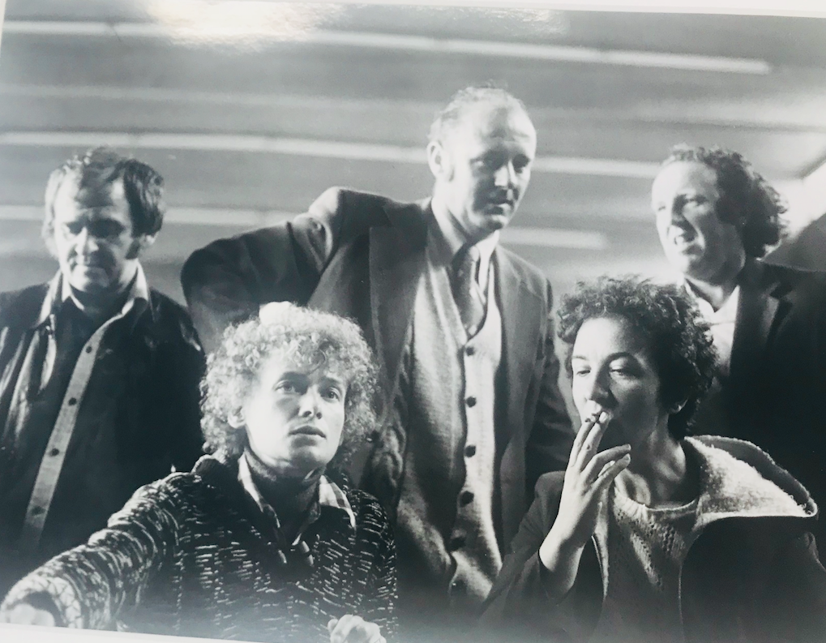 | TM_TPG_JJB_13 |  | Original: on loan from Side | Juvenile Jazz Bands | 120
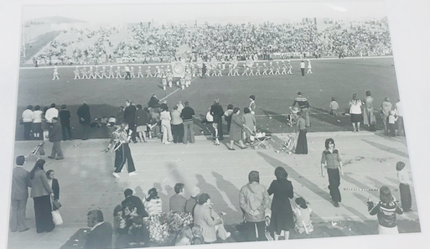 | TM_TPG_JJB_14 |  | Original: on loan from Side | Juvenile Jazz Bands | 121
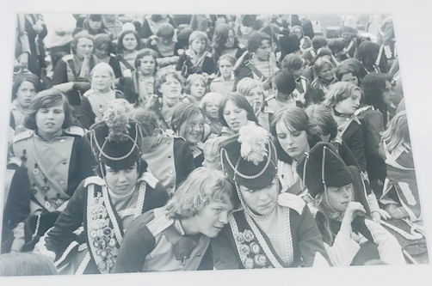 | TM_TPG_JJB_15 |  | Original: on loan from Side | Juvenile Jazz Bands | 122
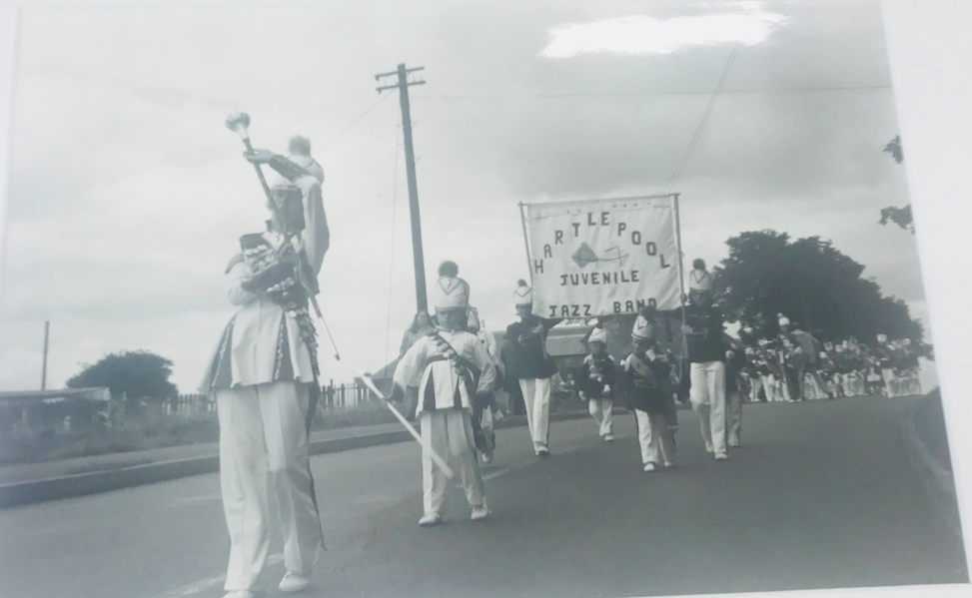 | TM_TPG_JJB_16 |  | Original: on loan from Side | Juvenile Jazz Bands | 123
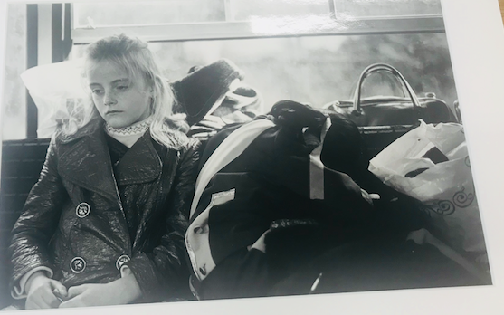 | TM_TPG_JJB_17 |  | Original: on loan from Side | Juvenile Jazz Bands | 124
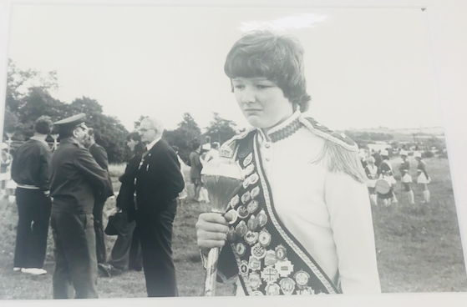 | TM_TPG_JJB_18 |  | Original: on loan from Side | Juvenile Jazz Bands | 125
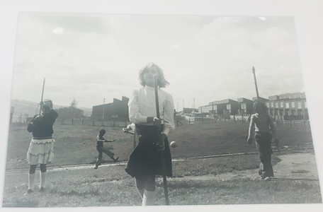 | TM_TPG_JJB_19 |  | Original: on loan from Side | Juvenile Jazz Bands | 126
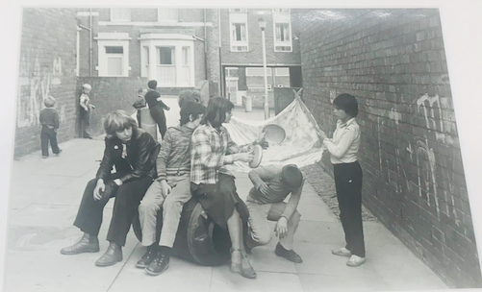 | TM_TPG_JJB_20 |  | Original: on loan from Side | Juvenile Jazz Bands | 127
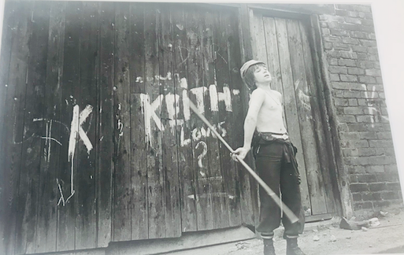 | TM_TPG_JJB_21 |  | Original: on loan from Side | Juvenile Jazz Bands | 128

