L Accessible to anyone, everywhere: Skelf as a case study for the virtual project space.
Claire Undy, 2025

Limitless spaces – background and curatorial approach
Skelf is a virtual project space, originally conceived with artist Heather Ross then curated and coded by Claire Undy. Existing entirely online at skelf.org.uk, Skelf presented work by over two hundred artists and writers in 50 exhibitions and projects between 2016-2022. Previous exhibitions remain in an archive on the site, and Skelf continues as a platform for one-off collaborations.
Initially devised in response to a lack of physical space and the funds to exhibit, amateur coding skills became a mode of constructing limitless spaces to work and collaborate in, unrestricted by real-world practicalities. Through early tests it became apparent that the devices that supported and cajoled artists into making new or experimental work such as exhibitions and deadlines could be constructed with equal impact online, and audiences could be reached without the need to share the same geographical location.
‘Accessible to anyone, everywhere’ became an essential objective for the site, and as the project evolved it prompted ongoing reflection about what was meant by accessibility. Accessibility of location was an immediate advantage: to see contemporary art, the viewer was not required to live in a major city or have the time and resources to visit galleries and project spaces during limited opening hours. Contributing artists could reach a new audience, working from anywhere in the world, and producing work in a flexible manner that accommodated their own personal responsibilities and restrictions. Viewing work on their own devices, an audience could adjust the sensory experience of the work to be comfortable and functional for them, using the same adaptive tools they might use to engage with the ‘real’ world.
Skelf was intended to exist amongst this ‘real’ world as opposed to the ivory tower of an art gallery or museum. Work shown on Skelf was site-specific and conceived without physical form, as opposed to being a digital record of artwork that existed materially elsewhere. As the project evolved, many of the most innovative works emerged from artists who did not ordinarily work with digital media. My curatorial strategy became to approach artists whose work relied upon a physical or material encounter and to reimagine their practice without this critical factor. This led to collaborations with painters, performance artists, sculptors, a choreographer and a dance company, amongst many others.
In many ways the ‘task’ of Skelf became establishing what the essence of a proposed work was, and how this might be experienced by a viewer. Through discussion with the artists, I would explore different coding techniques that captured this experience, going back and forth until we produced a new piece that felt as though it belonged within the artist’s practice, despite often being an entirely new approach. Coding as a do-it-yourself process is very forgiving to the amateur due to the huge array of tuition available online, and most Skelf exhibitions have been approached with the blind optimism of a creator learning on the job, discovering new possibilities through doing things ‘wrongly’.

Technical difficulties – the challenges of a virtual exhibition space
Preservation of virtual exhibitions can present a notable challenge. Frequently, artworks on Skelf have employed coding ‘workarounds’ to encourage browsers to present work in ways that contradict normal web behaviours. For example, many pieces in the Skelf Archive rely upon automatic playing of audio-visual elements, something that is frequently blocked by browsers as they replicate the behaviours of intrusive advertising. In just a few short years, several projects have ceased to function, as browsers update and the technology they rely upon becomes obsolete.
Web-based projects are coded innovatively, in response to the latest technology at the time of creation, yet the dramatic pace of technological advancement significantly reduces their longevity, leaving them “ephemeral and unstable” (Paul, 2008, p.25). Ironically, DIY and artist-run projects like Skelf, while created on a shoestring, would require a significant funding commitment over a long period of time to preserve. As a curator, technician, or collaborator (the role itself evolves and varies depending on the project) there is a huge sense of responsibility for the works on the site, which have all been produced with care, originality and hours of labour. Yet it would be almost impossible to keep up with the preservation of these projects without ongoing re-writing of the code, which in some cases would fundamentally alter the functionality of the piece.
One of the most significant differences between virtual and physical exhibitions is the control that an artist can have over the audience’s experience. In a gallery, an artist might take all manner of steps to ensure that the encounter is free from distractions and any aspects of the outside world that might detract from an optimum viewing experience. This is not possible online. Exhibitions must be built in a way that is fluid and variable—the same work would appear very differently depending on the device or browser the audience was using. Beyond the layout of the page, audience interactions might be taking place on a browser whilst simultaneously shopping, working, or any other online activity.
It is widely understood that our online concentration span is limited, so advertising and social media content is edited into ever-more succinct fragments designed to catch our attention. Online artwork that requires an audience to focus on something durational or in-depth sits as a direct challenge to this mode of engagement.
Francisco Soave’s (2017) Skelf work ‘Gone’ is a durational monochrome, where the page colour turns imperceptibly from yellow to red over the course of a month, before starting over again. Like a monochrome painting that refers to its own materiality, the digital monochrome does the same thing. Rather than something permanent or tangible, we become aware of the colour as something that is simply a coded instruction existing in the flux of time, irrespective of our perception of it. The impossibility of experiencing the entire artwork is written into its very nature and so we are absolved of guilt or responsibility and gifted the freedom to engage with it in any manner we wish.
Rather than resisting a distracted viewing experience, virtual exhibitions can exist in dialogue with the multiplicity and mundanity of everyday life. Arvanitis (2010) talks about the ephemeral knowledge of everyday life and how the ever-presence of phones within a museum can be used to give a voice to this knowledge, bringing it into dialogue with exhibited work. Much has been written about the encounter with artwork in the flesh as a form of spiritual experience and a trip to the Louvre in Paris to see the Mona Lisa might take on the qualities of a great pilgrimage. For Skelf, I intended to move the art away from this form of encounter and place it in the viewer’s hand or in their homes, for them to engage with in the same way they might with social media.
Social media’s power is in its ability to embed itself within our daily lives, providing an infinite number of unique experiences fuelled by the engagement of individuals. Hooper-Greenhill (2000) talks about the post-museum as a site where knowledge is formed from a plurality of perspectives, in dialogue with its audience as opposed to transmitted from a fixed source. It is this fluidity, and lack of a singular visual outcome that characterises the valuable possibilities and the challenges of exhibiting virtual art.

Relational space – producing art in conversation with everyday life
A virtual exhibition space is relational in several ways. Firstly in its form, as websites are inherently concomitant. Most code is a series of interrelated instructions that happen in dialogue with other aspects of the page and according to the proportions and restrictions of the browser it is being viewed upon. How websites (and web-based exhibitions) reveal themselves are also almost entirely down to the engagement of the viewer. Describing his influential early internet-based work Unfolding Object, John F. Simon, Jr. states “the expression of the code, its unfolding, is decided by the interaction of the code with the person unfolding it” (2002, para 6)
Web-based exhibitions also exist in relation to the positionality of our own personal lives, in practical terms through our devices and homes, but also in their capacity for a more distracted form of engagement. Hooper-Greenhill (2000) wrote, “It is possible that this embrace of pluralism is one feature shared by women, whose lives are frequently multiple, concerned with balancing complex and conflicting desires” (page ix). For several years, my construction of Skelf coincided with my life as a new parent during the pandemic, and I found many benefits in the ability to collaborate with other artists and ideas, even if this engagement was intermittent, nocturnal, or while a baby slept.
The pandemic itself created an involuntary blurring between creative and domestic spaces. Many artists were suddenly left without their studios, materials, collaborators, or the time, space and funds to make work as they had in the past. In July 2020, Skelf hosted a new exhibition, Ways and Means, showcasing the work of nineteen different artists, selected from applications from an open call, which artists in 33 different countries engaged with. The exhibition, visually presented as the suddenly ubiquitous group video call, celebrated new approaches to working that had developed in response to the challenges of the time. Many of the works in the exhibition focussed on conveying a sense of touch, or a haptic engagement with the world. Kate Squires & Jenny Dunseath’s collaborative film As Seen (2020) played with the interaction between tactile objects and the conveying of their phenomenology across multiple layers of real and virtual space (figure 1).
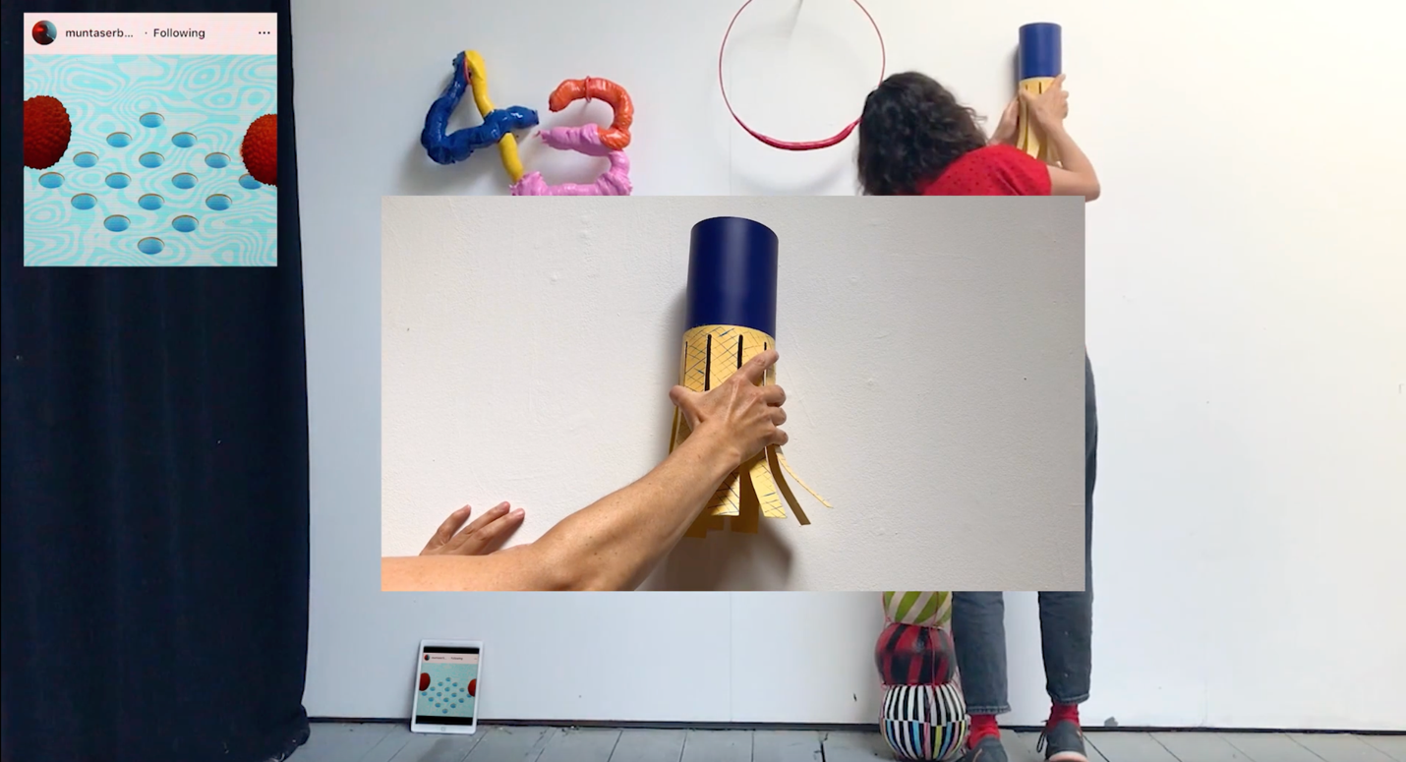Figure 1. Screen shot of As Seen by Kate Squires & Jenny Dunseath.
“What can we do online that we can’t do in real life?” This was the question I posed to dance company Corali, on a Zoom call at the beginning of our collaboration for their 2021 Skelf exhibition. Corali are a leader in dance by artists with a learning disability, and I became interested in working with them after seeing their virtual strategies for choreography during lockdown. Simple drawings, or instructions in relation to household objects became prompts for creating dance that was both individual and collective, made within the bubble of the home yet contributing towards a shared creative purpose. The suggestions the dancers made to my question were expansive and uninhibited— some wished to dance under the sea, some to never tire or be restricted by gravity, others wanted to dance with their pets.
Bubbles Together (2021), the final work, became an embodiment of all these thoughts- a dreamlike assemblage of bodies within bubbles floating at random under the sea (Figure 2). While the dancers existed as endlessly looping GIFs, the bubbles were generated using JavaScript to float at random, meaning that the piece was never the same, and different interactions between movements took place with each viewing. The bubbles enabled the dancers to dance communally at a time when many were vulnerable and isolating.

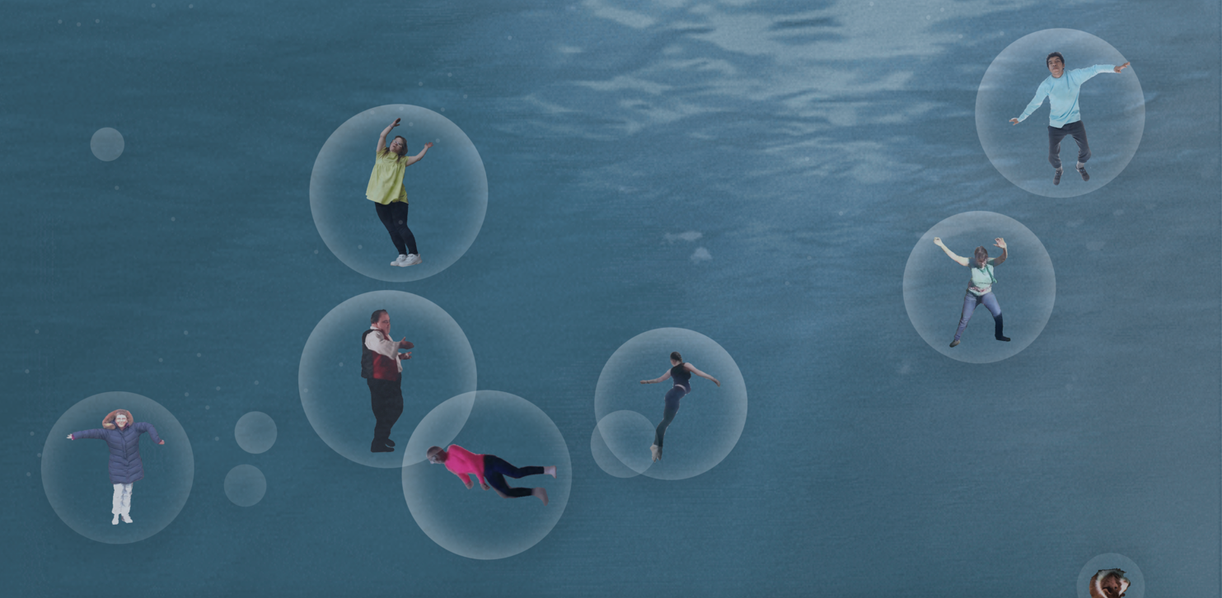Figure 2. Screenshot of Bubbles Together by Corali dance company.
During the pandemic, Skelf’s position as a virtual project space ceased to be that of an outsider, as increasing numbers of well-known galleries and museums began engaging with the new necessity to reach audiences virtually. For some, this was simply a placeholder, keeping a line of conversation open until ‘normal’ services could resume. However, I believe the pandemic accelerated a growing shift towards embracing the virtual within the everyday. Bourriaud (2002) defined relational art as that concerned with “the whole of human relations and their social context” (page 113). With that in mind, as society evolves to incorporate a hybridity of virtual and physical experience, it seems natural that art would find a place amongst this exchange.
Any sort of shift from an artworld which prioritises singularity and exclusivity will have an inevitable impact upon the value of an artwork and necessitates making a distinction between financial and other forms of value. Paul (2008) writes:
The value of art— at least when it comes to the traditional model— is inextricably linked to its economic value, but the ‘scarcity equals value’ model does not necessarily work when it comes to digital art. (pg. 24)
If an artist is to embrace the internet’s ability to duplicate and share information and imagery infinitely, it may also be imperative to rethink the notion that an artwork’s dominant value is as a commodity that might be sold to support the artist. If ‘value’ is no longer financial but related to the quality of the viewer experience, then the ‘support’ that the value brings becomes more subtle, usually in the engagement between artist and viewer, or the benefits of sharing the work with a wider audience.
In 2017, Skelf was invited to be digital partner to the Art Licks Weekend, a London-based art festival that championed artist-led and innovative small galleries and art platforms. For one weekend only Skelf hosted an ‘Art Feast’, where twelve artists gave their work away for free via the site for a fixed 48-hour period. Formats included GIFs, printable wallpaper, video and a radio programme. They were not inherently rare objects, all of them had the potential to be reproduced in any quantity, though they were no longer available online after the end of the festival, so their scarcity or otherwise became a result of how they were valued and chosen or shared by the viewer.
In order to embrace the new possibilities that online art presents, it might seem necessary to set aside art’s historical celebration of the original. If we are to queue in the Louvre to see the Mona Lisa, we must first accept the idea that there is inherent value to an in-person encounter with the original work of art. We understand the original to be something unmoved by the viewer or the conditions that surround it. Yet incorporating any work on a web page brings it into an uncontrolled environment, where it has the potential to be reproduced or taken out of context indefinitely. ‘Meaning’ might not necessarily travel within the artwork but be formed and reformed in dialogue with its surroundings.
Malraux’s 1947 proposition for a ‘museum without walls’ argued that reproductions in books have a value of their own, without negating the value of the original:
It no more causes us to neglect the originals than the phonograph caused neglect to the concert hall. It leads us to study those which are accessible to us, not to forget them; and if they are inaccessible, what would we know of them without it?. (pg. 111).
It would be simplistic to suggest that artists taking part in projects such as the Skelf Art Feast do so simply to reach new audiences, as this implies a talent show-style desire to be plucked from perceived obscurity and made famous. However, it would certainly be possible to say that all artists that have taken part in Skelf projects have valued their work being activated in some form, as opposed to remaining in a studio, on a laptop, or even as an unresolved idea- waiting for the ideal set of circumstances in which to share them.
When artworks take on new forms during this process of online distribution, it allows them to sit in fresh contexts, in dialogue with other previously unrelated artworks and ideas. Battro (2010) takes Malraux’s proposition further, finding value in the alterations made to an artwork in the act of its reproduction:
What happens when colour, material, volume and even dimensions are lost? A reproduction devoid of those essential attributes certainly cannot be like the original. It is a different work. But thanks to this loss it also gains something ... it finds synchrony with other works that seemed unrelated to it. (p.141-142).
The internet presents possibilities for a potentially infinite combination of ideas, images and engagements and the viewer becomes curator as they chose what to bring together. The online space continually redefines the artwork’s meaning and value (Müller, 2010). So it seems that the most impactful and site-specific virtual exhibitions embrace this fluid site-specificity, resisting an overarching narrative and thriving in their co-existence amongst any combination of art and everyday life.
Hooper-Greenhill's ‘post-museum’ is described as a site of decolonising thought-processes and embracing plurality. The internet enables meaning to be fully relational and to exist in the dialogues between artworks and their different contexts. Far from a limited alternative to a ‘real’ encounter, exhibiting virtually may present entirely new possibilities for engaging with art. “Where the modernist museum was (and is) imagined as a building, the museum in the future may be imagined as a process or an experience” (p. 152).

Looking forwards- virtual spaces as a reflection of art practice
The familiar model of the individual artist working alone to produce singular works that are sold commercially feels outdated for the majority in the present day. Challenging financial circumstances mean that many artists juggle their art practice amongst paid work, funding applications, group projects and teaching. Outcomes are a broad range of collaborations and contributions to projects that take a multitude of forms and are shared on whichever platforms are available. In this sense, the fluidity and multiplicity of virtual exhibition spaces feel fitting to an understanding of an artist no longer working in isolation but in collaboration with others and in dialogue with a broader picture of their lives beyond the studio.
As the projects that were laboured over for many hours on Skelf gradually become obsolete, the value of their conservation is raised. Historically, artworks were designed to be preserved for longevity and were constructed with materials that allowed for this. However, the mercurial nature of web development does the opposite, so we cannot consider web-based artworks in the same way as oil paintings or marble statues. If we think of the works on Skelf within the realms of live art, performance or social practice, then their temporal nature becomes an inherent quality rather than a failing. Greater value might be found in producing new work than labouring over short-term preservation of the old.
As an artist, I have often considered my practice to be ‘doing’ rather than ‘making’ and have been more concerned about the experience of working, learning and collaboration than an autonomous result that could be sold or shown. Virtual projects lend themselves perfectly to this approach to art practice, allowing for meaningful collaborations and engagement within incredibly varied contexts. Perhaps the term ‘exhibition’ loses its relevance, with its implication of conclusion and direct transmission from artist to audience. Instead, Skelf feels to be a process of sharing an ongoing conversation across many different art practices.
It is my belief that the most innovative virtual exhibitions will not attempt to mimic the traditions and approaches of physical exhibitions in museums and galleries but will reflect the new possibilities that our evolving connectivity offers us, presenting new possibilities for both artists and audiences.

References
Arvanitis, K. (2010). Museums outside walls: Mobile phones and the museum in the everyday. In Parry, R. (Ed.), Museums in a Digital Age. (pp. 170-176). London: Routledge.

Battro, A. (2010). From Malraux's Imaginary Museum to the Virtual Museum In Parry, R. (Ed.), Museums in a Digital Age (pp. 136-148). London: Routledge.

Bourriaud, N. (2002) Relational Aesthetics (S. Pleasance & F. Woods, Trans). Les presses du réel.

Hooper-Greenhill, E. (2000) Museums and the Interpretation of Visual Culture. London: Routledge.

Malraux, A. (1967). Museum Without Walls (S. Gilbert & F. Price, Trans). London: Secker & Warburg. (Original work published in 1965).

Müller, K. (2010). Museums and Virtuality In Parry, R. (Ed.), Museums in a Digital Age (pp. 295 -305). London: Routledge.

Paul, C. (2008) Digital Art. London: Thames and Hudson.

Simon Jr, J.F. and Ippolito, J. (2002) Code As Creative Writing--An Interview with John F. Simon, Jr. Rhizome Digest, March 2002. https://rhizome.org/editorial/2011/mar/31/rhizome-archives/

